**EXPERIMENT NO:1**

**AIM**: Implement basic commands in R,R Graphics,Indexeing data,loading data,Additional graphical and numerical summaries .

**BASIC COMMANDS IN R:**

**DESCRIPTION**: R uses functions to perform operations. To run a function called funcname , we type funcname(input1, input2) , where the inputs (or arguments) input1 and input2 tell R how to run the function. A function can have any number of inputs. For example, to create a vector of numbers, we use the function c() (for concatenate). Any numbers inside the parentheses are joined together.

**CODE**:

x <- c(1,3,2,5)

x

x = c(1,6,2)

x

y = c(1,4,3)

length(x)

length(y)

x+y

ls()

rm(x,y)

ls()

character(0)

rm(list=ls())

?matrix

x=matrix(data=c(1,2,3,4), nrow=2, ncol=2)

x’

**OUTPUT**:

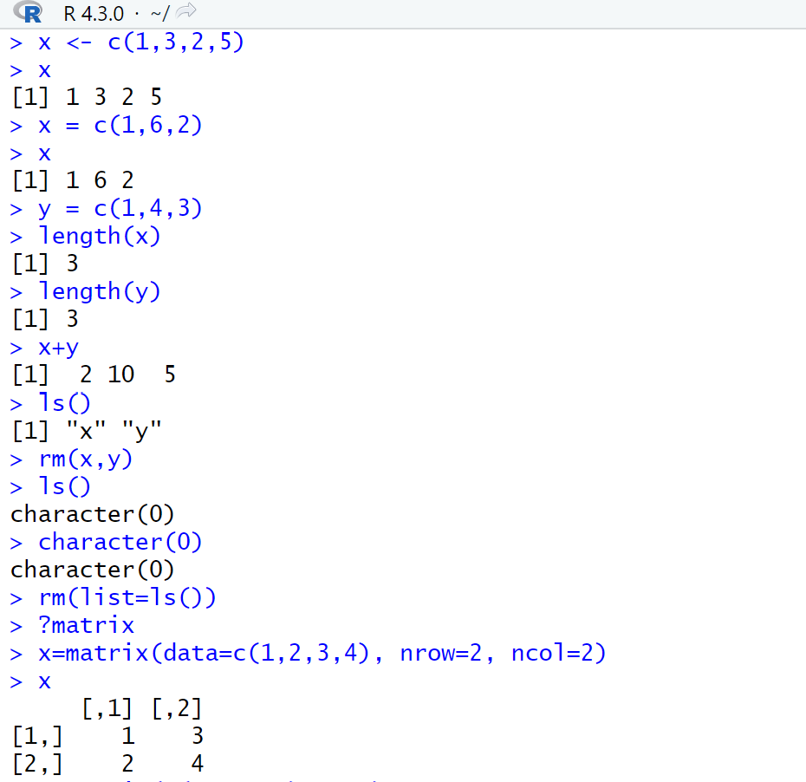

**CODE**:

x=matrix(c(1,2,3,4) ,2,2)

matrix(c(1,2,3,4) ,2,2,byrow=TRUE)

sqrt(x)

x^2

x=rnorm(50)

y=x+rnorm(50,mean=50,sd=.1)

cor(x,y)

set.seed(1303)

rnorm(50)

set.seed(3)

y=rnorm(100)

mean(y)

var(y)

sqrt(var(y))

sd(y)

**OUTPUT**:

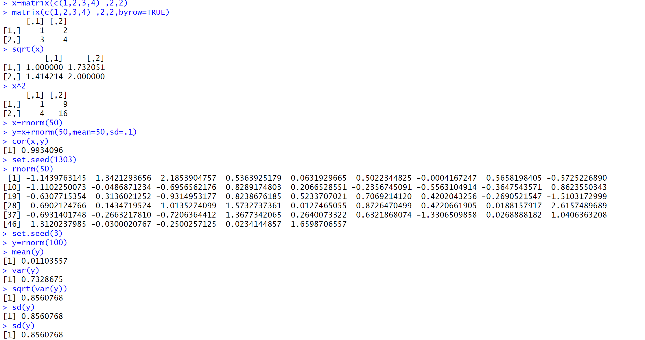

**GRAPHICS IN R**:

**DESCRIPTION**: The plot() function is the primary way to plot data in R . For instance, plot(x,y) produces a scatterplot of the numbers in x versus the numbers in y . There are many additional options that can be passed in to the plot() function.

**CODE**:

x=rnorm(100)

y=rnorm(100)

plot(x,y)

plot(x,y,xlab="this is the x-axis",ylab="this is the y-axis", main="Plot of X vs Y")

pdf("Figure.pdf")

plot(x,y,col="green")

dev.off()

x=seq(1,10)

x

x=1:10

x

**OUTPUT**:

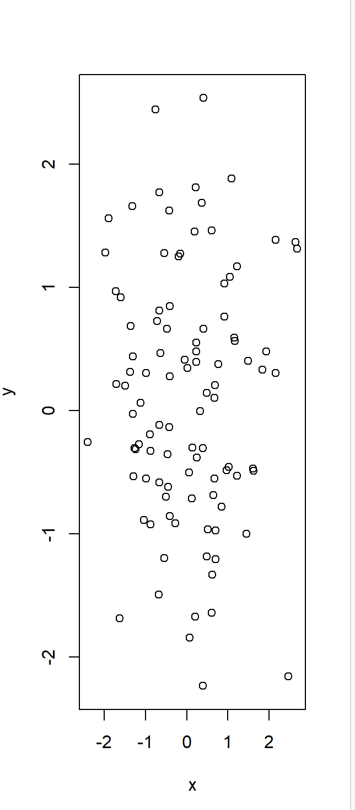 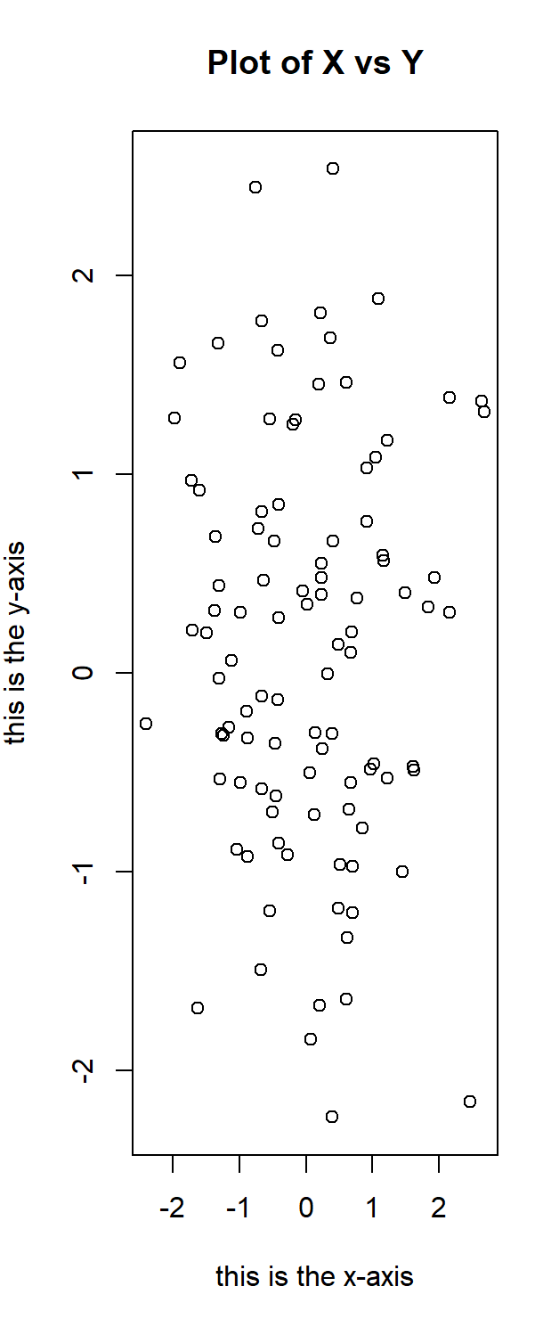

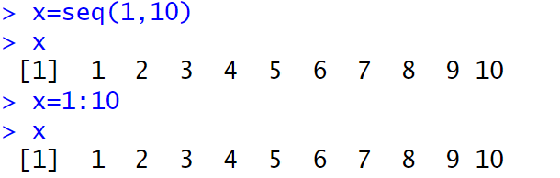

**CODE**:

x=seq(-pi,pi,length =50)

y=x

f=outer(x,y,function(x,y)cos(y)/(1+x^2))

contour(x,y,f)

contour(x,y,f,nlevels=45,add=T)

fa=(f-t(f))/2

contour(x,y,fa,nlevels=15)

**OUTPUT**:

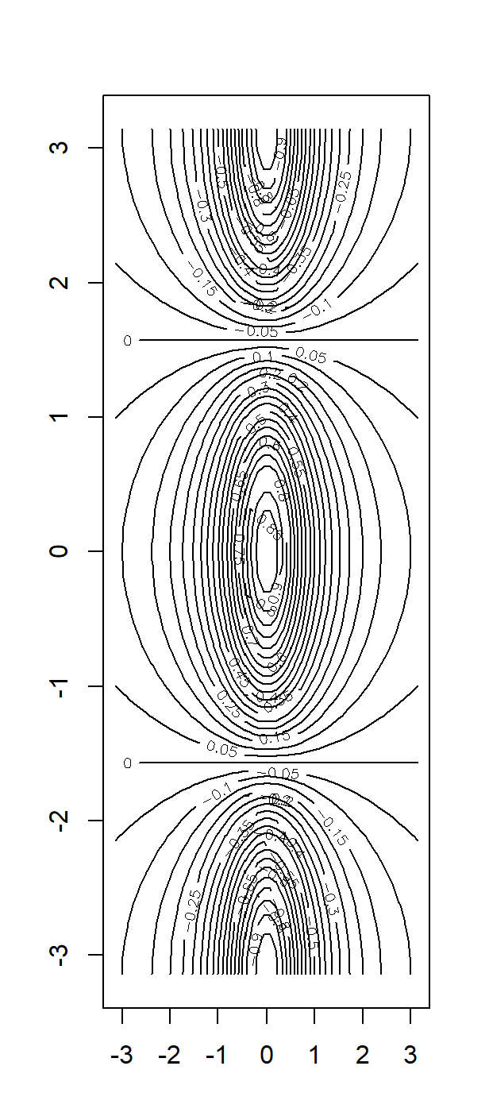 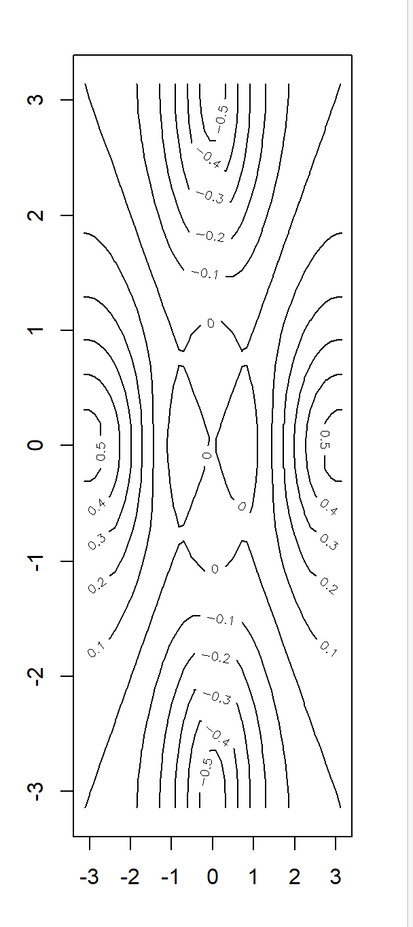

**CODE**:

image(x,y,fa)

persp(x,y,fa)

persp(x,y,fa,theta =30)

persp(x,y,fa,theta=30,phi=20)

**OUTPUT**:

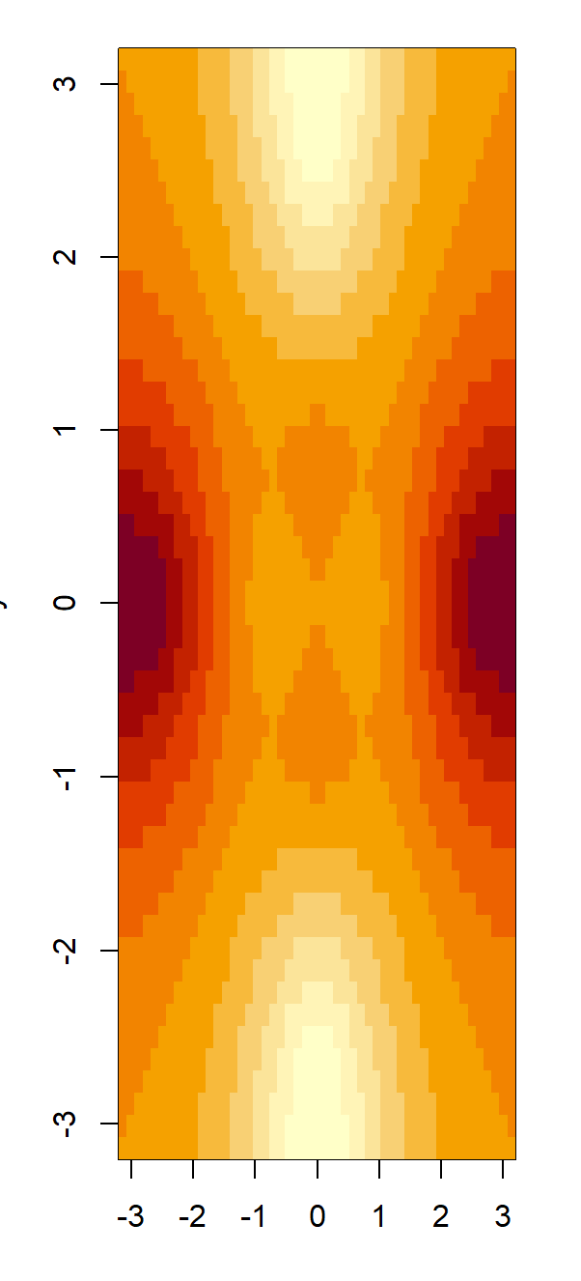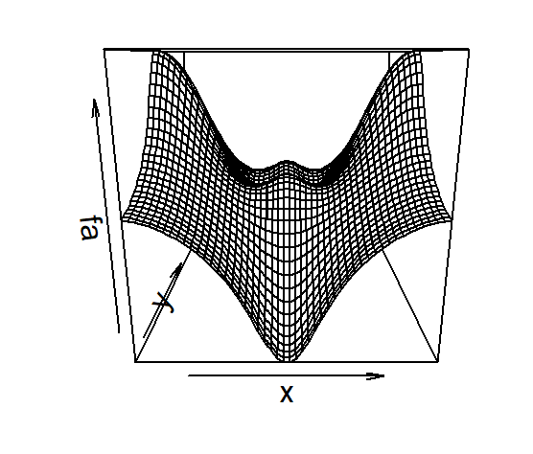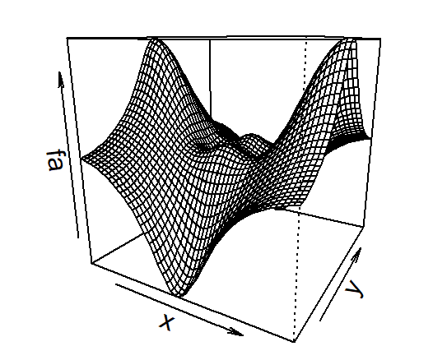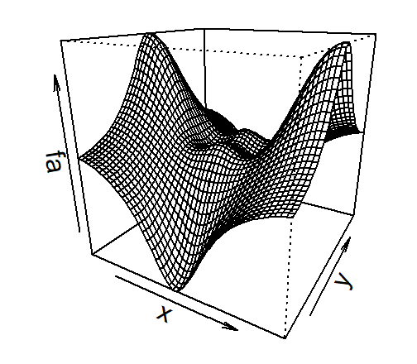

**CODE**:

persp(x,y,fa,theta=30,phi=70)

persp(x,y,fa,theta=30,phi=40)

OUTPUT:

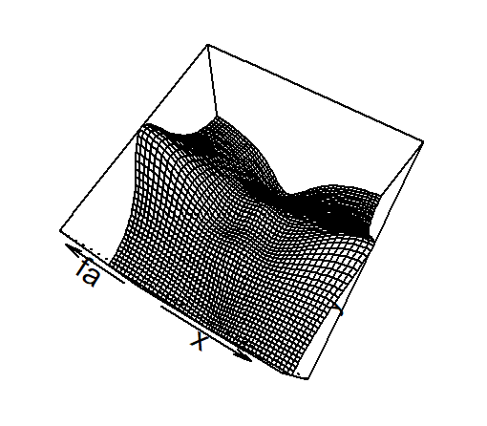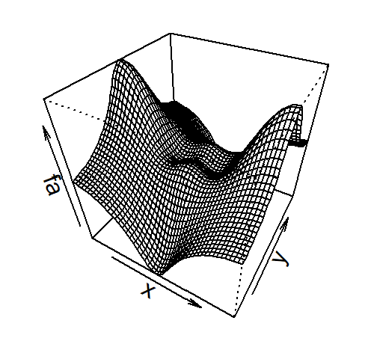

**INDEXING DATA:**

**DESCRIPTION**: We often wish to examine part of a set of data. Suppose that our data is stored in the matrix A .

**CODE**:

A=matrix(1:16,4,4)

A

A[2,3]

A[c(1,3),c(2,4)]

A[1:3,2:4]

A[1:2,]

**OUTPUT**:

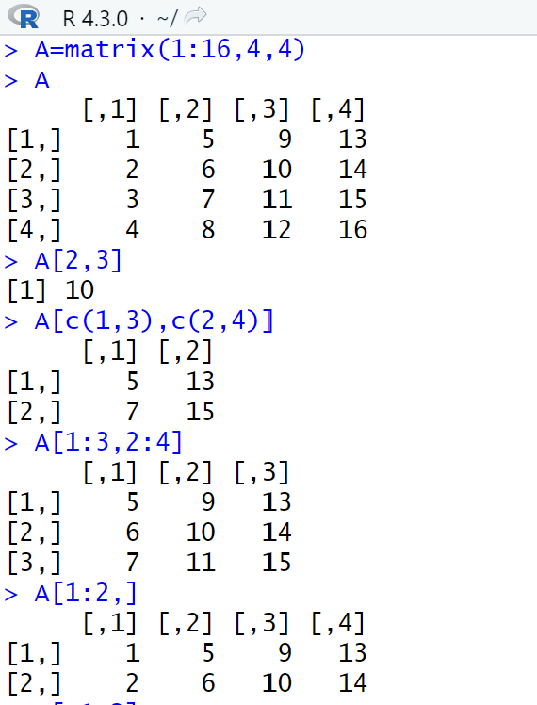

**CODE**:

A[,1:2]

A[1,]

A[-c(1,3),]

A[-c(1,3),-c(1,3,4)]

dim(A)

OUTPUT:

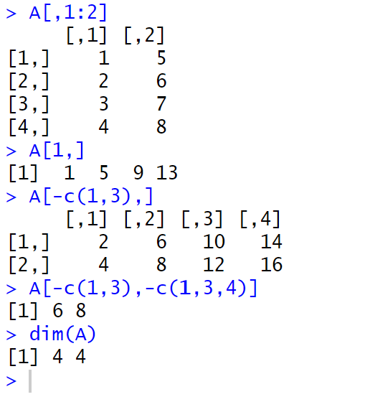

**LOADING DATA:**

**DESCRIPTION**: For most analyses, the first step involves importing a data set into R . The read.table() function is one of the primary ways to do this. The help file read.table() contains details about how to use this function. We can use the function write.table() to export data.

**CODE**:

auto<- read_excel("C:/Users/Hp/OneDrive/Desktop/ML/auto_mpg.csv.xlsx")

str(auto)

auto[1:4,]

auto=na.omit(auto)

dim(auto)

names(auto)

OUTPUT:

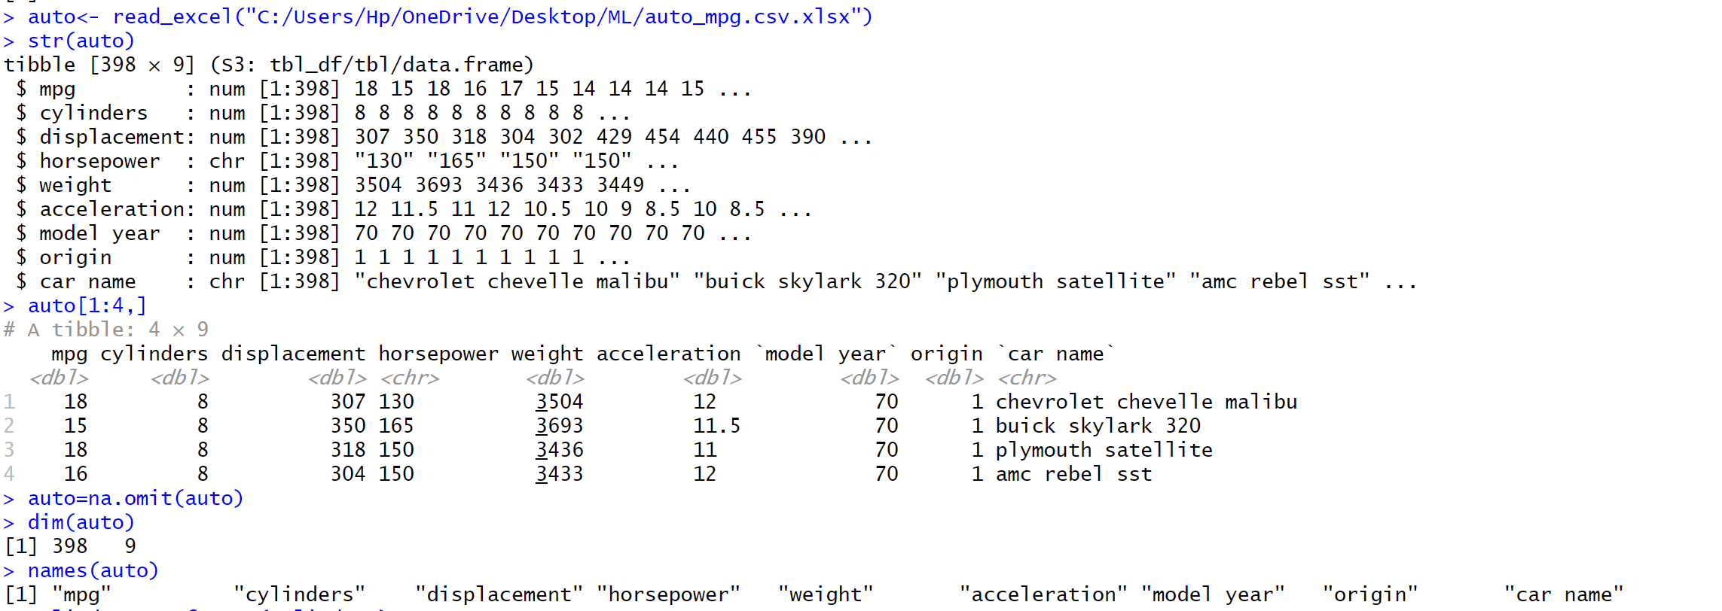

**ADDITIONAL GRAPHICAL AND NUMERICAL SUMMARIES :**

**DESCRIPTION**: We can use the plot() function to produce scatterplots of the quantitative variables. However, simply typing the variable names will produce an error message, because R does not know to look in the Auto data set for those variables.

**CODE**:

attach(auto)

plot(cylinders, mpg)

cylinders=as.factor(cylinders)

plot(cylinders,mpg)

**OUTPUT**:

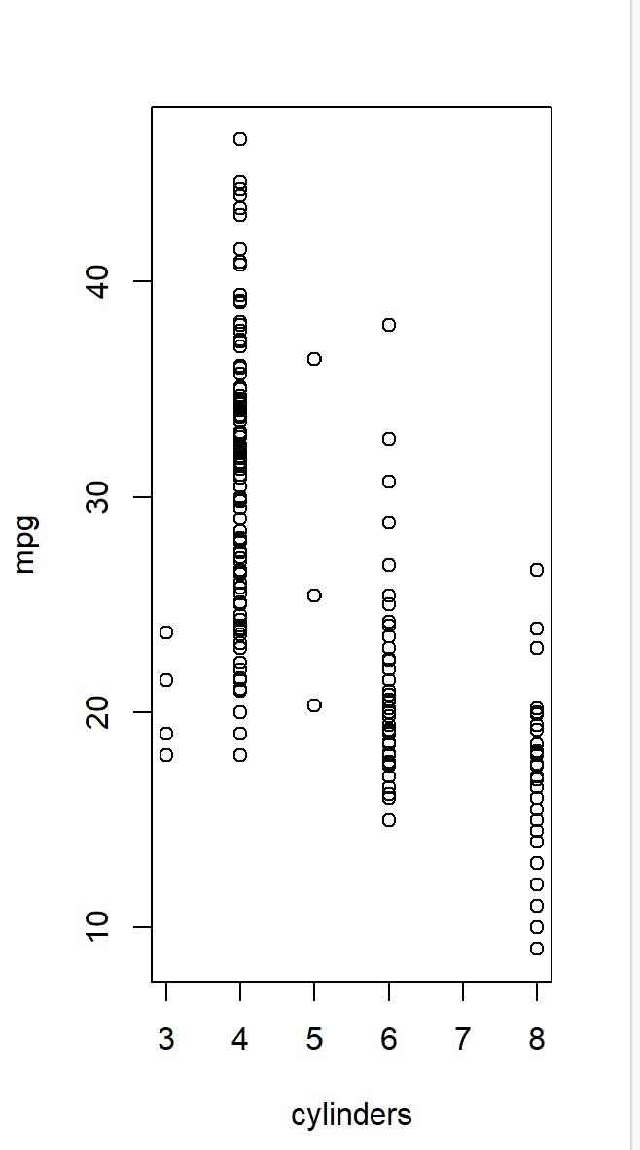 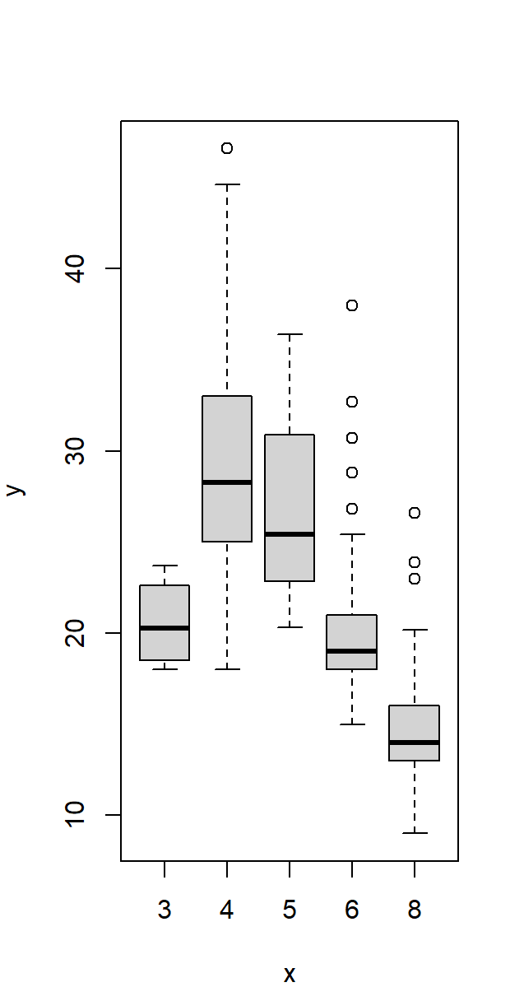

**CODE**:

plot(cylinders,mpg,col="red")

plot(cylinders,mpg,col="red",varwidth=T)

**OUTPUT**:

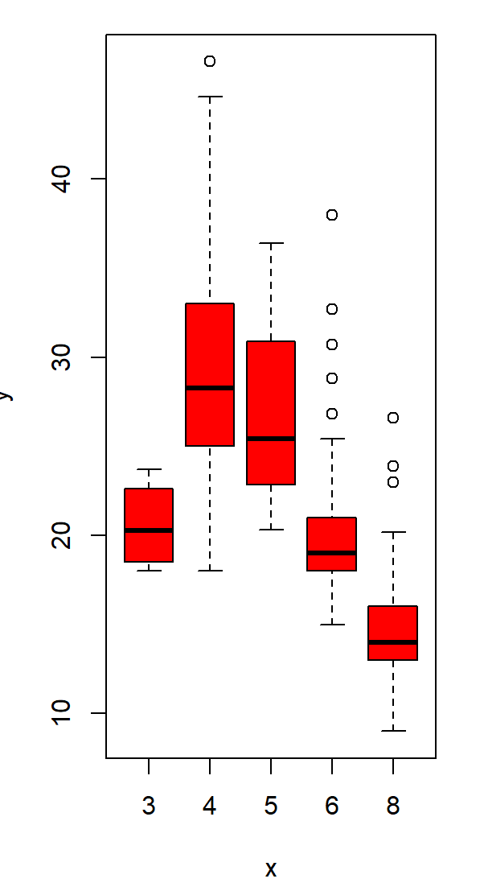

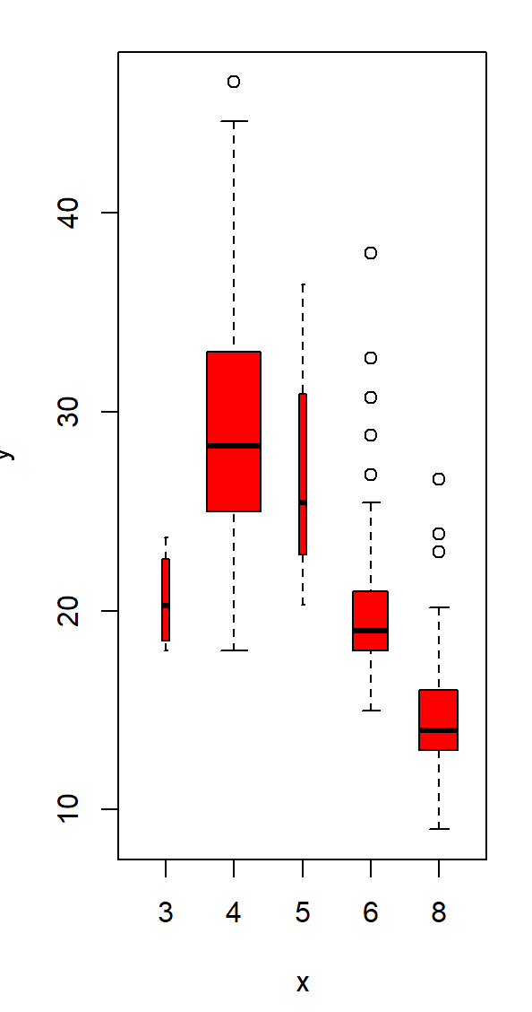

**CODE**:

plot(cylinders,mpg,col="red",varwidth=T,horizontal =T)

plot(cylinders,mpg,col="red",varwidth=T,xlab="cylinders",ylab="MPG")

**OUTPUT**:

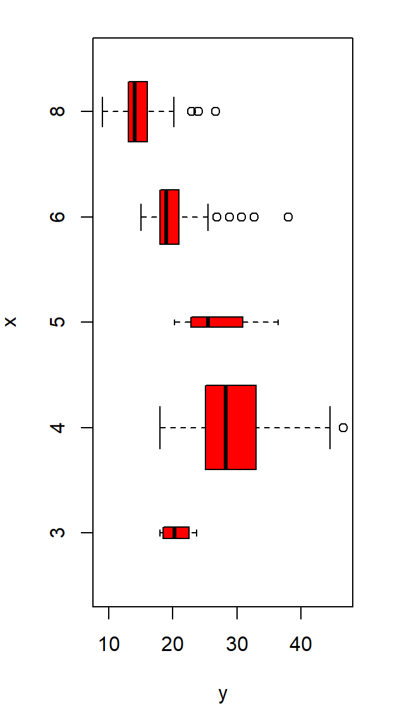

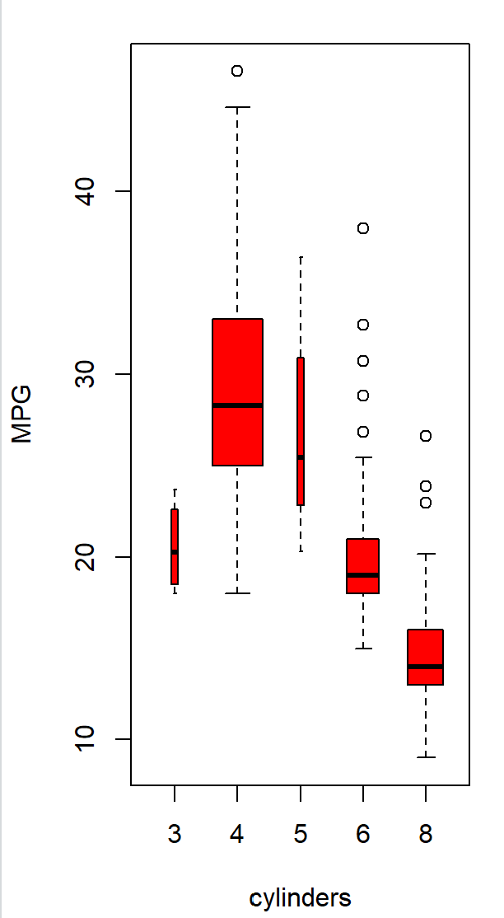

**CODE**:

hist(mpg)

hist(mpg,col=2)

**OUTPUT**:

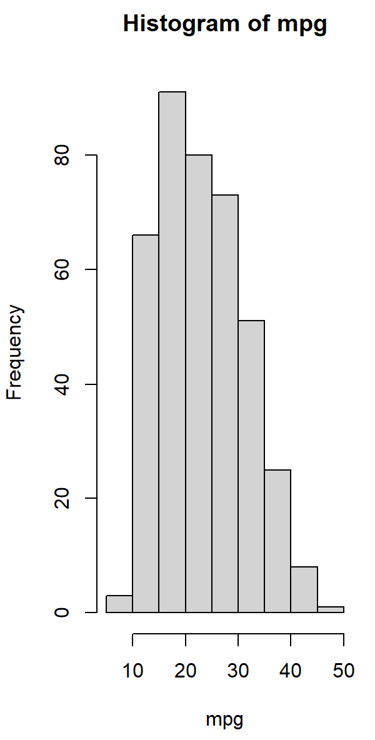

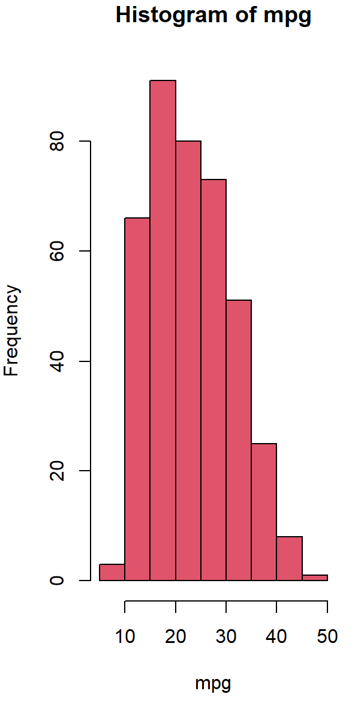

**CODE**:

hist(mpg,col=2,breaks=15)

plot(horsepower,mpg)

**OUTPUT**:

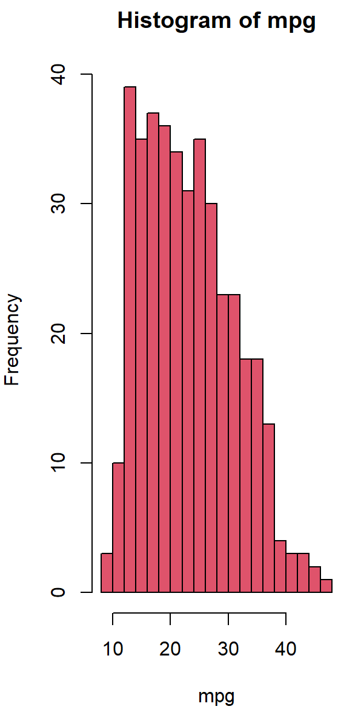

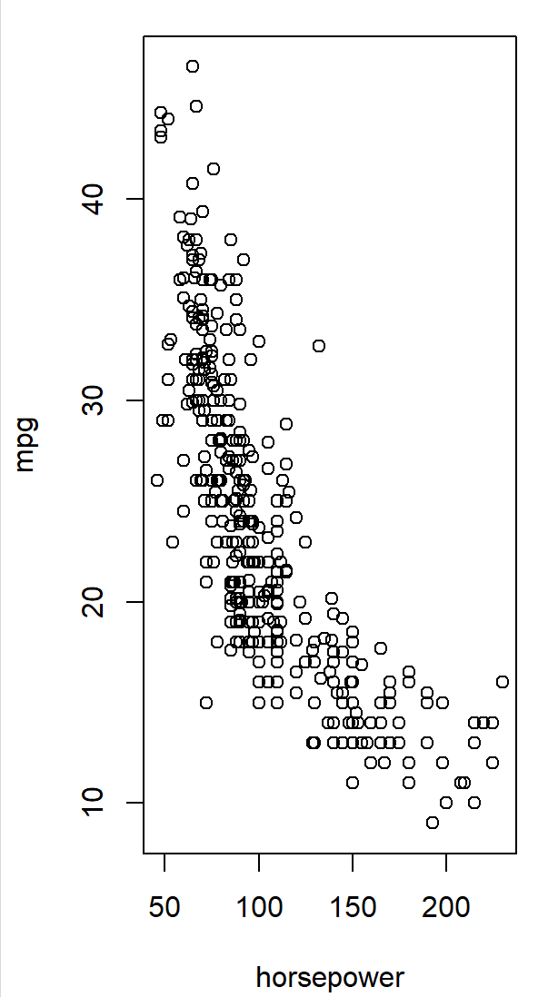

**CODE**:

identify(horsepower,mpg,car.name)

summary(auto)

summary(auto$mpg)

**OUTPUT**:

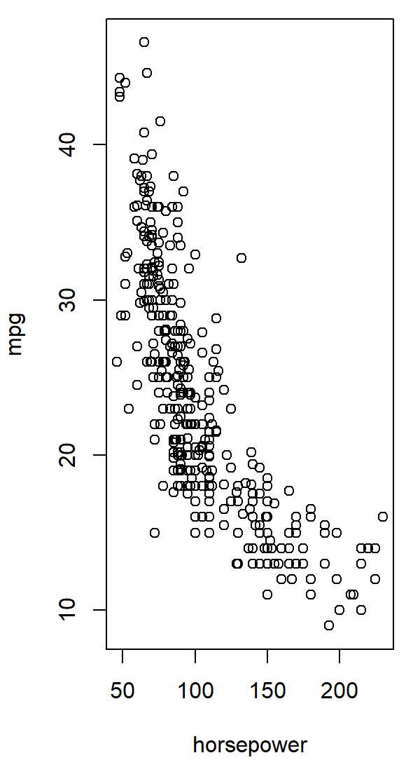

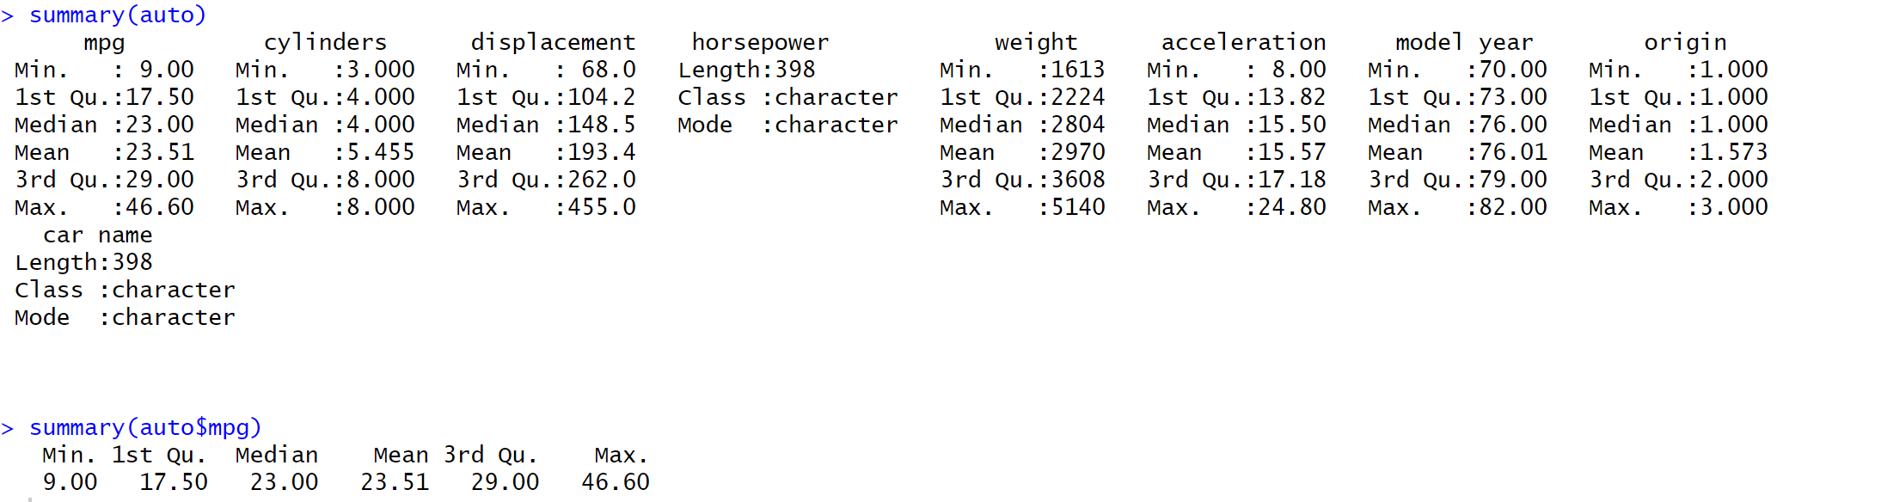

**EXPERIMENT NO.-2**

**AIM: Implement the code using of simple linear regression on the Auto data set.**

**a. Use the lm() function to perform a simple linear regression with mpg as the response and horsepower as the predictor.**

**b. Plot the response and the predictor. Use the abline() function to display the least squares regression line.**

**c. Use the plot() function to produce diagnostic plots of the least squares regression fit. Comment on any problems you see with the fit.**

**d. Produce a scatterplot matrix which includes all of the variables in the data set.**

**(2.a) AIM: Use the lm() function to perform a simple linear regression with mpg as the response and horsepower as the predictor.**

**DESCRIPTION:** The library() function is used to load libraries, or groups of functions and library() data sets that are not included in the base R distribution. Basic functions that perform least squares linear regression and other simple analyses come standard with the base distribution, but more exotic functions require additional libraries. Here we load the MASS package, which is a very large collection of data sets and functions. . Alternatively, this can be done at the R command line via install.packages("ISLR").The lm() function to fit a simple linear regression lm() model, with medv as the response and lstat as the predictor. The basic syntax is lm(y∼x,data), where y is the response, x is the predictor, and data is the data set in which these two variables are kept

**CODE:**

library(ISLR)

library(MASS)

data("auto")

head(auto)

lm.fit<-lm(mpg~horsepower,data=Auto)

summary(lm.fit)

**OUTPUT:**

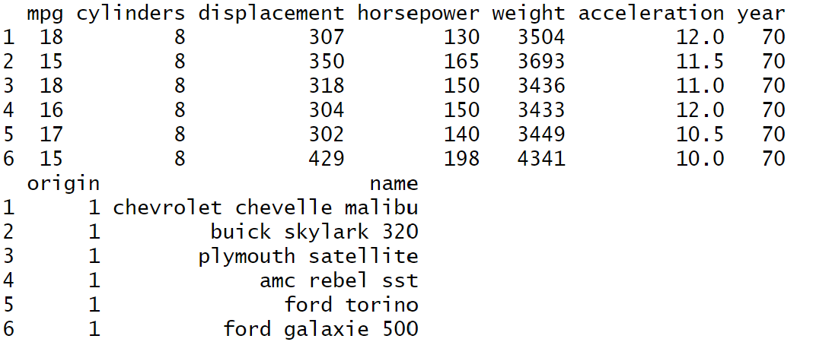

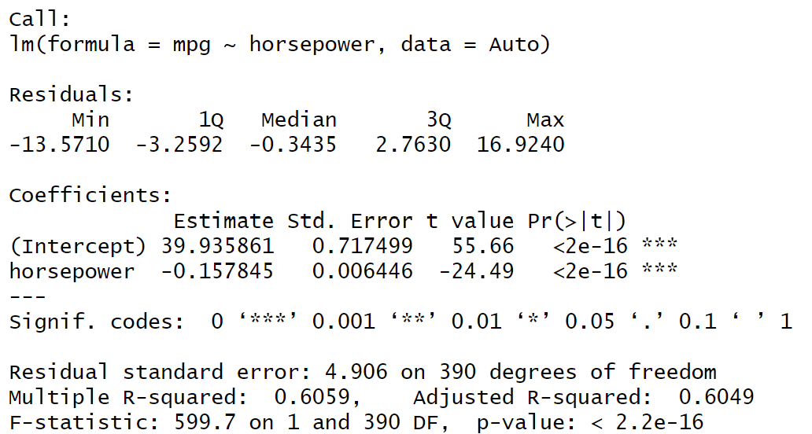

**CODE:**

predict(lm.fit,data.frame(horsepower=c(98)),interval="prediction")

predict(lm.fit,data.frame(horsepower=c(98)),interval="confidence")

**OUTPUT:**

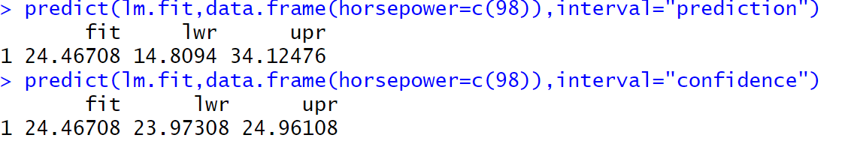

**(2.b) AIM : Plot the response and the predictor. Use the abline() function to display the least squares regression line.**

**DESCRIPTION:** The abline() function can be used to draw any line, not just the least squares regression line. To draw a line with intercept a and slope b, we type abline(a,b). Below we experiment with some additional settings for plotting lines and points. The lwd=3 command causes the width of the regression line to be increased by a factor of 3; this works for the plot() and lines() functions also.

**CODE:**

attach(Auto)

plot(horsepower,mpg)

abline(lm.fit,lwd=5,col="blue")

**OUTPUT:**

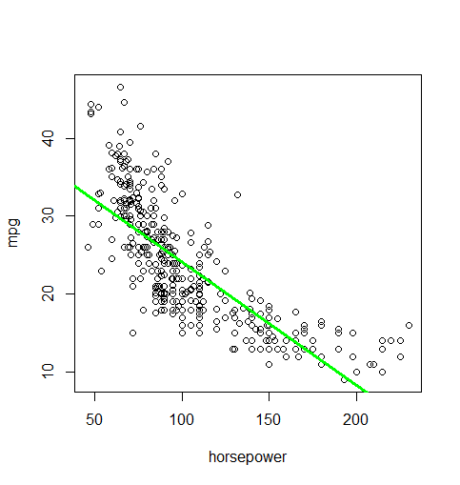

**(2.c) AIM: Use the plot() function to produce diagnostic plots of the least squares regression fit. Comment on any problems you see with the fit.**

**DESCRIPTION:** Plot() function in R programming Language is defined as a generic function for plotting.**The plot() function in R is “used to create a plot”. It has many options and arguments to control many things, such as the plot type, labels, titles, and colors. For example, plot(x, y) creates a scatter plot of x and y numeric vectors.**

**CODE:**

which.max(hatvalues(lm.fit))

par(mfrow=c(2,2))

plot(lm.fit)

**OUTPUT:**

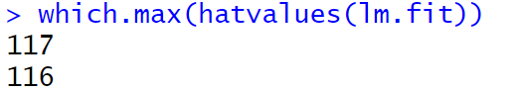

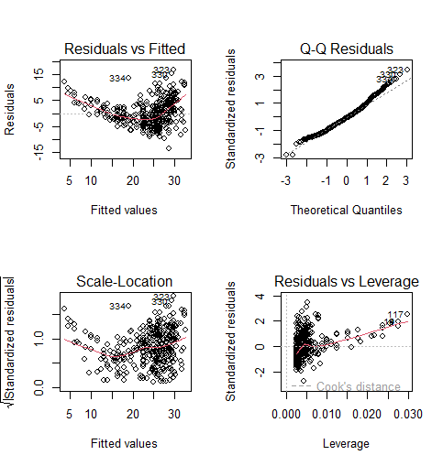

**(2.d) AIM: . Produce a scatterplot matrix which includes all of the variables in the data set.**

**DESCRIPTION:** A scatterplot is a set of dotted points representing individual data pieces on the horizontal and vertical axis.In a graph in which the values of two variables are plotted along the axis X and Y,the pattern of the resulting points reveals a correlation between them.We can create a scatter plot in R programming Language using the plot() function.

**CODE:**

Pairs(Auto)

**OUTPUT:**

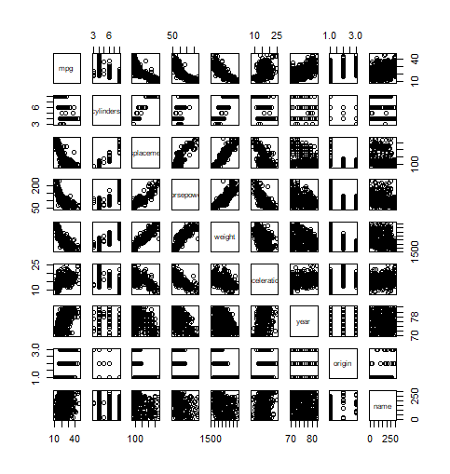

**EXPERIMENT NO:- 3**

**AIM:- Using multiple linear regression perform the following tasks on the Auto data set.**

**(a) Produce a scatter plot matrix which includes all of the variable sin the data set.**

**(b) Compute the matrix of correlations between the variables using the function cor() . You will need to exclude the name variable, cor() which is qualitative.**

**(c) Use the lm() function to perform a multiple linear regression with mpg as the response and all other variables except name as the predictors. Use the summary() function to print the results. Comment on the output, That is**

**i. Is there a relationship between the predictors and the response?**

**ii. Which predictors appear to have a statistically significant relationship to the response?**

**iii. What does the coefficient for the year variable suggest?**

**(d) Use the plot() function to produce diagnostic plots of the linear regression fit. Comment on any problems you see with the fit. Do the residual plots suggest any unusually large outliers? Does the leverage plot identify any observations with unusually high leverage?**

**(e) Use the * and : symbols to fit linear regression models with interaction effects. Do any interactions appear to be statistically significant?**

**(f) Try a few different transformations of the variables, such aslog(X),√ X, X 2 . Comment on your findings.**

**(3a) AIM:- Produce a scatter plot matrix which includes all of the variable sin the data set.**

**DESCRIPTION:** A scatterplot is a set of dotted points representing individual data pieces on the horizontal and vertical axis. In a graph in which the values of two variables are plotted along the axis X and Y, the pattern of the resulting points reveals a correlation between them. We can create a scatter plot in R programming Language using the plot() function.

**CODE:**

data("Auto", package = "ISLR")

pairs(Auto)

**OUTPUT:**



**(3b) AIM:- Compute the matrix of correlations between the variables using the function cor() . You will need to exclude the name variable, cor() which is qualitative.**

**DESCRIPTION:** cor() function in R Language is used to measure the correlation coefficient value between two vectors. This returns a simple correlation matrix showing the correlations between pairs of variables (devices). You can choose the correlation coefficient to be computed using the method parameter. The default method is Pearson, but you can also compute Spearman or Kendall coefficients.

**CODE:**

cor(subset(Auto, select = -name))

**OUTPUT:**

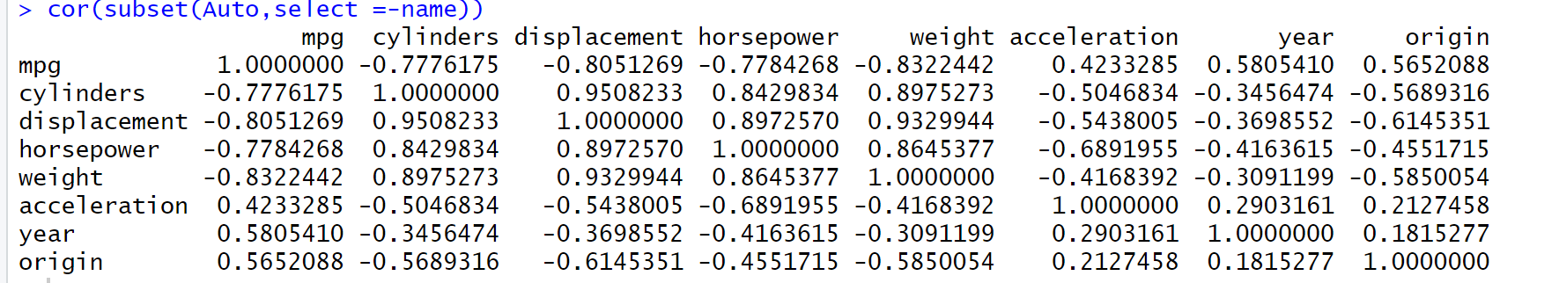

**(3c) Use the lm() function to perform a multiple linear regression with mpg as the response and all other variables except name as the predictors. Use the summary() function to print the results. Comment on the output, That is**

**i. Is there a relationship between the predictors and the response?**

**ii. Which predictors appear to have a statistically significant relationship to the response?**

**iii. What does the coefficient for the year variable suggest?**

**DESCRIPTION:** The lm() function to fit a simple linear regression lm() model, with medv as the response and lstat as the predictor. The basic syntax is lm(y∼x,data), where y is the response, x is the predictor, and data is the data set in which these two variables are kept.

**CODE:**

lm.fit1 <- lm(mpg ~ . - name, data = Auto)

summary(lm.fit1)

**OUTPUT:**

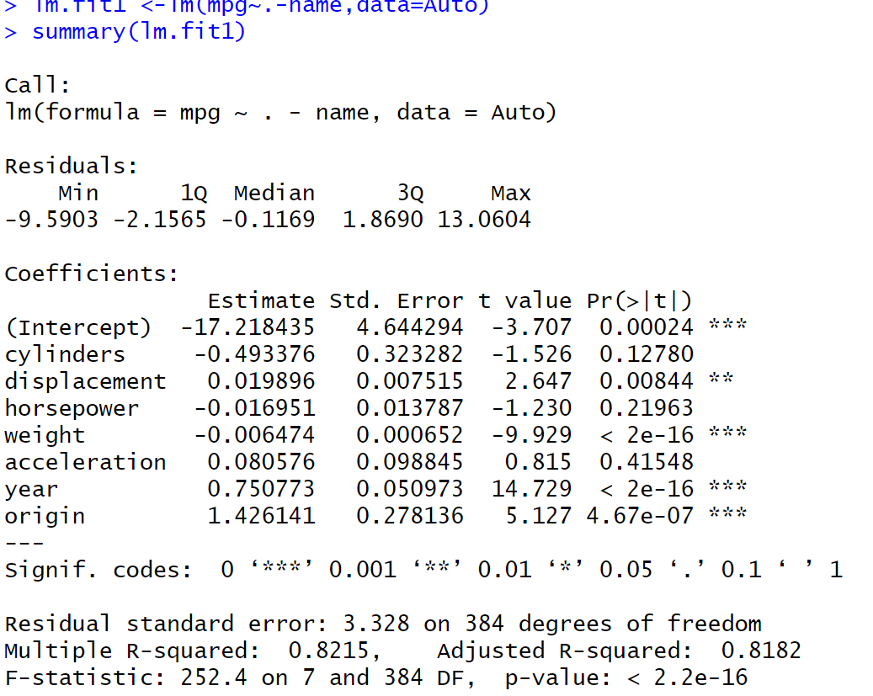

**(3.c)**

**(i). Is there a relationship between the predictors and the response?**

Yes, there is a relationship between the predictors and the response by testing the null hypothesis of whether all the regression coefficients are zero. The F-statistic is far from 1 (with a small p-value), indicating evidence against the null hypothesis.

**(3.c)**

**(ii). Which predictors appear to have a statistically significant relationship to the response?**

Looking at the p-values associated with each predictor’s t-statistic, we see that displacement, weight, year, and origin have a statistically significant relationship , while cylinders, horsepower, and acceleration do not.

**(3.c)**

**(iii).** **What does the coefficient for the `year` variable suggest?**

The regression coefficient for year, 0.7507727, suggests that for every one year, mpg increases by the coefficient. In other words, cars become more fuel efficient every year by almost 1 mpg / year.

**(3d) AIM:- Use the plot() function to produce diagnostic plots of the linear regression fit. Comment on any problems you see with the fit. Do the residual plots suggest any unusually large outliers? Does the leverage plot identify any observations with unusually high leverage?**

**DESCRIPTION:** Based on the plot of Residuals versus fitted values there appears to be non linearity in the data and based on the Residuals vs Leverage plot below, there does appear to be outliers due to the fact that there are data points outside of the -2 and 2 standardized residuals. And there does appear to be high leverage observations greater then 0.05.

**CODE:**

par(mfrow = c(2, 2))

plot(lm.fit1)

**OUTPUT:**

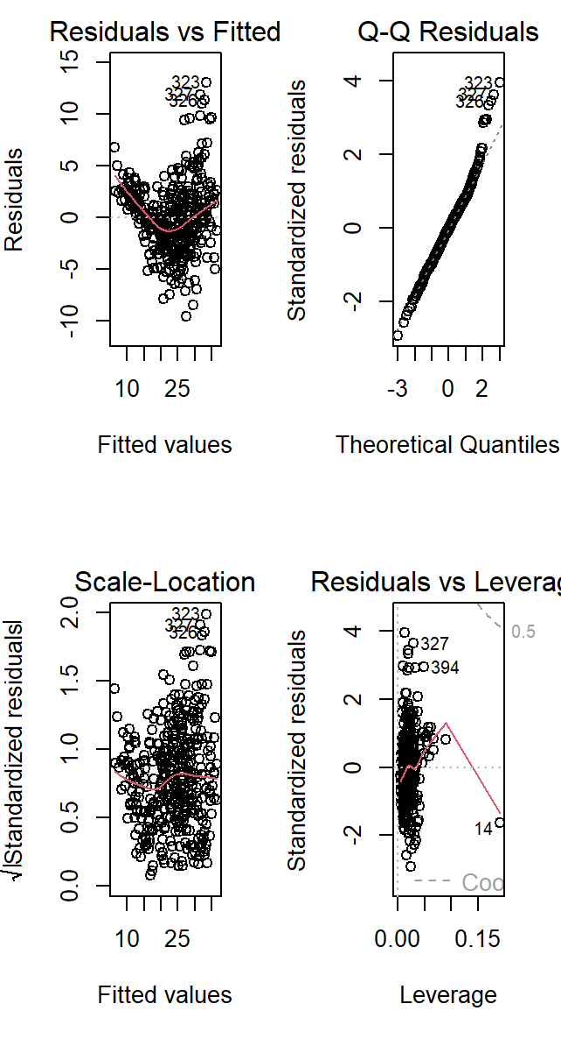

**CODE:**

plot(predict(lm.fit1),rstudent(lm.fit1))

**OUTPUT:**

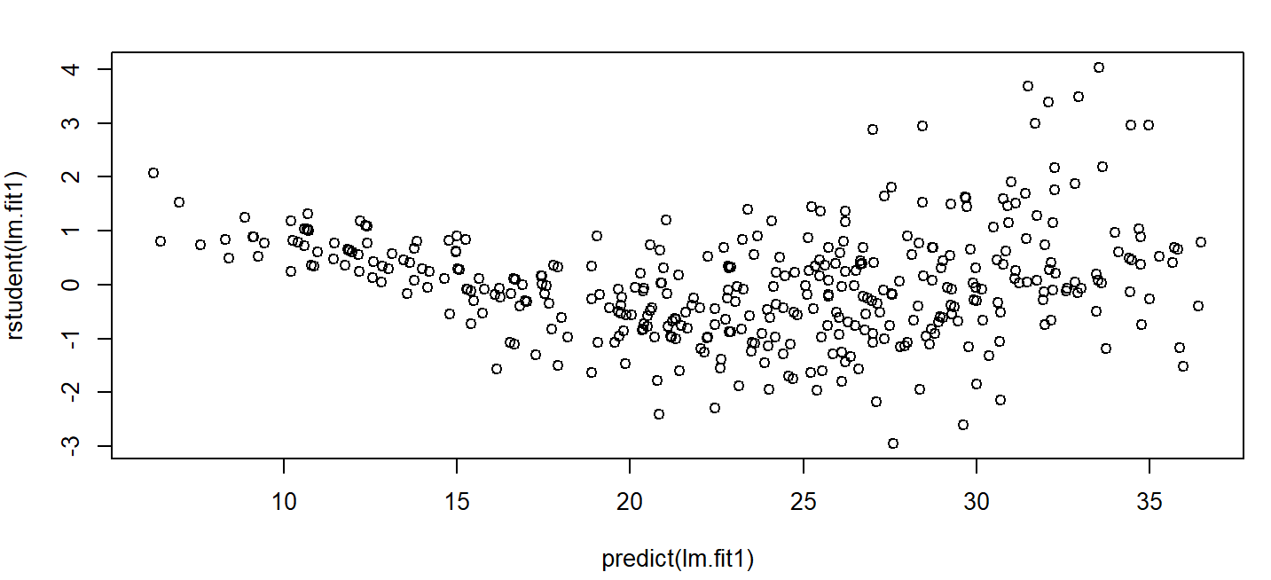

**(3e) AIM:- Use the * and : symbols to fit linear regression models with interaction effects. Do any interactions appear to be statistically significant?**

**DESCRIPTION:** Based on here it appears that the interactions between ‘cylinders’ and ‘displacement are not statistically significant but the interactions between ’horsepower’ and ‘weight’ is significant and the interaction between ‘acceleration’ and ‘year’ is significant.

**CODE:**

lm.fit2 <- lm(mpg ~ cylinders * displacement + displacement * weight, data = Auto)

summary(lm.fit2)

**OUTPUT:**

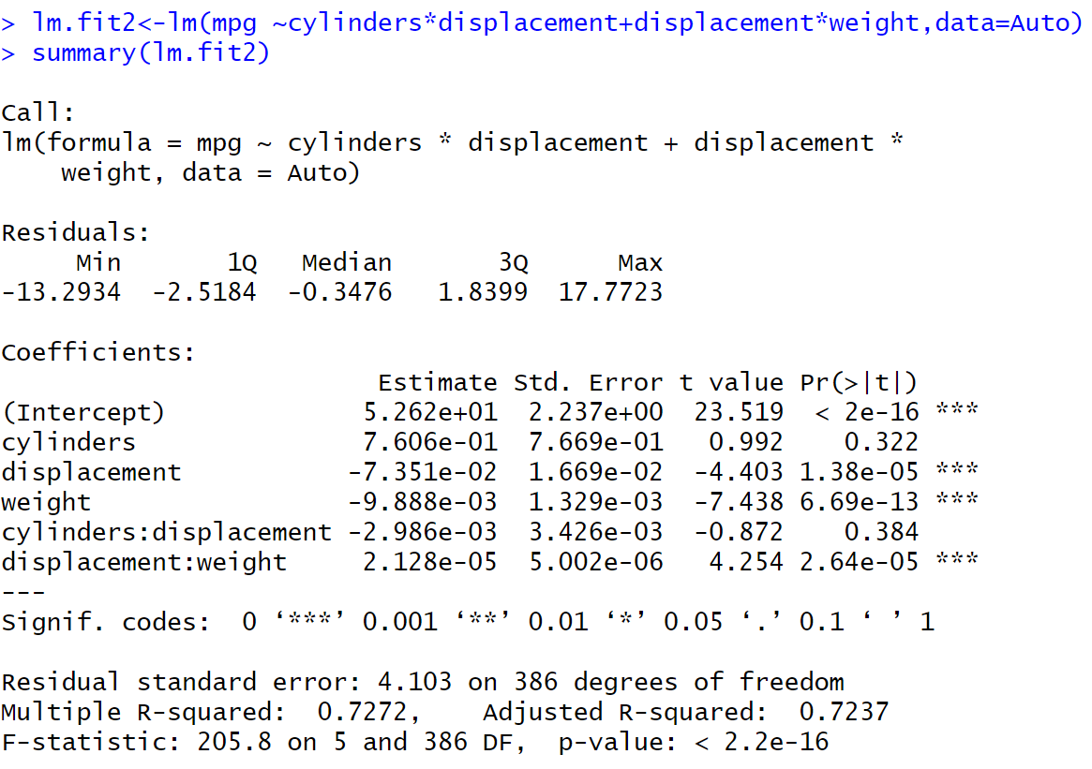

**(3f) AIM:- Try a few different transformations of the variables, such aslog(X),√ X, X 2 . Comment on your findings.**

**DESCRIPTION: :** Applying the log() function on a vector, data frame, or other data set in R results in a log transformation. To avoid applying a logarithm to a 0 number, 1 is added to the base value prior to applying the logarithm.

**CODE:** summary(lm(mpg ~ . -name + log(acceleration), data=Auto))

summary(lm(mpg ~ . -name + I(horsepower^2), data=Auto))

**OUTPUT:**

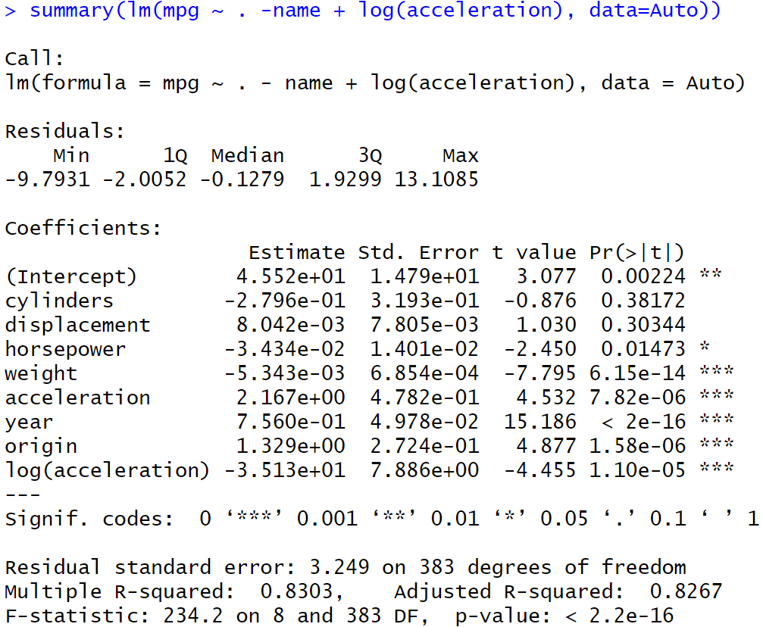

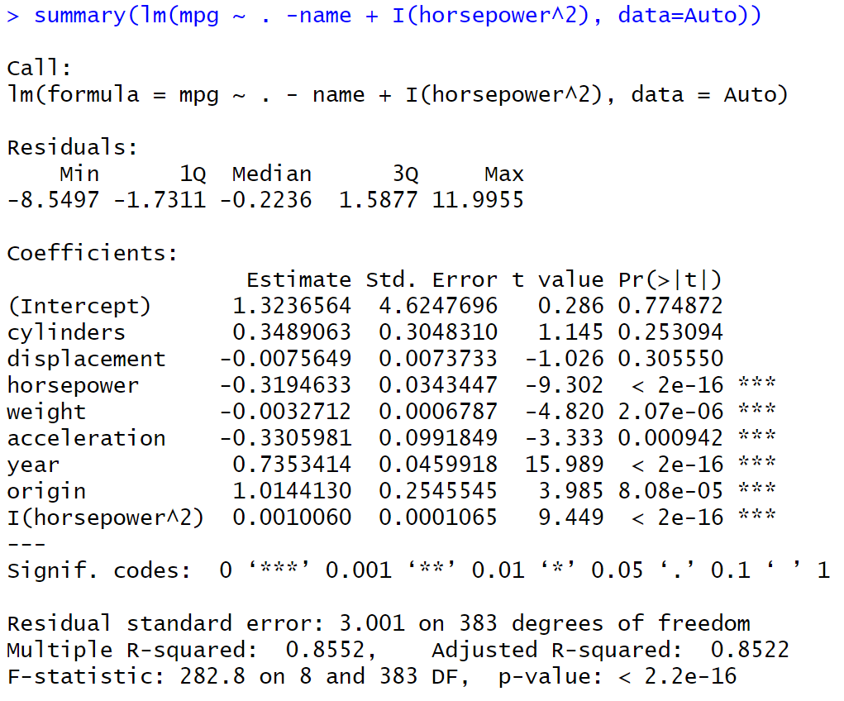

**EXPERIMENT-4**

**AIM:** **Implementation of KNN on the German Credit Data set.**

**DESCRIPTION:** To minimize loss from the bank’s perspective, the bank needs a decision rule regarding who to give approval of the loan and who not to. An applicant’s demographic and socio-economic profiles are considered by loan managers before a decision is taken regarding his/her loan application. The German Credit Data contains data on 20 variables and the classification whether an applicant is considered a Good or a Bad credit risk for 1000 loan applicants. A predictive model developed on this data is expected to provide bank manager guidance for making a decision whether to approve a loan to a prospective applicant based on his/her profiles

**DESCRIPTION:**

The K-NN working can be explained on the bias of the below algorithm:

o Step-1: Select the number K of the neighbours

o Step-2: Calculate the Euclidean distance of K number of neighbours

o Step-3: Take the K nearest neighbours as per the calculated Euclidean distance.

o Step-4: Among these k neighbours, count the number of the data points in each category.

o Step-5: Assign the new data points to that category for which the number of the neighbour is maximum.

o Step-6: Our model is ready.2

**Steps Involved in performing KNN algorithm:**

1. Data Collection.

2. Preparing and exploring the data.

▪ Understanding data structure.

▪ Feature selection (if required)

▪ Data normalization.

▪ Creating Training and Test data set.

3. Training a model on data.

4. Evaluate the model performance.

5. Improve the performance of model.

**1.DATA COLLECTION:**

**CODE:**

gc <- read.csv("C:/Users/Hp/OneDrive/Desktop/ML-LAB/german_credit.csv")

gc.bkup <- gc

head (gc)

**OUTPUT:**

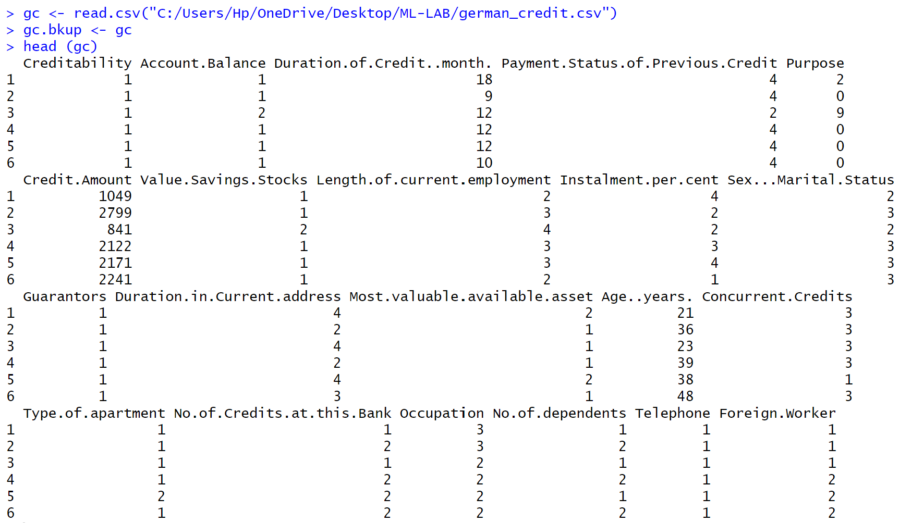

2.**PREPARING AND EXPLORING THE DATA:**

**CODE:**

str(gc)

gc.subset <- gc[c('Creditability','Age..years.','Sex...Marital.Status','Occupation','Account.Balance','Credit.Amount','Length.of.current.employment','Purpose')]

head(gc.subset)

normalize <- function(x) { return ((x - min(x)) / (max(x) - min(x))) }

gc.subset.n<- as.data.frame(lapply(gc.subset[,2:8], normalize))

head(gc.subset.n)

set.seed(123)

dat.d <- sample(1:nrow(gc.subset.n),size=nrow(gc.subset.n)*0.7,replace = FALSE)

train.gc <- gc.subset[dat.d,]

test.gc <- gc.subset[-dat.d,]

train.gc_labels <- gc.subset[dat.d,1]

test.gc_labels <- gc.subset[-dat.d,1]

**OUTPUT:**

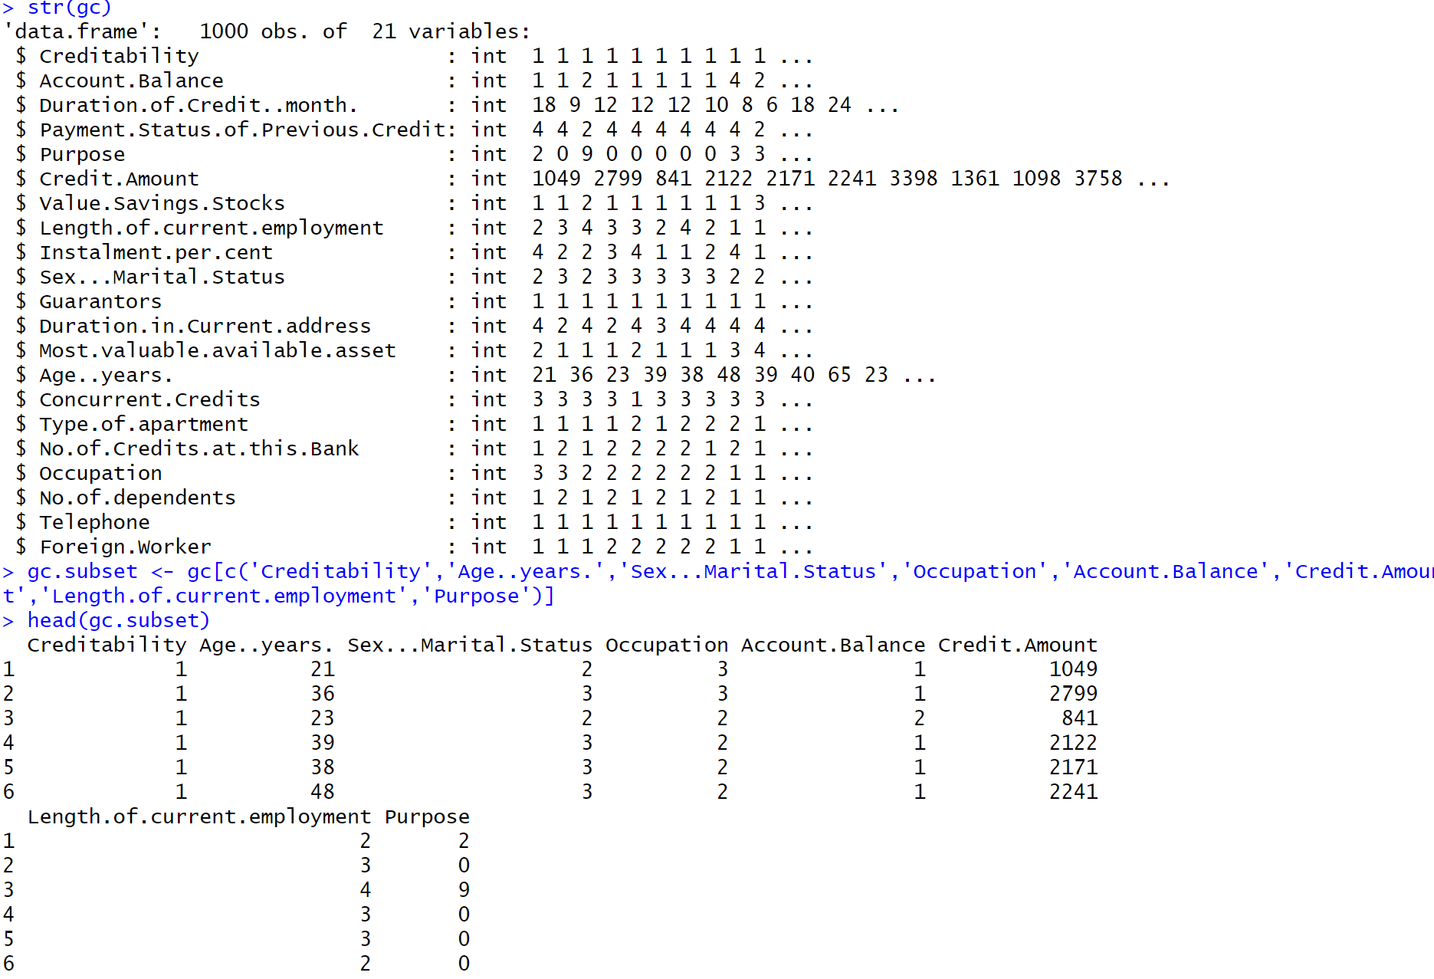

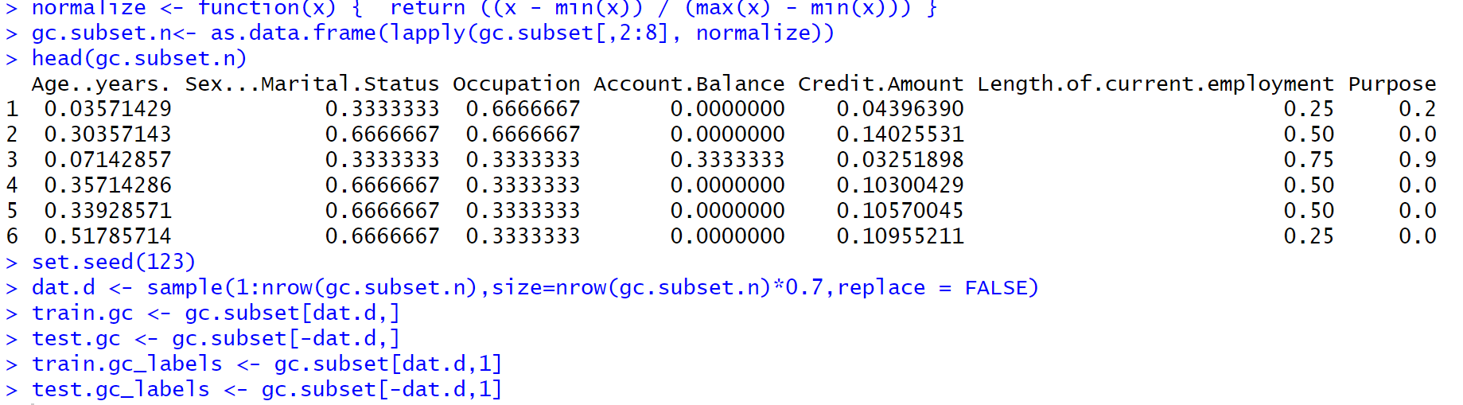

**3.TRAINING A MODEL ON DATA:**

**CODE:**

library(class)

NROW(train.gc_labels)

knn.26 <- knn(train=train.gc, test=test.gc, cl=train.gc_labels, k=26)

knn.27 <- knn(train=train.gc, test=test.gc, cl=train.gc_labels, k=27)

**OUTPUT:**

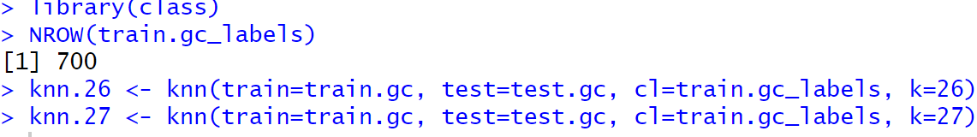

**4.EVALUATE THE MODEL PERFORMANCE:**

**CODE:**

ACC.26 <- 100 * sum(test.gc_labels == knn.26)/NROW(test.gc_labels)

ACC.27 <- 100 * sum(test.gc_labels == knn.27)/NROW(test.gc_labels)

ACC.26

ACC.27

table(knn.26 ,test.gc_labels)

table(knn.27 ,test.gc_labels)

install.packages('caret')

library(caret)

test.gc_labels=as.factor(test.gc_labels)

confusionMatrix(knn.26 ,test.gc_labels)

**OUPUT:**

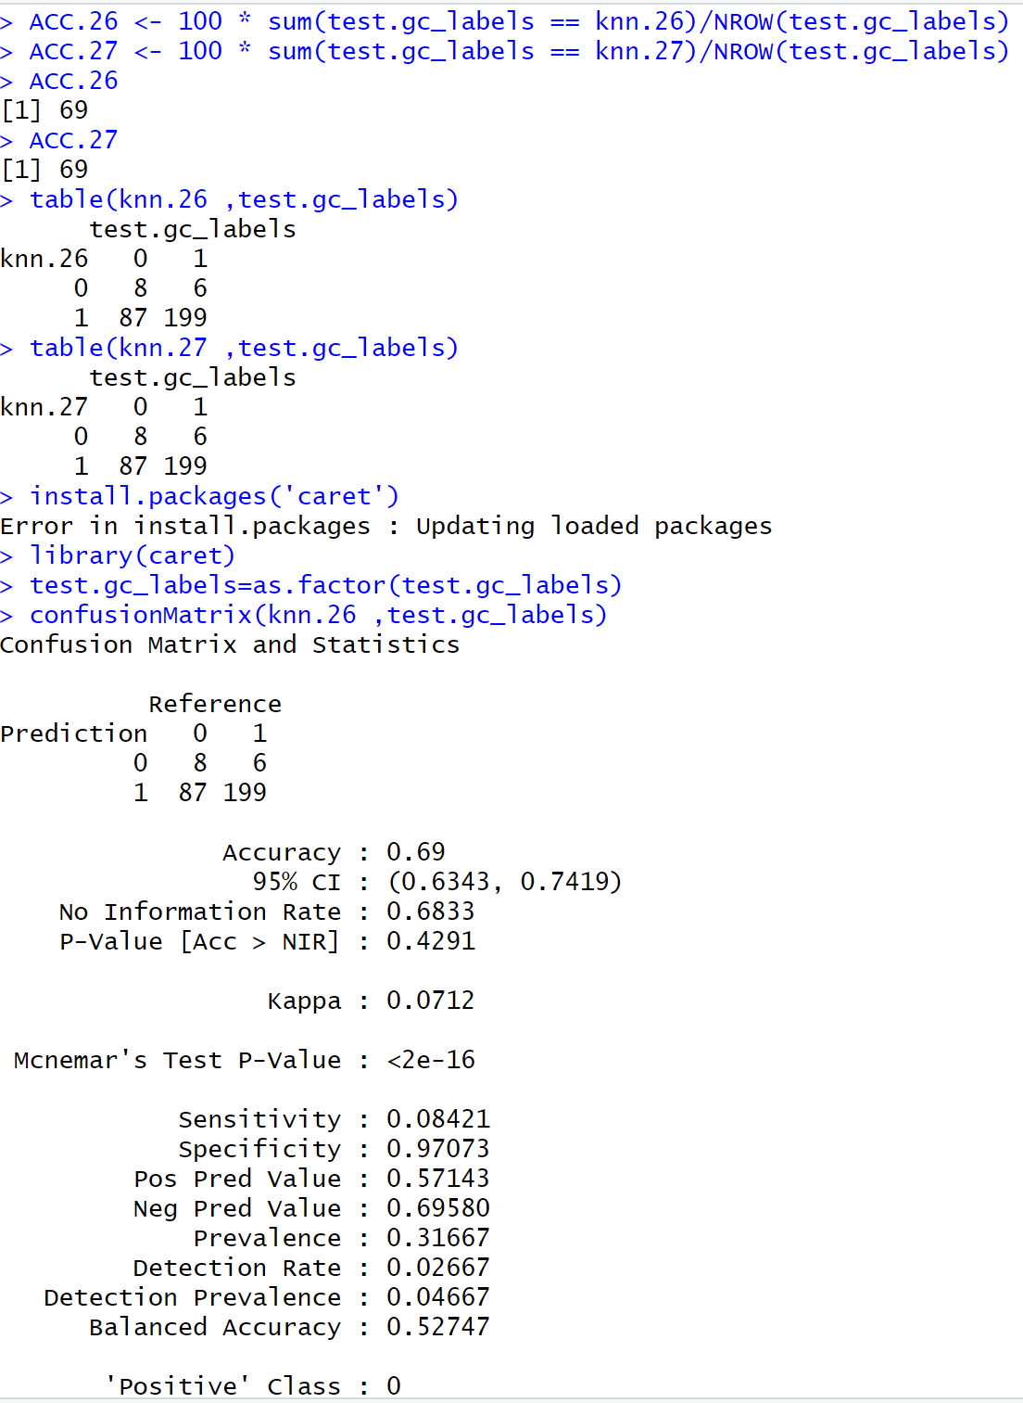

**CODE:**

confusionMatrix(knn.27 ,test.gc_labels)

**OUTPUT:**

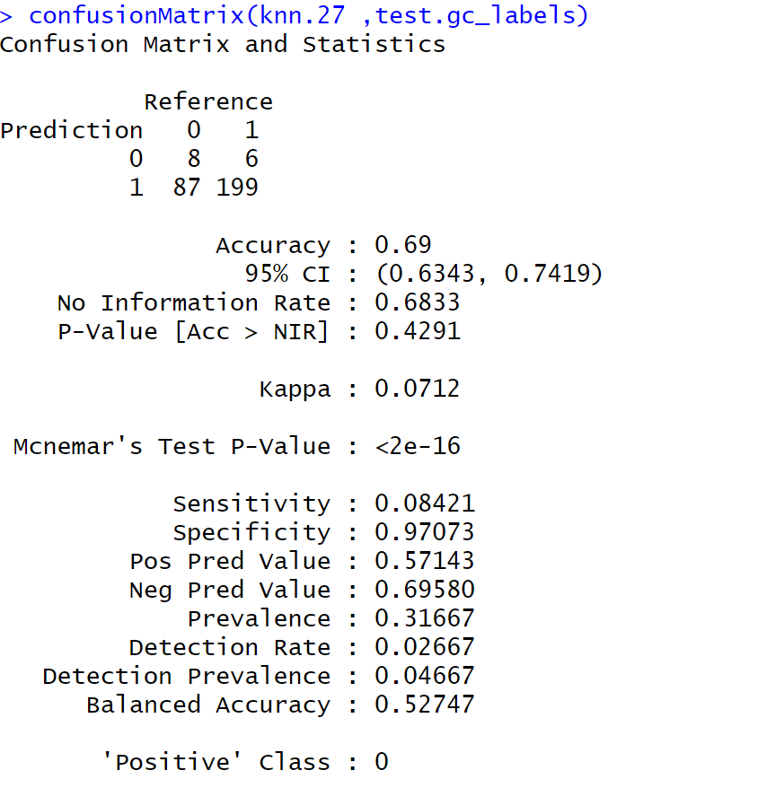

**5.IMPROVE THE PERFORMANCE OF MODEL:**

**CODE:**

i=1

k.optm=1

for (i in 1:28){

knn.mod <- knn(train=train.gc, test=test.gc, cl=train.gc_labels, k=i)

k.optm[i] <- 100 * sum(test.gc_labels == knn.mod)/NROW(test.gc_labels)

k=i

cat(k,'=',k.optm[i],'\n')

}

**OUTPUT:**

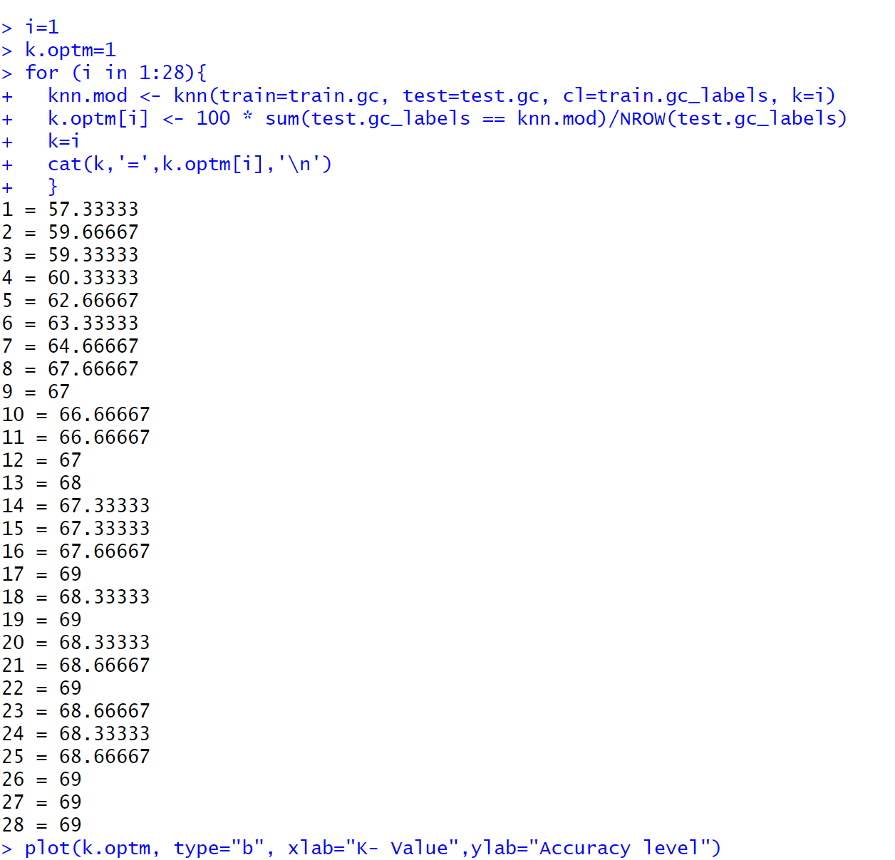

**CODE:**

plot(k.optm, type="b", xlab="K- Value",ylab="Accuracy level")

**OUTPUT:**

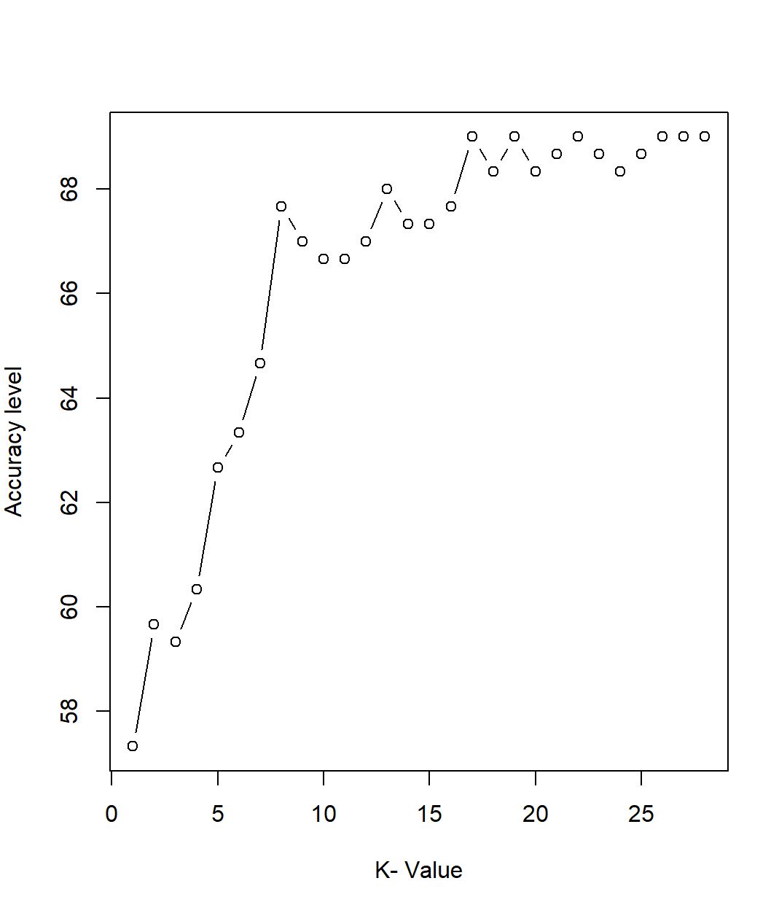

**EXPERIMENT NO: 5**

**AIM: To implement Linear Discriminant Analysis, Quadratic Discriminant Analysis and Naive Bayes algorithms on Stock market Dataset.** `

**DESCRIPTION**:

* **Linear Discriminant Analysis (LDA)** is a supervised learning algorithm used for classification tasks in machine learning. It is a technique used to find a linear combination of features that best separates the classes in a dataset. Quadratic Discriminant Analysis (QDA) is a supervised learning algorithm and extension of linear discriminant analysis. QDA models are designed to be used for classification problems .i.e. when the response variable can be placed into classes or categories. Naive Bayes classifiers (NB) are a collection of classification algorithms based on Bayes Theorem. It is not a single algorithm but a family of algorithms where all of them share a common principle ,i.e. every pair of features being classified is independent of each other.

**Formula for LDA :-**

For a two-class problem, LDA calculates the discriminant function as follows:

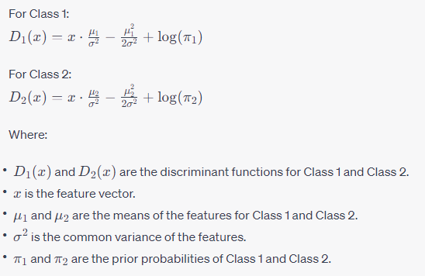

* **Quadratic Discriminant Analysis (QDA)** is a supervised machine learning algorithm used for classification tasks. It is a generative model, meaning that it assumes that the data is generated from a known distribution, in this case a multivariate Gaussian distribution. QDA estimates the mean and covariance matrix for each class, and then uses this information to calculate the probability of a new data point belonging to each class. The data point is then assigned to the class with the highest probability.

**Formula for QDA :-**

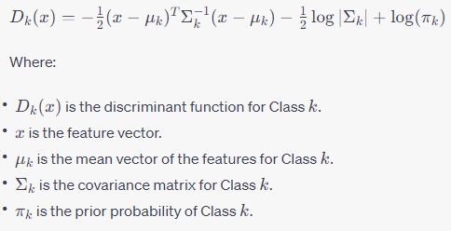

* **Naive Bayes** is a supervised machine learning algorithm used for classification tasks. It is a probabilistic classifier, which means that it predicts on the basis of the probability of an object. Naive Bayes is based on Bayes' theorem, which is a mathematical formula for calculating the probability of an event occurring, given that another event has already occurred. In the context of Naive Bayes, the event we are trying to predict is the class label of a data point, and the events we have already observed are the values of the data point's features.

**Steps for Navie Bayes :-**

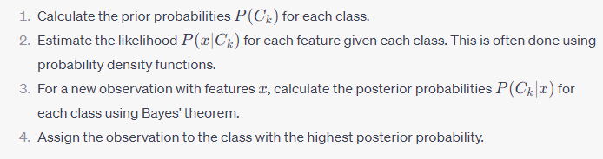

**Formula for Navie Bayes :-**

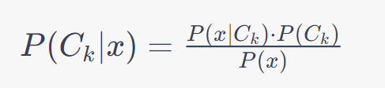

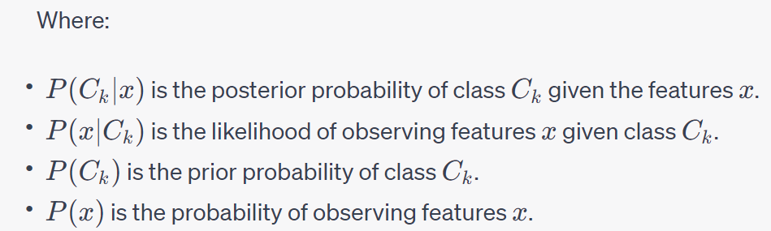

**CODE:**

**# Load required libraries**

library(quantmod)

library(MASS)

library(e1071)

library(caret)

library(ggplot2)

library(pROC)

**#Fetch the stock market data**

symbols <- c("AAPL","MSFT")

**#calculate daily returns**

start_date <- "2020-01-01"

end_date <- "2023-01-01"

getSymbols(symbols, from = start_date, to = end_date)

**OUTPUT:**



**CODE:**

stock_data <- merge(Ad(AAPL),Ad(MSFT))

colnames(stock_data) <- symbols

stock_returns <- diff(log(stock_data))

**#creating labels based on return threshold**

return_threshold <- 0.01

stock_labels <- ifelse(apply(abs(stock_returns), 1, max) > return_threshold, "High", "Low")

**# Combine returns and labels into a data frame**

stock_df <- data.frame(stock_returns, stock_labels)

**# Split data into training and testing sets**

set.seed(123)

train_indices <- sample(1:nrow(stock_df),0.75* nrow(stock_df))

train_data <- stock_df[train_indices, ]

test_data <- stock_df[-train_indices, ]

**# When the input data contains missing values, make sure our 'test_data' does not have any missing or NA values. We can use the is.na() function to identify them**

any_na <-apply(test_data,2,function(column)

any(is.na(column)))

**CODE:**

print(any_na)

**OUTPUT:**

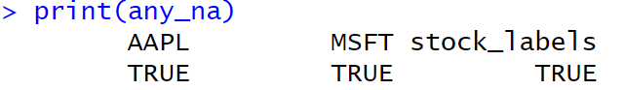

**CODE:**

**# If we find missing values, we can clean the data by removing or imputing them before using it for prediction.**

**# Remove rows with missing values**

test_data <- test_data[complete.cases(test_data), ]

**#LDA**

lda_model <- lda(stock_labels ~ ., data = train_data)

lda_predictions <- predict(lda_model, newdata = test_data)$class

**#QDA**

qda_model <- qda(stock_labels ~ ., data = train_data)

qda_predictions <- predict(qda_model, newdata = test_data)$class

**#NAIVEBAYES Classification**

nb_model <- naiveBayes(stock_labels ~ ., data = train_data)

nb_predictions <- predict(nb_model, newdata = test_data)

**#calculate accuracies**

lda_accuracy <- mean(lda_predictions == test_data$stock_labels)

qda_accuracy <- mean(qda_predictions == test_data$stock_labels)

nb_accuracy <- mean(nb_predictions == test_data$stock_labels)

**# Print the accuracy results**

cat("LDA ACCURACY:" , lda_accuracy,"\n")

cat("QDA ACCURACY:" , qda_accuracy, "\n")

cat("navive bayes accuracy:",nb_accuracy, "\n")

**OUTPUT:**

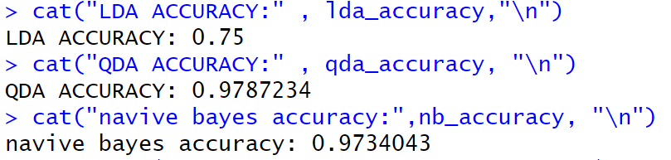

**CODE:**

**# Inorder to avoid the error: `data` and `reference` should be factors with the same levels.**

test_data$stock_labels=as.factor(test_data$stock_labels)

**#Calculate and print confusion matrix**

lda_cm <- confusionMatrix(lda_predictions, test_data$stock_labels)

qda_cm <- confusionMatrix(qda_predictions, test_data$stock_labels)

nb_cm <- confusionMatrix(nb_predictions, test_data$stock_labels)

print(lda_cm)

print(qda_cm)

print(nb_cm)

**OUTPUT:**

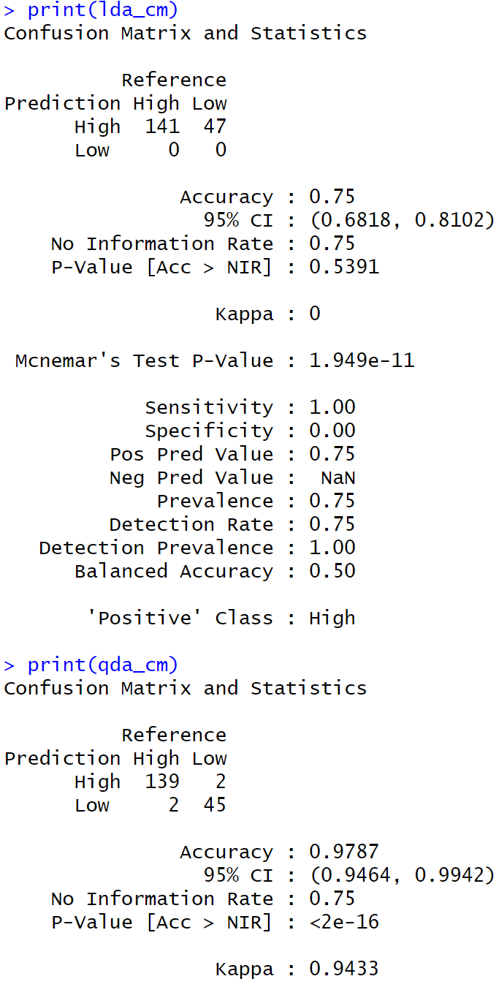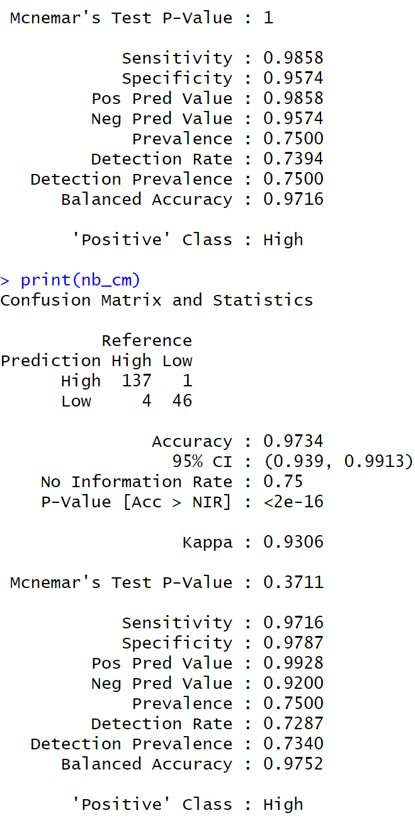

**CODE:**

**# Create data frame for accuracy comparison**

accuracy_df <- data.frame(Classifier = c("LDA", "QDA", "Naive Bayes"),Accuracy = c(lda_accuracy,qda_accuracy,nb_accuracy))

**#create accuracy plot**

accuracy_plot <- ggplot(accuracy_df, aes(x= Classifier, y= Accuracy, fill = Classifier))+ geom_bar(stat = "identity", position = "dodge")+labs(y = "Accuracy", title = "Classifier Comparision")+theme_minimal()+theme(legend.position = "bottom")

print(accuracy_plot)

**#create ROC curves**

roc_lda <- roc(test_data$stock_labels, as.numeric(lda_predictions == "high"))

roc_qda <- roc(test_data$stock_labels, as.numeric(qda_predictions == "High"))

roc_nb <- roc(test_data$stock_labels, as.numeric(nb_predictions == "High"))

**# Determine the common length of sensitivities**

min_length <- min(length(roc_lda$sensitivities), length(roc_qda$sensitivities), length(roc_nb$sensitivities))

**# Combine ROC curve data into a single data frame**

roc_data <- data.frame(

FPR = c(roc_lda$specificities[1:min_length], roc_qda$specificities[1:min_length], roc_nb$specificities[1:min_length]),

TPR = c(roc_lda$sensitivities[1:min_length], roc_qda$sensitivities[1:min_length], roc_nb$sensitivities[1:min_length]),

Classifier = rep(c("LDA", "QDA", "Naive Bayes"), each = min_length)

)

**# Create combined ROC curve plot**

roc_combined_plot <- ggplot(roc_data, aes(x = FPR, y = TPR, color = Classifier, linetype = Classifier)) + geom_line(linewidth = 1)+

labs(x = "False Positive Rate (1 - Specificity)", y = "True Positive Rate (Sensitivity)", title = "ROC Curves - Classifier Comparision") +

scale_color_manual(values = c("blue", "green", "red"))+

scale_linetype_manual(values = c("solid", "dashed", "dotted"))+

theme_minimal()+

theme(legend.position = "bottom")

print(roc_combined_plot)

**OUTPUT:**

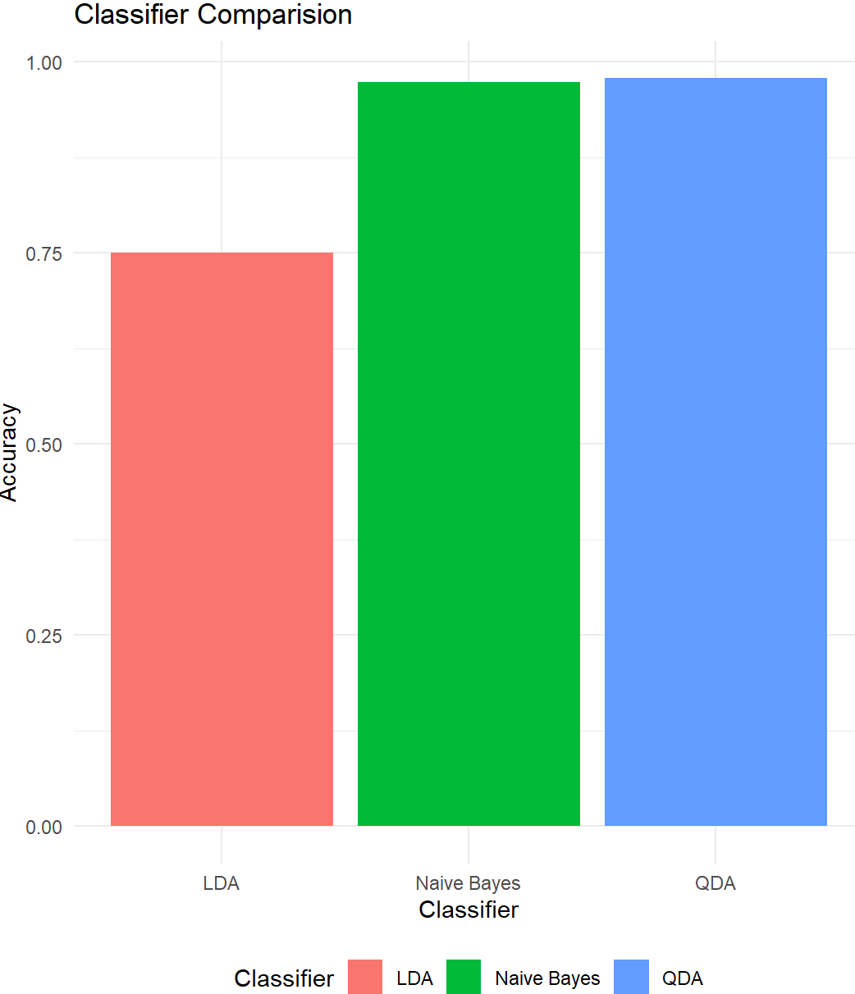

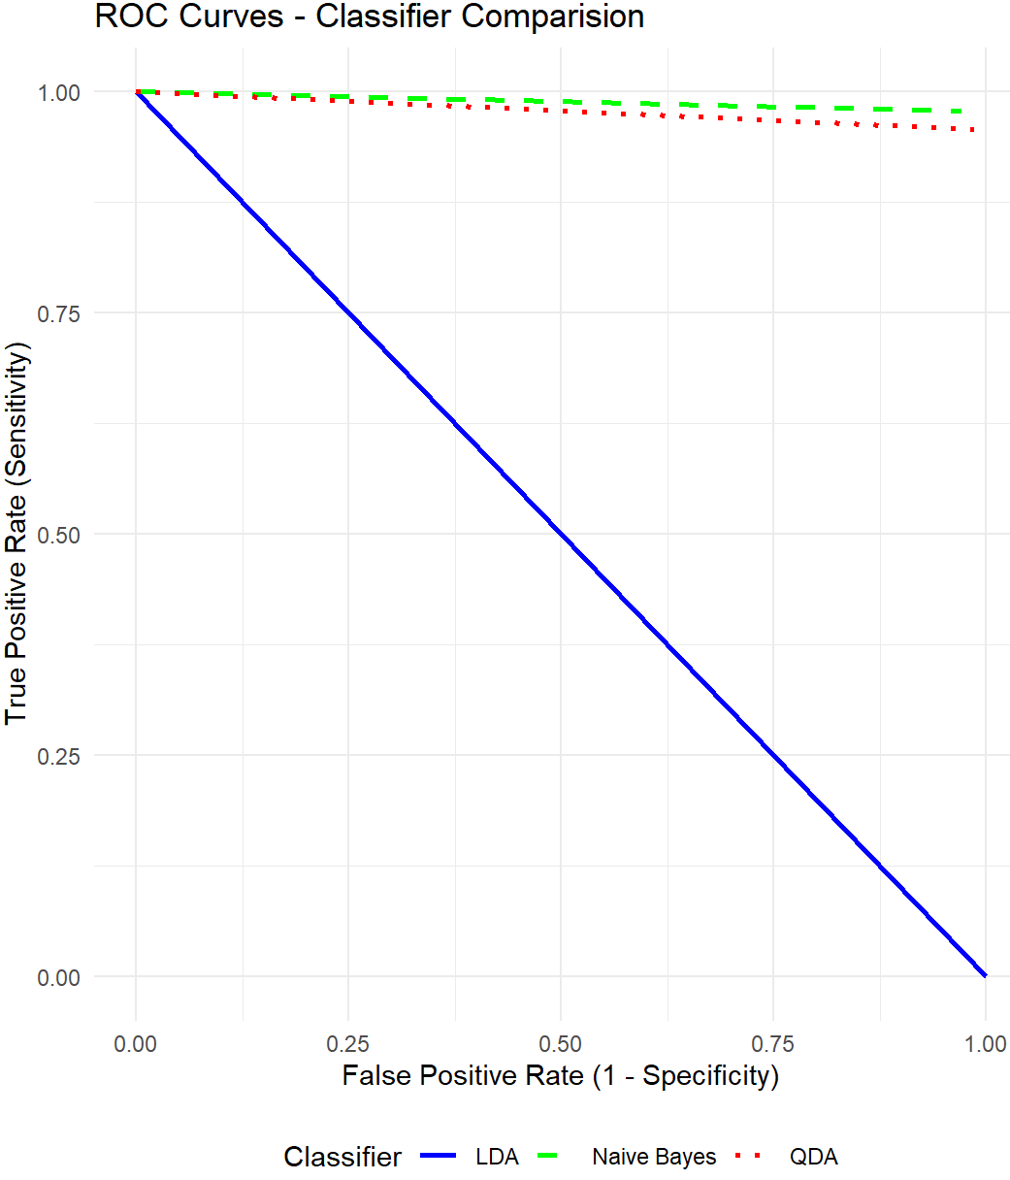

**Findings:**

**Quadratic Discriminant Analysis (QDA)** is the best algorithm with accuracy rate 97.8% among the Linear Discriminant Analysis(LDA) with accuracy rate 75% ,naive bayes classification with accuracy rate 97.3%.

**EXPERIMENT NO:6**

**AIM:**

Write R program to Implement decision trees using mushrooms dataset.

**DESCRIPTION:**

# Decision Tree Classification Algorithm:

Decision Tree is a **Supervised learning technique**that can be used for both classification and Regression problems, but mostly it is preferred for solving Classification problems. It is a tree-structured classifier, where**internal nodes represent the features of a dataset, branches represent the decision rules** and **each leaf node represents the outcome.**

#### **Note: A decision tree can contain categorical data (YES/NO) as well as numeric data.**

* Below diagram explains the general structure of a decision tree.

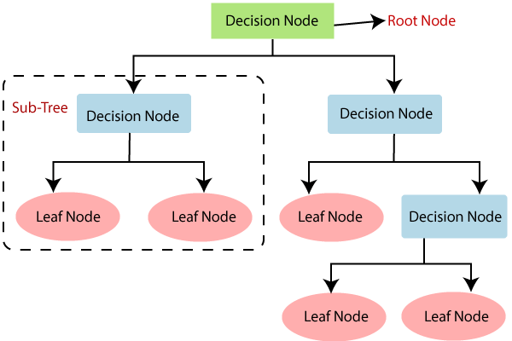

## **Decision Tree Terminologies:**

**Root Node:** Root node is from where the decision tree starts. It represents the entire dataset, which further gets divided into two or more homogeneous sets.

· **Leaf Node:** Leaf nodes are the final output node, and the tree cannot be segregated further after getting a leaf node.

· **Splitting:** Splitting is the process of dividing the decision node/root node into sub-nodes according to the given conditions.

· **Branch/Sub Tree:** A tree formed by splitting the tree.

· **Pruning:** Pruning is the process of removing the unwanted branches from the tree.

· **Parent/Child node:** The root node of the tree is called the parent node, and other nodes are called the child nodes.

**How does the Decision Tree algorithm Work?**

In a decision tree, for predicting the class of the given dataset, the algorithm starts from the root node of the tree. This algorithm compares the values of root attribute with the record (real dataset) attribute and, based on the comparison, follows the branch and jumps to the next node.

For the next node, the algorithm again compares the attribute value with the other sub-nodes and move further. It continues the process until it reaches the leaf node of the tree. The complete process can be better understood using the below algorithm:

* **Step-1:** Begin the tree with the root node, says S, which contains the complete dataset.
* **Step-2:** Find the best attribute in the dataset using **Attribute Selection Measure (ASM).**
* **Step-3:** Divide the S into subsets that contains possible values for the best attributes.
* **Step-4:** Generate the decision tree node, which contains the best attribute.
* **Step-5:** Recursively make new decision trees using the subsets of the dataset created in step -3. Continue this process until a stage is reached where you cannot further classify the nodes and called the final node as a leaf node.

**Example:** Suppose there is a candidate who has a job offer and wants to decide whether he should accept the offer or Not. So, to solve this problem, the decision tree starts with the root node (Salary attribute by ASM). The root node splits further into the next decision node (distance from the office) and one leaf node based on the corresponding labels. The next decision node further gets split into one decision node (Cab facility) and one leaf node. Finally, the decision node splits into two leaf nodes (Accepted offers and Declined offer). Consider the below diagram:

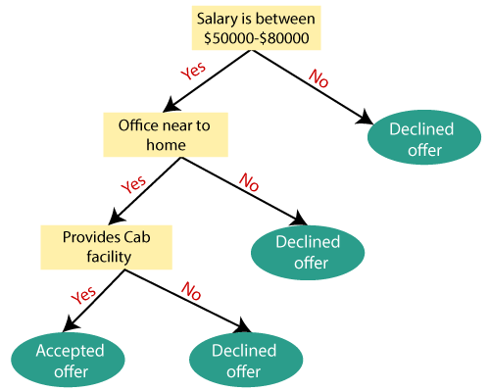

## **Attribute Selection Measures:**

While implementing a Decision tree, the main issue arises that how to select the best attribute for the root node and for sub-nodes. So, to solve such problems there is a technique which is called as **Attribute selection measure or ASM.**By this measurement, we can easily select the best attribute for the nodes of the tree. There are two popular techniques for ASM, which are:

* **Information Gain**
* **Gini Index**

### **1. Information Gain:**

* Information gain is the measurement of changes in entropy after the segmentation of a dataset based on an attribute.

1. Information Gain= Entropy(S)- [(Weighted Avg) *Entropy(each feature)

**Entropy:** Entropy is a metric to measure the impurity in a given attribute. It specifies randomness in data. Entropy can be calculated as:

Entropy(s)= -P(yes)log2 P(yes)- P(no) log2 P(no)

**Where,**

* **S= Total number of samples**
* **P(yes)= probability of yes**
* **P(no)= probability of no**

### **2. Gini Index:**

* Gini index is a measure of impurity or purity used while creating a decision tree in the CART(Classification and Regression Tree) algorithm.
* Gini index can be calculated using the below formula:

Gini Index= 1- ∑jPj2

## **Pruning: Getting an Optimal Decision tree:**

## Pruning is a process of deleting the unnecessary nodes from a tree in order to get the optimal decision tree.

## A too-large tree increases the risk of overfitting, and a small tree may not capture all the important features of the dataset. Therefore, a technique that decreases the size of the learning tree without reducing accuracy is known as Pruning. There are mainly two types of tree **pruning**technology used:

* **Cost Complexity Pruning**
* **Reduced Error Pruning.**

## **Steps involved in Implementation of Decision Tree:**

## For this, we will use the dataset "**user_data.csv**," which we have used in previous classification models. By using the same dataset, we can compare the Decision tree classifier with other classification models such as [KNN](https://www.javatpoint.com/k-nearest-neighbor-algorithm-for-machine-learning) [SVM,](https://www.javatpoint.com/machine-learning-support-vector-machine-algorithm) [LogisticRegression,](https://www.javatpoint.com/logistic-regression-in-machine-learning) etc.

Steps will also remain the same, which are given below:

* **Data Pre-processing step**
* **Fitting a Decision-Tree algorithm to the Training set**
* **Predicting the test result**
* **Test accuracy of the result(Creation of Confusion matrix)**
* **Visualizing the test set result.**

**CODE:**

library(rpart)

library(rpart.plot)

library(partykit)

library(caret)

library(pROC)

library(ROCR)

**OUTPUT:**

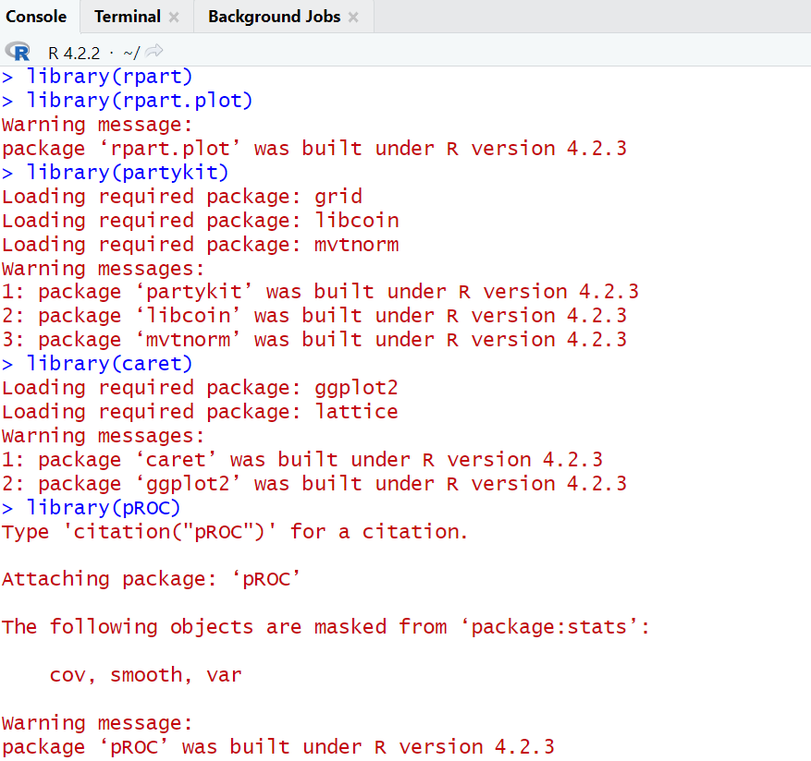

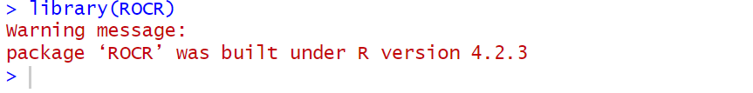

**CODE:**

**#Load the mushrooms data set**

dataset<-read.csv("D:\VVIT.BTECH\3_1\ML_lab\exp-6\mushrooms.csv")

**#Convert class labels to factors**

dataset$class<-as.factor(dataset$class)

set.seed(123)

sample_indices<-sample(nrow(dataset),0.8*nrow(dataset))

train_data<-dataset[sample_indices,]

test_data<-dataset[-sample_indices,]

**OUTPUT:**

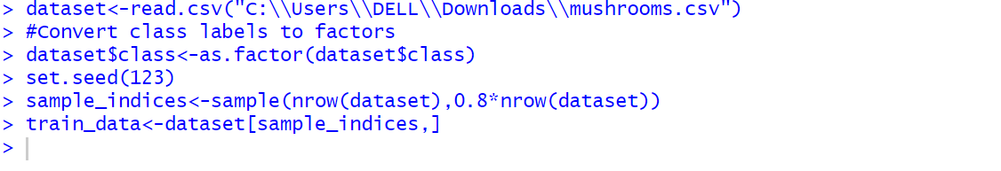

**CODE:**

**#Build the model**

tree_model<-rpart(class~.,data=train_data,method="class")

print(tree_model)

**#Make predictions on test set**

predictions=predict(tree_model,test_data,type = "class")

**#Accuracy score**

accuracy=sum(predictions == test_data$class)/nrow(test_data)

cat("Accuracy:",accuracy,"\n")

**OUTPUT:**

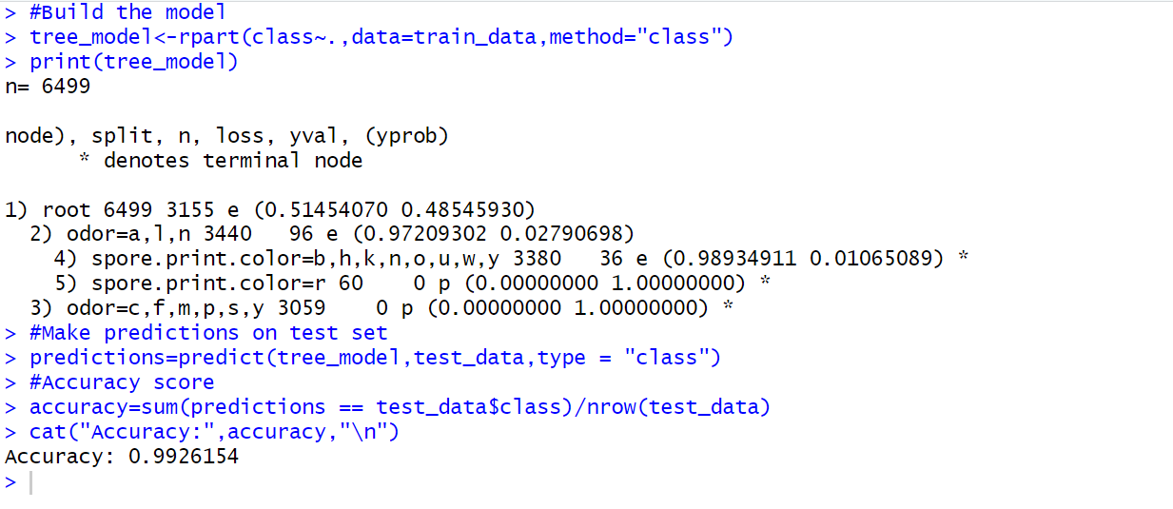

**CODE:**

**#Visualize the tree**

party_tree<-as.party(tree_model)

plot(party_tree)

**OUTPUT:**

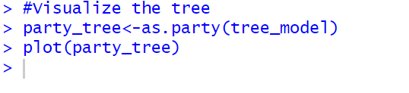

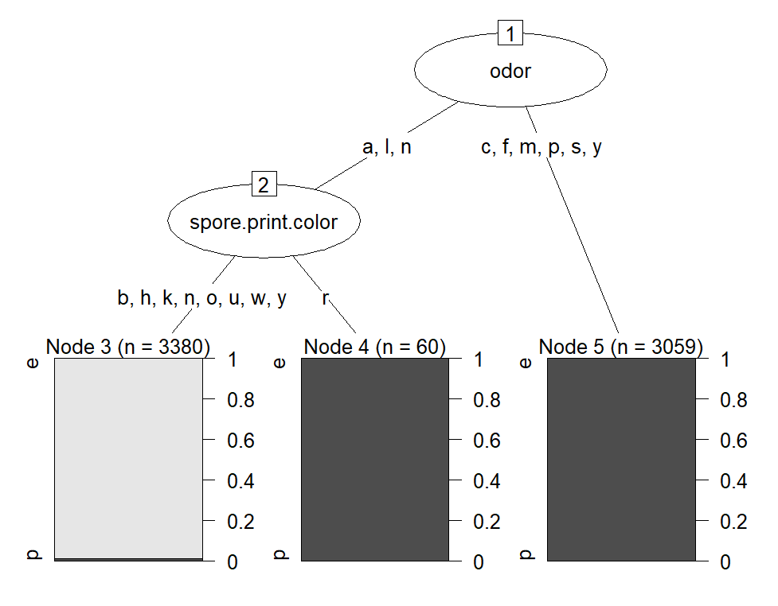

**CODE:**

**#Display the few predictions**

predictions=predict(tree_model,newdata=test_data,type = "class")

head(predictions)

**#Calculate the precision,recall and F1-score.**

actual_labels<-test_data$class

confusion_matrix<-table(actual_labels,predictions)

print(confusion_matrix)

**OUTPUT:**

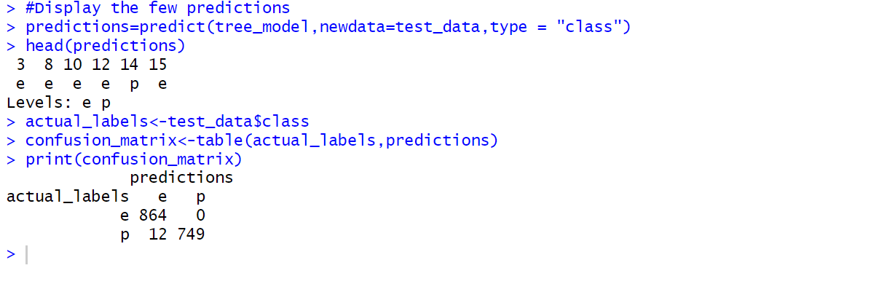

**CODE:**

precision<-diag(confusion_matrix)/rowSums(confusion_matrix)

recall<-diag(confusion_matrix)/colSums(confusion_matrix)

f1_score<-2*(precision*recall)/(precision+recall)

result_df<-data.frame(Precision=precision,Recall=recall,F1_Score=f1_score)

rownames(result_df)<-levels(predictions)

print(result_df)

**OUTPUT:**

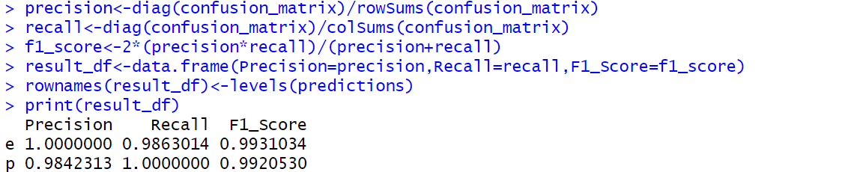

**CODE:**

binary_predictions<-ifelse(predictions=="p",1,0)

roc_obj<-roc(as.numeric(test_data$class == "p"),binary_predictions)

plot(roc_obj,print.auc=TRUE)

**OUTPUT:**

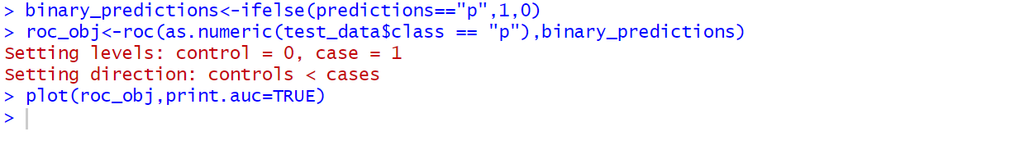

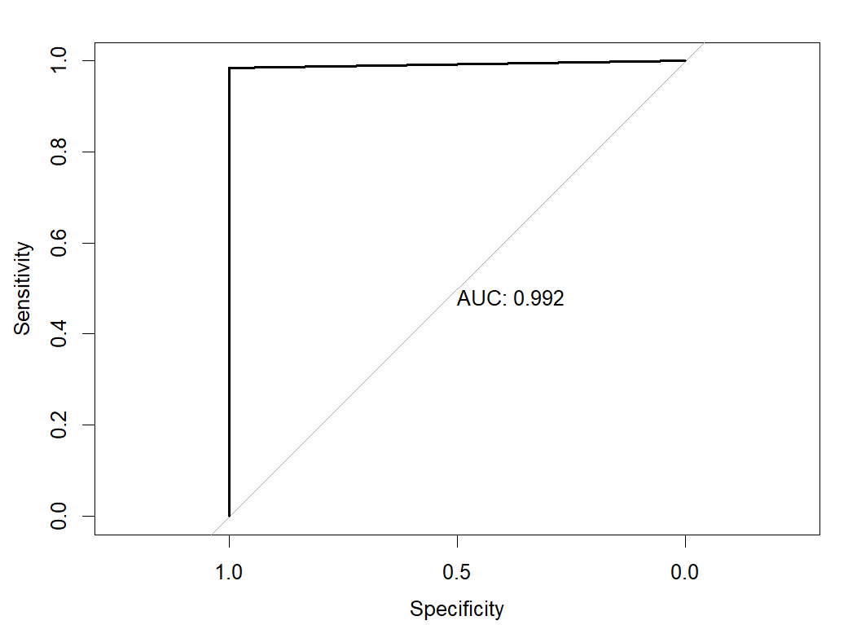

**CODE:**

auc_score<-auc(roc_obj)

cat("AUC-ROC:",auc_score,"\n")

summary(tree_model)

**OUTPUT:**

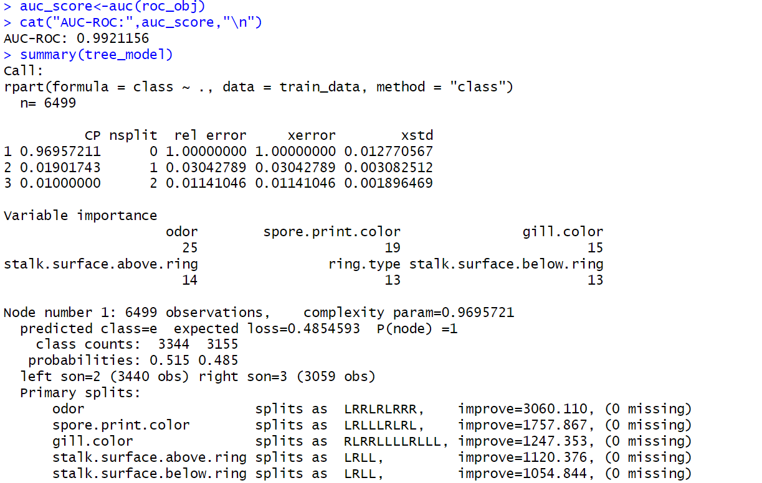

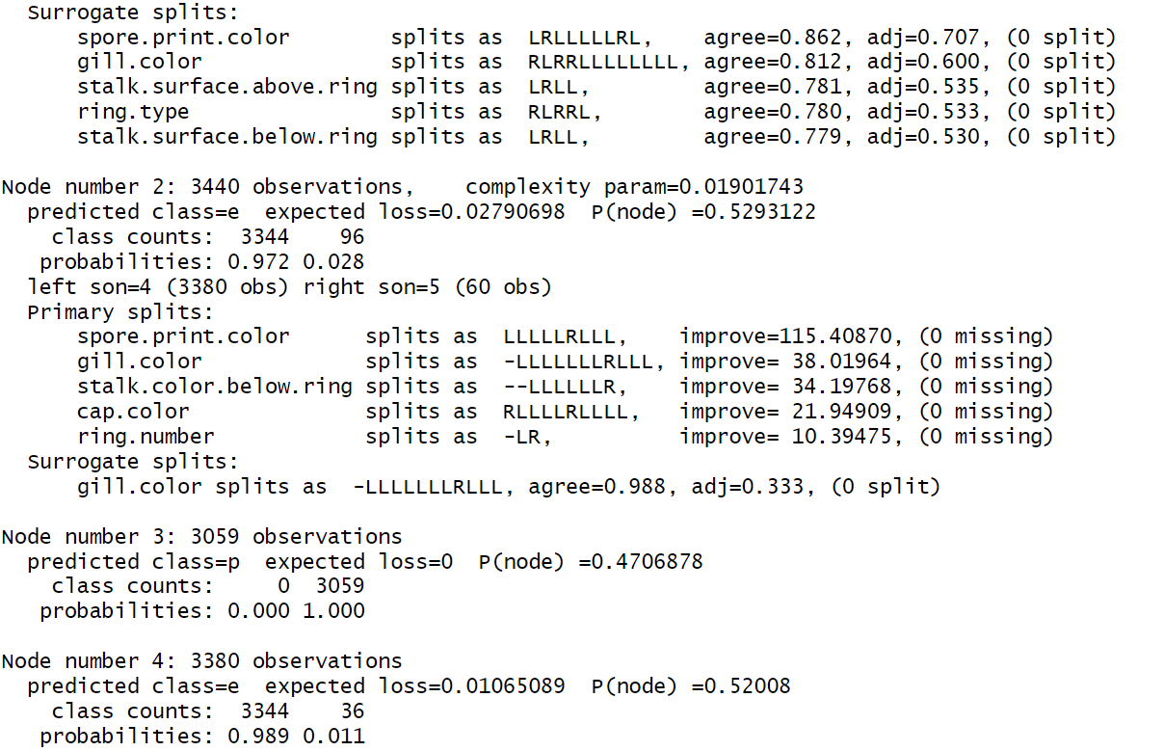

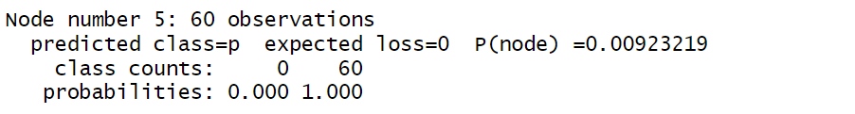

**CODE:**

pruned_tree<-prune(tree_model,cp=0.01)

summary(pruned_tree)

**OUTPUT:**

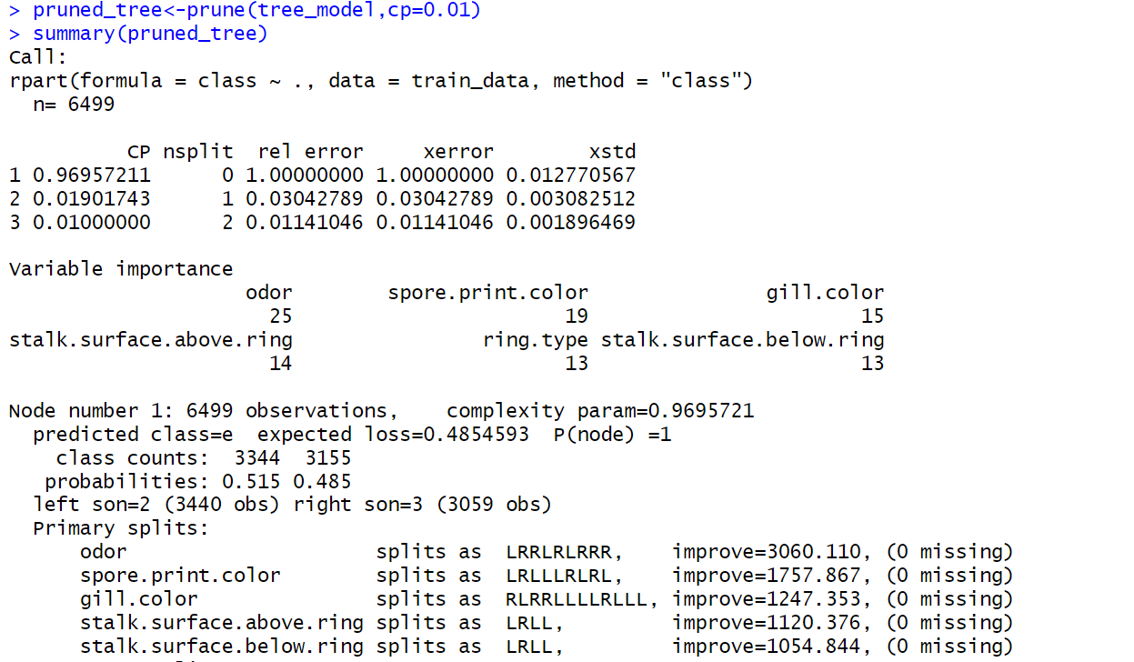

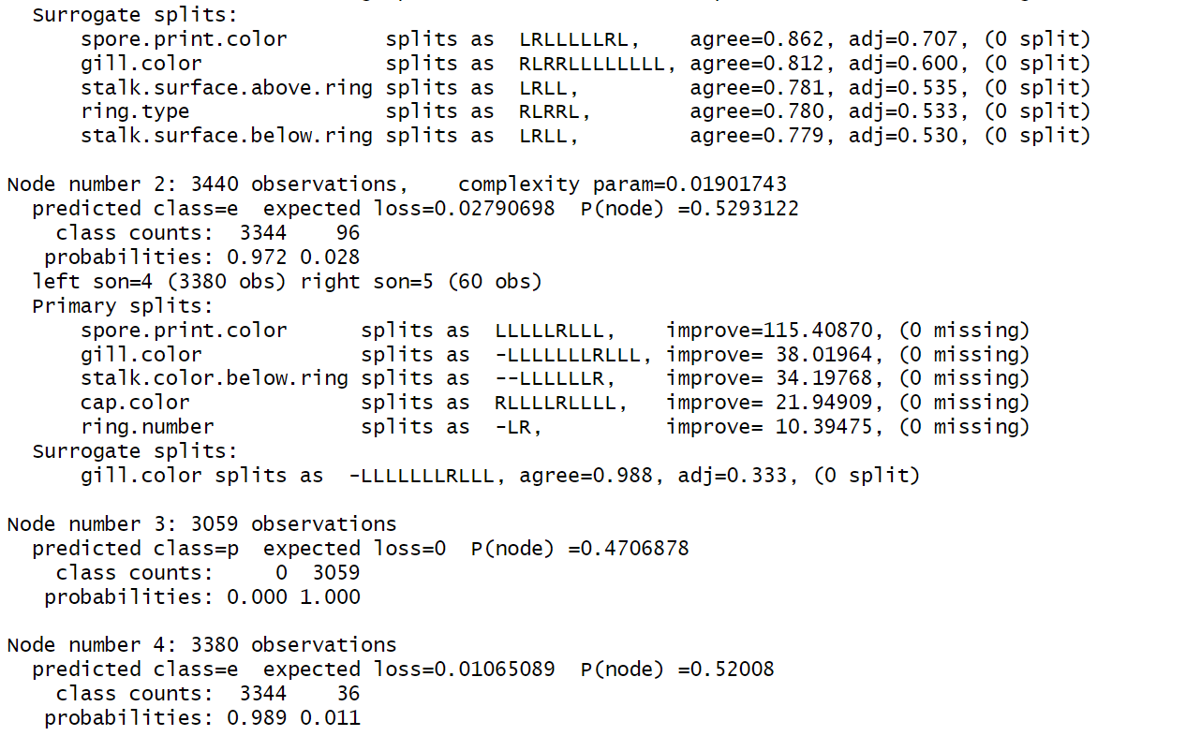

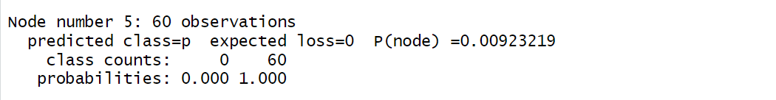

**CODE:**

rpart.plot(pruned_tree)

**OUTPUT:**

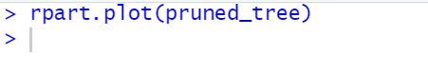

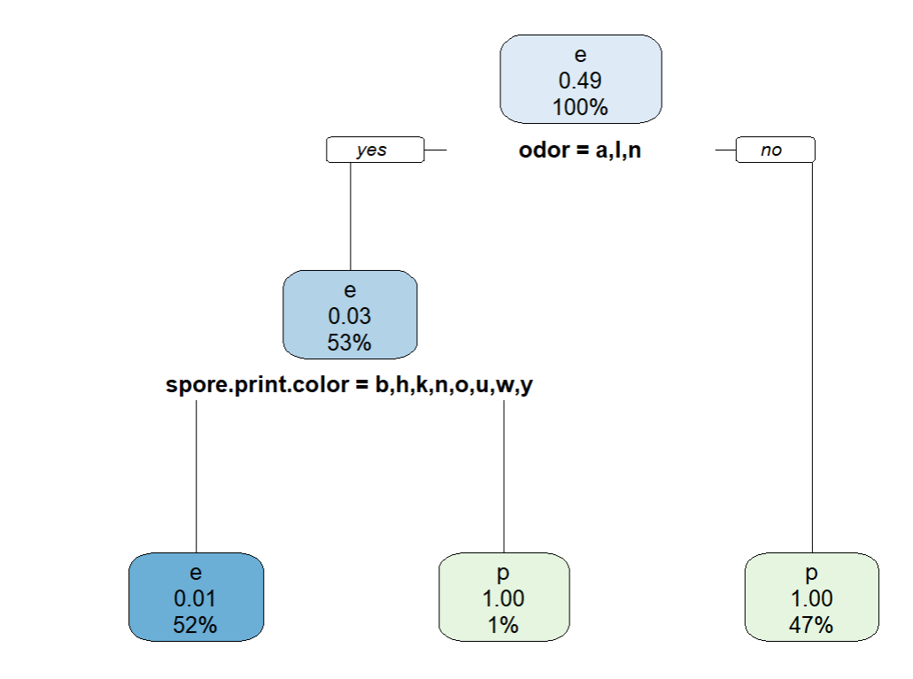

**CODE:**

**#make predictions on the test set using pruned_tree.**

pruned_predictions<-predict(pruned_tree,newdata = test_data,type = "class")

pruned_cm<-confusionMatrix(pruned_predictions,test_data$class)

print(pruned_cm)

**OUTPUT:**

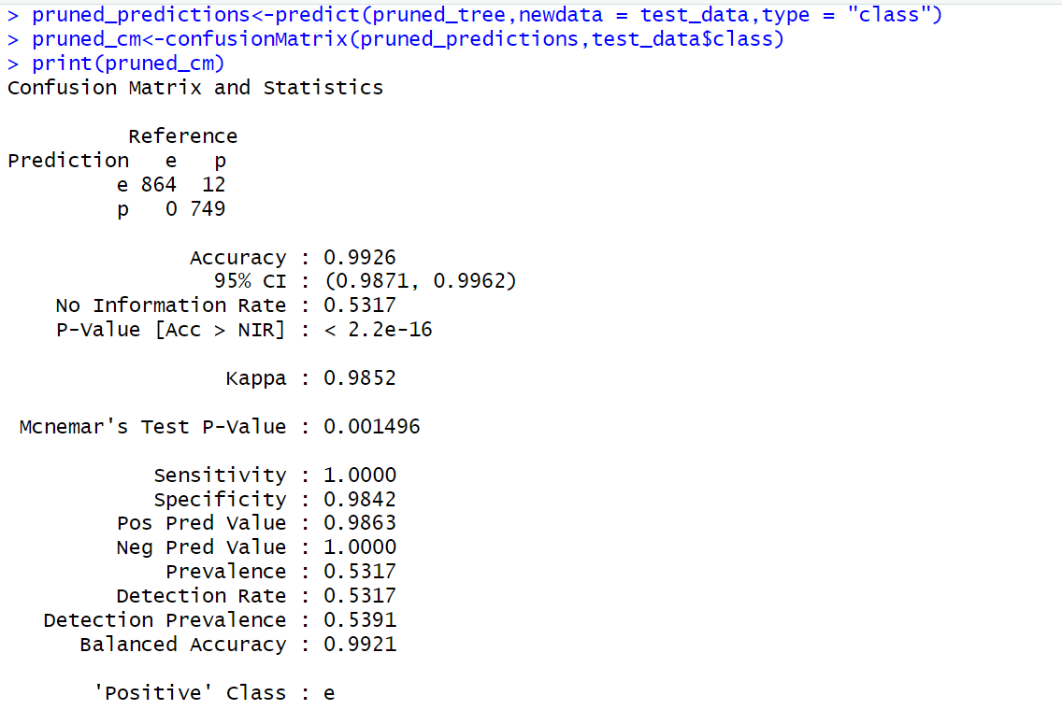

**CODE:**

pruned_accuracy<-sum(pruned_predictions==test_data$class)/length(test_data$class)

cat("Pruned Model Accuracy : ",pruned_accuracy,"\n")

pruned_cm<-confusionMatrix(pruned_predictions,test_data$class)

pruned_precision<-pruned_cm$byClass["Positive predictive value"]

pruned_recall<-pruned_cm$byClass["Sensitivity"]

pruned_f1_score<-pruned_cm$byClass["F1"]

cat("Pruned model precision: ",pruned_precision,"\n")

cat("Pruned model recall: ",pruned_recall,"\n")

cat("Pruned model f1-score: ",pruned_f1_score,"\n")

**OUTPUT:**

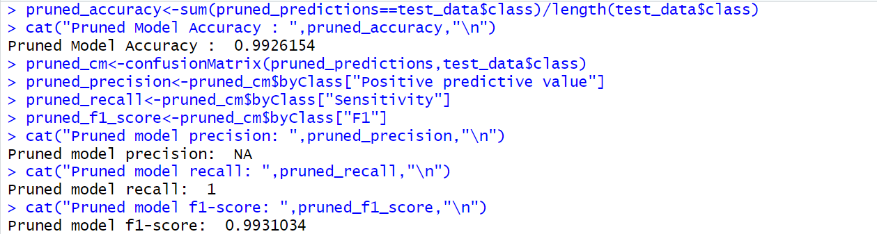

**Findings:**

**Pruned model accuracy:** 0.9926154

**Pruned model precision:** NA

**Pruned model recall:** 1

**Pruned model f1-score:** 0.9931034

**EXPERIMENT NO:7**

**AIM:**

Write R program to implement Support Vector Machine(SVM) for Gene Expression Data.

**DESCRIPTION:**

**Support Vector Machine:**

Support Vector Machine (SVM) is a supervised machine learning algorithm used for both classification and regression. Though we say regression problems as well it’s best suited for classification. The main objective of the SVM algorithm is to find the optimal hyperplane in an N-dimensional space that can separate the data points in different classes in the feature space. The hyperplane tries that the margin between the closest points of different classes should be as maximum as possible. The dimension of the hyperplane depends upon the number of features. If the number of input features is two, then the hyperplane is just a line. If the number of input features is three, then the hyperplane becomes a 2-D plane. It becomes difficult to imagine when the number of features exceeds three.

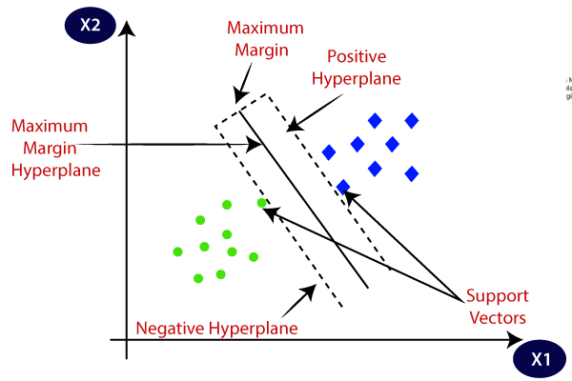

**Support Vector Machine Terminology:**

1. **Hyperplane:** Hyperplane is the decision boundary that is used to separate the data points of different classes in a feature space. In the case of linear classifications, it will be a linear equation i.e., wx+b = 0.
2. **Support Vectors:** Support vectors are the closest data points to the hyperplane, which makes a critical role in deciding the hyperplane and margin.
3. **Margin**: Margin is the distance between the support vector and hyperplane. The main objective of the support vector machine algorithm is to maximize the margin. The wider margin indicates better classification performance.
4. **Kernel**: Kernel is the mathematical function, which is used in SVM to map the original input data points into high-dimensional feature spaces, so, that the hyperplane can be easily found out even if the data points are not linearly separable in the original input space. Some of the common kernel functions are linear, polynomial, radial basis function (RBF), and sigmoid.

# Hard Margin: The maximum-margin hyperplane or the hard margin hyperplane is a hyperplane that properly separates the data points of different categories without any misclassifications.

1. **Soft Margin:** When the data is not perfectly separable or contains outliers, SVM permits a soft margin technique. Each data point has a slack variable introduced by the soft-margin SVM formulation, which softens the strict margin requirement and permits certain misclassifications or violations. It discovers a compromise between increasing the margin and reducing violations.
2. **C:** Margin maximisation and misclassification fines are balanced by the regularisation parameter C in SVM. The penalty for going over the margin or misclassifying data items is decided by it. A stricter penalty is imposed with a greater value of C, which results in a smaller margin and perhaps fewer misclassifications.
3. **Hinge Loss:** A typical loss function in SVMs is hinge loss. It punishes incorrect classifications or margin violations. The objective function in SVM is frequently formed by combining it with the regularisation term.
4. **Dual Problem:** A dual Problem of the optimisation problem that requires locating the Lagrange multipliers related to the support vectors can be used to solve SVM. The dual formulation enables the use of kernel tricks and more effective computing.

**Mathematical intuition of Support Vector Machine:**

Consider a binary classification problem with two classes, labelled as +1 and -1. We have a training dataset consisting of input feature vectors X and their corresponding class labels Y.

The equation for the linear hyperplane can be written as:



The vector W represents the normal vector to the hyperplane. i.e the direction perpendicular to the hyperplane. The parameter **b** in the equation represents the offset or distance of the hyperplane from the origin along the normal vector **w**.

The distance between a data point x_i and the decision boundary can be calculated as:



where ||w|| represents the Euclidean norm of the weight vector w. Euclidean norm of the normal vector W

For Linear SVM classifier:

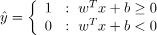

**Optimization:**

* **For Hard margin linear SVM classifier:**

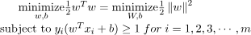

The target variable or label for the ith training instance is denoted by the symbol ti in this statement. And ti=-1 for negative occurrences (when yi= 0) and ti=1positive instances (when yi = 1) respectively. Because we require the decision boundary that satisfy the

constraint: 

* **For Soft margin linear SVM classifier:**

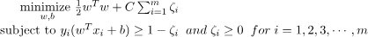

* **Dual Problem:** A dual Problem of the optimisation problem that requires locating the Lagrange multipliers related to the support vectors can be used to solve SVM. The optimal Lagrange multipliers α(i) that maximize the following dual objective function



where,

* αi is the Lagrange multiplier associated with the ith training sample.
* K(xi, xj) is the kernel function that computes the similarity between two samples xi and xj. It allows SVM to handle nonlinear classification problems by implicitly mapping the samples into a higher-dimensional feature space.
* The term ∑αi represents the sum of all Lagrange multipliers.

The SVM decision boundary can be described in terms of these optimal Lagrange multipliers and the support vectors once the dual issue has been solved and the optimal Lagrange multipliers have been discovered. The training samples that have i > 0 are the support vectors, while the decision boundary is supplied by:

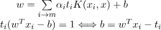

**Types of Support Vector Machine:**

Based on the nature of the decision boundary, Support Vector Machines (SVM) can be divided into two main parts:

* **Linear SVM:** Linear SVMs use a linear decision boundary to separate the data points of different classes. When the data can be precisely linearly separated, linear SVMs are very suitable. This means that a single straight line (in 2D) or a hyperplane (in higher dimensions) can entirely divide the data points into their respective classes. A hyperplane that maximizes the margin between the classes is the decision boundary.
* **Non-Linear SVM:** Non-Linear SVM can be used to classify data when it cannot be separated into two classes by a straight line (in the case of 2D). By using kernel functions, nonlinear SVMs can handle nonlinearly separable data. The original input data is transformed by these kernel functions into a higher-dimensional feature space, where the data points can be linearly separated. A linear SVM is used to locate a nonlinear decision boundary in this modified space.

**Popular kernel functions in SVM:**

The SVM kernel is a function that takes low-dimensional input space and transforms it into higher-dimensional space, i.e., it converts non separable problems to separable problems.

It is mostly useful in non-linear separation problems. Simply put the kernel, does some extremely complex data transformations and then finds out the process to separate the data based on the labels or outputs defined.

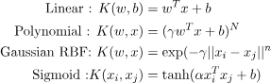

**CODE:**

# Load necessary packages

library(ISLR2)

library(pROC)

library(ggplot2)

library(e1071)

library(plotmo)

library(plotly)

# Display column names of the Khan dataset

names(Khan)

# Check dimensions of training and testing sets dim(Khan$xtrain)

dim(Khan$xtest)

# Check the length of training and testing labels length(Khan$ytrain)

length(Khan$ytest)

# Display class distribution in training and testing labels table(Khan$ytrain)

table(Khan$ytest)

**OUTPUT:**

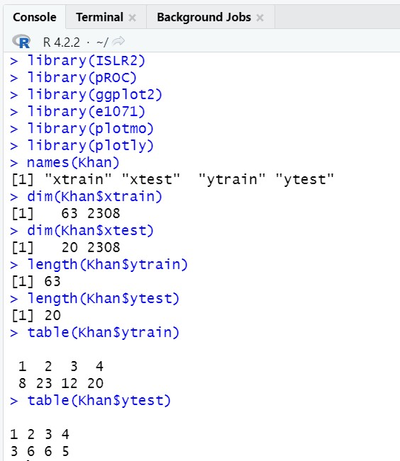

**CODE:**

# Create a dataframe 'dat' with training features and labels

dat <- data.frame(x = Khan$xtrain,y = as.factor(Khan$ytrain))

# Train an SVM model with linear kernel

out <- svm(y ~ ., data = dat, kernel = "linear", cost = 10)

# Display summary of the trained SVM model

summary(out)

# Compare the fitted values with actual labels in the training data

table(out$fitted, dat$y)

# Create a dataframe 'dat.te' with testing features and labels

dat.te <- data.frame(x = Khan$xtest, y = as.factor(Khan$ytest))

# Predict using the trained SVM model on the testing data

pred.te <- predict(out, newdata = dat.te)

# Compare the predicted values with actual labels in the testing data table(pred.te, dat.te$y)

# Confusion matrix for training data

train_pred <- predict(out, newdata = dat)

train_conf_matrix <- table(train_pred, dat$y)

**OUTPUT :**

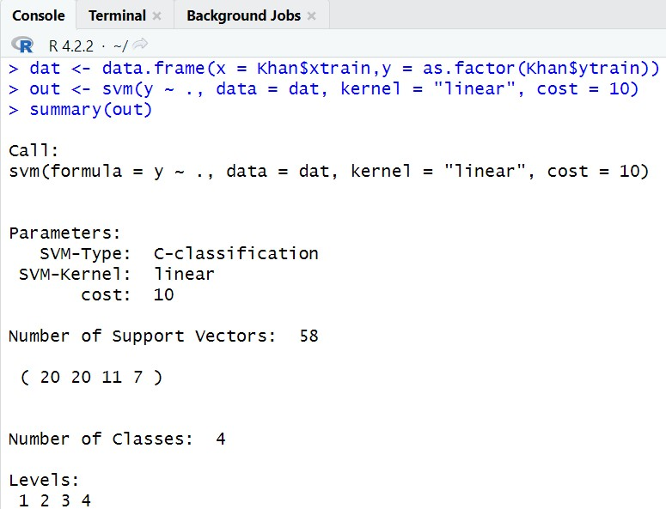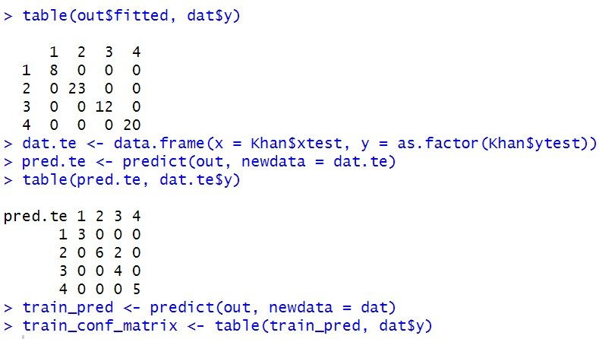

**CODE:**

# Convert the confusion matrix to a dataframe

train_conf_df <- as.data.frame(as.table(train_conf_matrix))

# Rename the columns for better readability

colnames(train_conf_df) <- c("Predicted", "Actual", "Frequency")

# Create the heatmap

ggplot(train_conf_df, aes(x = Predicted, y = Actual, fill = Frequency)) + geom_tile() +

scale_fill_gradient(low = "white", high = "blue") + l

abs(x = "Predicted Class", y = "Actual Class", fill = "Frequency") +

theme_minimal()

# Convert factor levels to numeric (1 or 2)

numeric_pred <- as.numeric(train_pred)

**CODE**

**:**

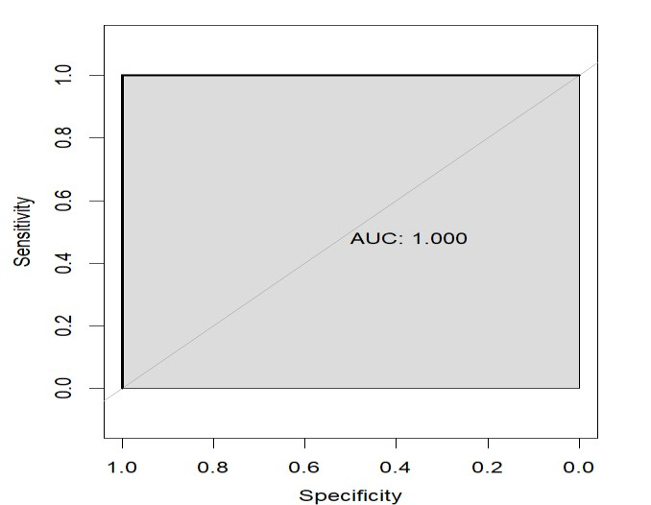

for (i in 2:length(train_roc$rocs)) { lines(train_roc$rocs[[i]], col = i, print.auc = TRUE, auc.polygon = TRUE)}

# Add a legend

legend("bottomright", legend = levels(dat$y), col = 1:length(train_roc$rocs), lwd = 2)

# Calculate performance metrics for training data

train_pred <- predict(out, newdata = dat)

train_conf_matrix <- table(train_pred, dat$y)

# Calculate accuracy for training data

train_accuracy <- sum(diag(train_conf_matrix)) / sum(train_conf_matrix)

# Calculate precision, recall, and F1-score for each class in training data class_names <- levels(dat$y)

train_metrics <- data.frame(Class = character(), Precision = numeric(), Recall = numeric(),

F1_Score = numeric(), stringsAsFactors = FALSE)

**OUTPUT:**

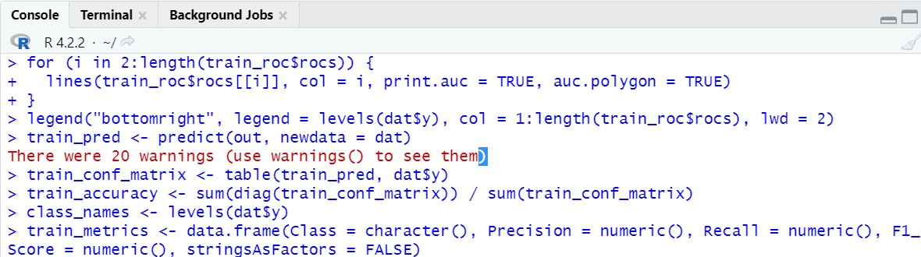

**OUTPUT:**

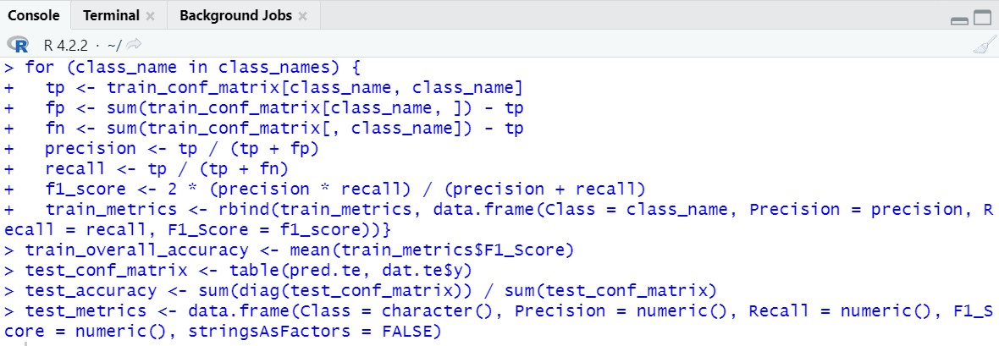

**CODE:**

for (class_name in class_names) {

tp <- test_conf_matrix[class_name, class_name]

fp <- sum(test_conf_matrix[class_name, ]) - tp

fn <- sum(test_conf_matrix[, class_name]) - tp

precision <- tp / (tp + fp)

recall <- tp / (tp + fn)

f1_score <- 2 * (precision * recall) / (precision + recall)

test_metrics <- rbind(test_metrics, data.frame(Class = class_name, Precision = precision, Recall = recall, F1_Score = f1_score))}

# Calculate overall classification accuracy for testing data

test_overall_accuracy <- mean(test_metrics$F1_Score)

# Print performance metrics for both training and testing data

cat("Performance Metrics for Training Data:\n")

cat("Overall Accuracy:", train_accuracy, "\n") print(train_metrics)

cat("Overall Classification Accuracy (F1-Score):", train_overall_accuracy, "\n\n") cat("Performance Metrics for Testing Data:\n")

cat("Overall Accuracy:", test_accuracy, "\n")

print(test_metrics)

cat("Overall Classification Accuracy (F1-Score):", test_overall_accuracy, "\n")

**OUTPUT:**

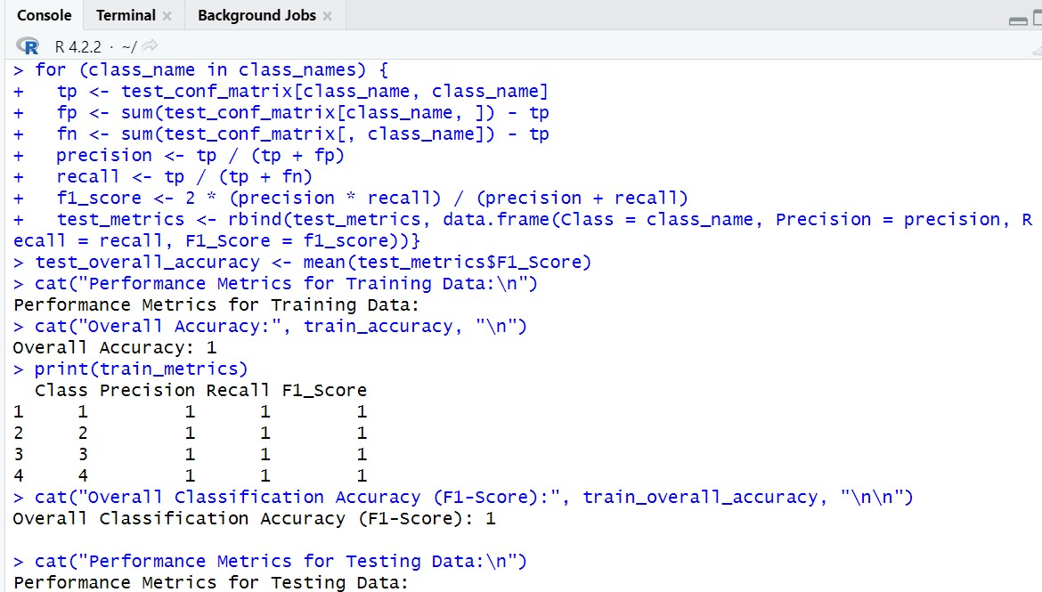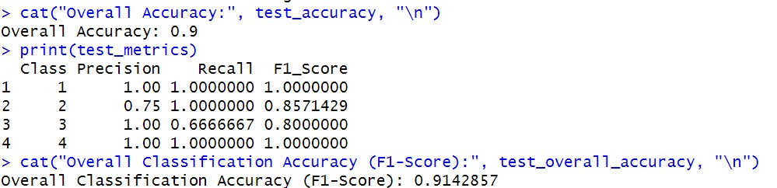

**CODE:**

# Create a dataframe for training metrics

train_metrics_df <- data.frame(

Class = train_metrics$Class,

Precision = train_metrics$Precision,

Recall = train_metrics$Recall,

F1_Score = train_metrics$F1_Score)

# Create a bar plot for training metrics

ggplot(train_metrics_df, aes(x = Class, y = F1_Score, fill = Class)) + geom_bar(stat = "identity", position = "dodge") +

labs(

title = "Performance Metrics for Training Data",

y = "F1-Score",p

x = "Class" )

theme_minimal() +

theme(axis.text.x = element_text(angle = 45, hjust = 1))

# Calculate multiclass ROC curve and AUC for training data train_roc <- multiclass.roc(dat$y, numeric_pred)

# Plot the multiclass ROC curves for each class plot(train_roc$rocs[[1]], col = 1, print.auc = TRUE, auc.polygon = TRUE)

**OUTPUT:**

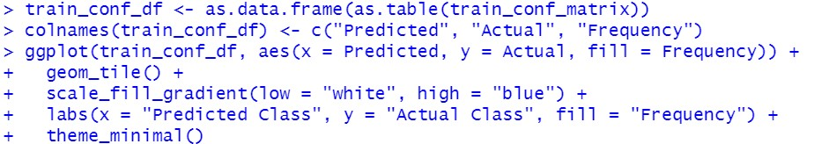

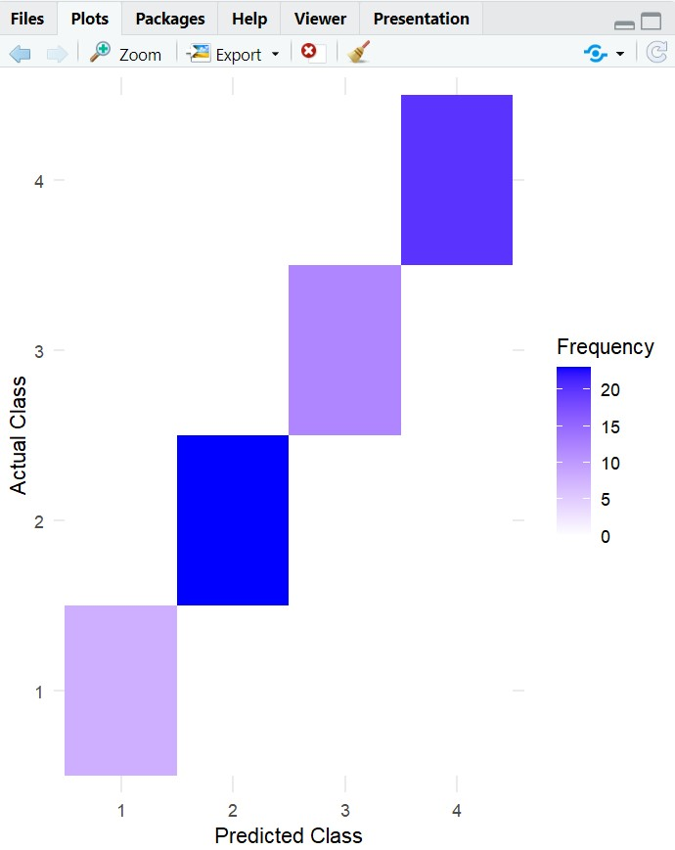

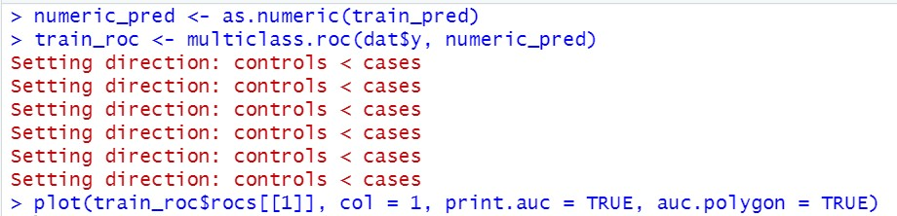

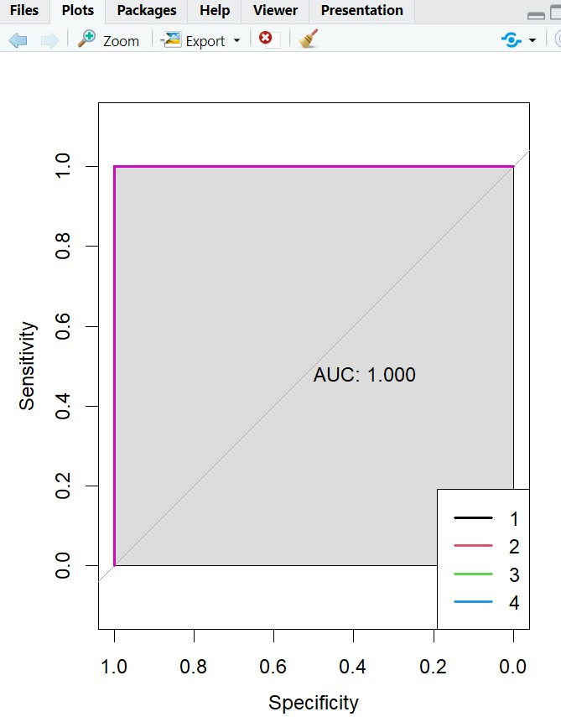

**CODE:**

for (class_name in class_names) {

tp <- train_conf_matrix[class_name, class_name]

fp <- sum(train_conf_matrix[class_name, ]) - tp

fn <- sum(train_conf_matrix[, class_name]) - tp

precision <- tp / (tp + fp) recall <- tp / (tp + fn)

f1_score <- 2 * (precision * recall) / (precision + recall)

train_metrics <- rbind(train_metrics, data.frame(Class = class_name, Precision = precision, Recall = recall, F1_Score = f1_score))}

# Calculate overall classification accuracy for training data train_overall_accuracy <- mean(train_metrics$F1_Score)

# Calculate performance metrics for testing data

test_conf_matrix <- table(pred.te, dat.te$y)

# Calculate accuracy for testing data

test_accuracy <- sum(diag(test_conf_matrix)) / sum(test_conf_matrix)

# Calculate precision, recall, and F1-score for each class in testing data

test_metrics <- data.frame(Class = character(), Precision = numeric(), Recall = numeric(), F1_Score = numeric(), stringsAsFactors = FALSE)

**OUTPUT:**

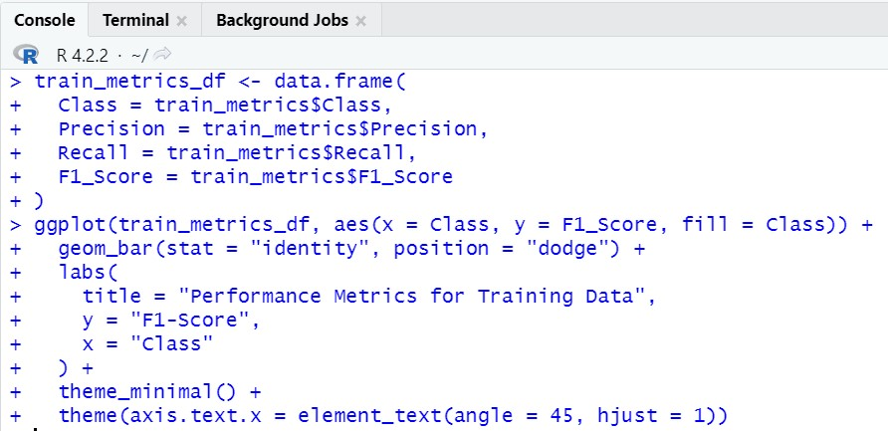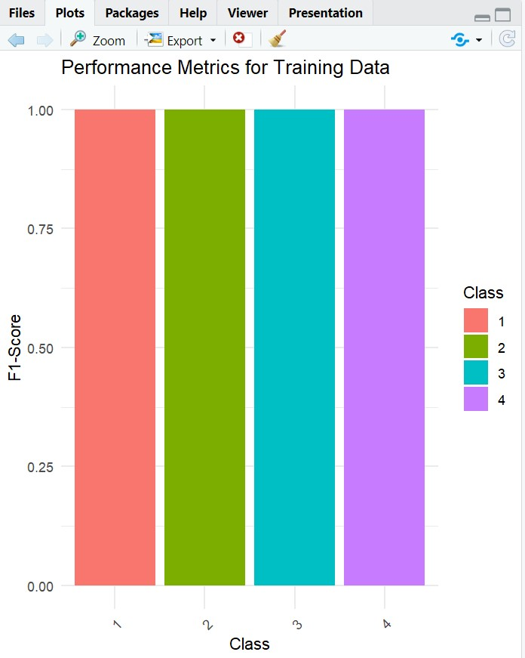

**CODE:**

# Create a dataframe for testing metrics

test_metrics_df <- data.frame(Class = test_metrics$Class,

Precision = test_metrics$Precision,

Recall = test_metrics$Recall,

F1_Score = test_metrics$F1_Score)

# Create a bar plot for testing metrics

ggplot(test_metrics_df, aes(x = Class, y = F1_Score, fill = Class)) + geom_bar(stat = "identity", position = "dodge") +

labs(

title = "Performance Metrics for Testing Data",

y = "F1-Score",

x = "Class"

) +

theme_minimal() +

theme(axis.text.x = element_text(angle = 45, hjust = 1))

**OUTPUT:**

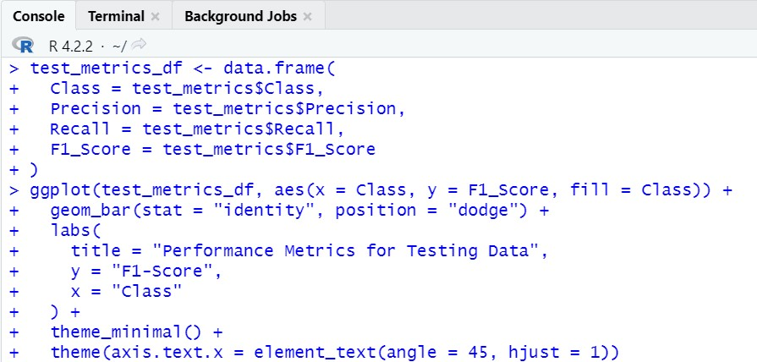

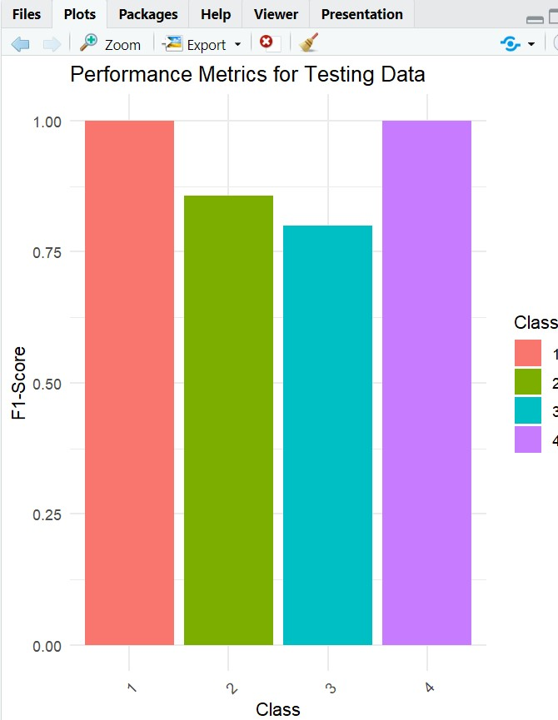

**EXPERIMENT NO: 8**

**AIM:** To Implement Principal Component Analysis on the US Arrests data set.

**DESCRIPTION:**

Principal Component Analysis is an unsupervised learning algorithm that is used for the dimensionality reduction in machine learning [. I](https://www.javatpoint.com/machine-learning)t is a statistical process that converts the observations of correlated features into a set of linearly uncorrelated features with the help of orthogonal transformation. These new transformed features are called the **Principal Components**. It is one of the popular tools that is used for exploratory data analysis and predictive modeling. It is a technique to draw strong patterns from the given dataset by reducing the variances.

PCA generally tries to find the lower-dimensional surface to project the high-dimensional data.

PCA works by considering the variance of each attribute because the high attribute shows the good split between the classes, and hence it reduces the dimensionality. Some real-world applications of PCA are ***image processing, movie recommendation system, optimizing the power allocation in various communication channels.*** It is a feature extraction technique, so it contains the important variables and drops the least important variable.

The PCA algorithm is based on some mathematical concepts such as: o Variance and Covariance

o Eigenvalues and Eigen factors

**Some common terms used in PCA algorithm:**

* **Dimensionality:** It is the number of features or variables present in the given dataset. More easily, it is the number of columns present in the dataset.
* **Correlation:** It signifies that how strongly two variables are related to each other. Such as if one changes, the other variable also gets changed. The correlation value ranges from -1 to +1. Here, -1 occurs if variables are inversely proportional to each other, and +1 indicates that variables are directly proportional to each other.
* **Orthogonal:** It defines that variables are not correlated to each other, and hence the correlation between the pair of variables is zero.
* **Eigenvectors:** If there is a square matrix M, and a non-zero vector v is given. Then v will be eigenvector if Av is the scalar multiple of v.
* **Covariance Matrix:** A matrix containing the covariance between the pair of variables is called the Covariance Matrix.

**Principal Components in PCA:**

* As described above, the transformed new features or the output of PCA are the Principal Components. The number of these PCs are either equal to or less than the original features present in the dataset. Some properties of these principal components are given below:
* The principal component must be the linear combination of the original features.
* These components are orthogonal, i.e., the correlation between a pair of variables is zero.

* The importance of each component decreases when going to 1 to n, it means the 1 PC has the most importance, and n PC will have the least importance.

\

**Steps for PCA algorithm:**

1. **Getting the dataset**

Firstly, we need to take the input dataset and divide it into two subparts X and Y, where X is the training set, and Y is the validation set.

1. **Representing data into a structure**

Now we will represent our dataset into a structure. Such as we will represent the two-dimensional matrix of independent variable X. Here each row corresponds to the data items, and the column corresponds to the Features. The number of columns is the dimensions of the dataset.

1. **Standardizing the data**

In this step, we will standardize our dataset. Such as in a particular column, the features with high variance are more important compared to the features with lower variance.

If the importance of features is independent of the variance of the feature, then we will divide each data item in a column with the standard deviation of the column. Here we will name the matrix as Z.

1. **Calculating the Covariance of Z**

To calculate the covariance of Z, we will take the matrix Z, and will transpose it. After transpose, we will multiply it by Z. The output matrix will be the Covariance matrix of Z.

1. **Calculating the Eigen Values and Eigen Vectors**

Now we need to calculate the eigenvalues and eigenvectors for the resultant covariance matrix Z. Eigenvectors or the covariance matrix are the directions of the axes with high information. And the coefficients of these eigenvectors are defined as the eigenvalues.

1. **Sorting the Eigen Vectors**

In this step, we will take all the eigenvalues and will sort them in decreasing order, which means from largest to smallest. And simultaneously sort the eigenvectors accordingly in matrix P of eigenvalues. The resultant matrix will be named as P*.

1. **Calculating the new features Or Principal Components**

Here we will calculate the new features. To do this, we will multiply the P* matrix to the Z. In the resultant matrix Z*, each observation is the linear combination of original features. Each column of the Z* matrix is independent of each other.

1. **Remove less or unimportant features from the new dataset.**

The new feature set has occurred, so we will decide here what to keep and what to remove. It means, we will only keep the relevant or important features in the new dataset, and unimportant features will be removed out. library(ggplot2) library(gridExtra) library(caret)

library(ISLR2)

#LOAD THE USARrrests dataset data("USArrests")

#STANDARDISE THE DATA

scaled_data<-scale(USArrests)

#perform PCA

pca_result<-prcomp(scaled_data,center=TRUE,scale.=TRUE)

#summary the PCA result summary(pca_result)

#variable explained by each principle component

variance_explained <- pca_result$sdev^2 / sum(pca_result$sdev^2) * 100

#print the variance explained by each pc cat("variance explained by each principal component:\n") print(variance_explained)

**OUTPUT:**

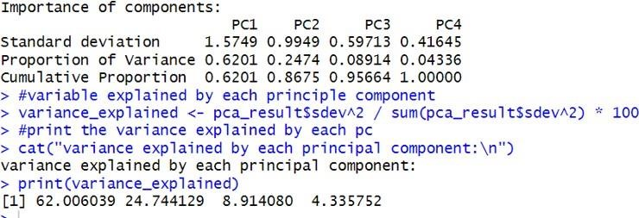

#scree plot to visualize the variance explained by each pc

plot(variance_explained,type = "b",xlab="principal component",ylab = "variance explained(%)")

#calculate the cumulative proportion of variance explained variance_explained <- pca_result$sdev^2 / sum(pca_result$sdev^2) cumulative_variance_explained <- cumsum(variance_explained)

plot(cumulative_variance_explained, type = "b", xlab = "number of principal component",

ylab = "cumulative variance explained",ylim = c(0,1))

#add a horizontal line at 0.95 to visualize the 95% threshold abline(h=0.95,col = "red",lty=2)

#find the number of pcs needed to explain atleast 95% of the variance num_pcs_to_reach_95_percent <- which(cumulative_variance_explained >=0.95)[1] text(num_pcs_to_reach_95_percent,0.96, labels = paste0("PCs",num_pcs_to_reach_95_percent), col = "blue")

**OUTPUT:**

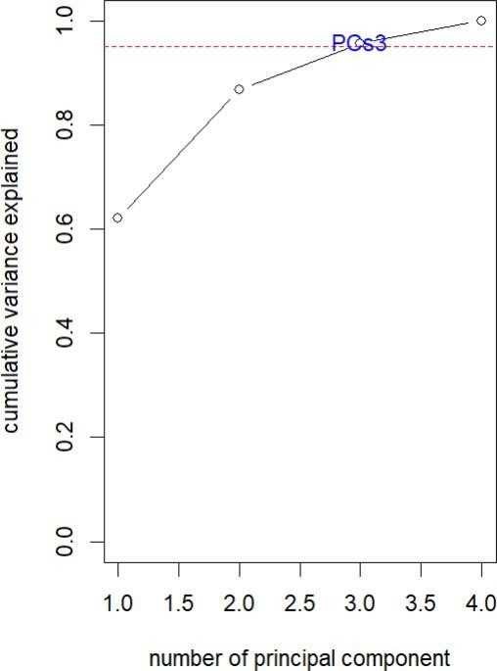

**CODE:**

#define the desired threshold (e.g,90%) desired_threshold <- 0.90

#find the number of PCs needed to reach or exceed the desired threshold

num_pcs_to_reach_threshold <- which(cumulative_variance_explained >= desired_threshold)[1]

#extract the top "n" principal components

top_n_pcs <- pca_result$x[,1:num_pcs_to_reach_threshold]

#print the result you can now use top_n_pcs

cat("Number if PCs to convert at least",(desired_threshold * 100),

"% variance:",num_pcs_to_reach_threshold,"\n")

#Retain the first 4 principal components top_4_pcs <- pca_result$x[, 1:4]

#create a data frame with the top 4 PCs and the mpg variable data_with_pcs <- data.frame(top_4_pcs,mpg = USArrests$Murder)

#split the data into a training set (75%) nd a testing set(25%) set.seed(123)

train_index <- createDataPartition(data_with_pcs$mpg, p =0.75, list = FALSE) train_data <- data_with_pcs[train_index, ] test_data <- data_with_pcs[-train_index, ] model <- lm(mpg ~ . , data = train_data) predictions <- predict(model, newdata = test_data) rmse <- sqrt(mean((test_data$mpg - predictions)^2)) cat("Root Mean Squared Error (RMSE):", rmse , "\n") result_data <- data.frame(Actual = test_data$mpg,

Predicted = predictions)

ggplot(result_data, aes(x = Actual, y = Predicted)) +

geom_point() +

geom_smooth(method = "lm", se = FALSE, color = "blue") + labs(

1. = "Actual mpg",
2. = "Actual vs. Predicted mpg"

)

residuals <- test_data$mpg - predictions screen_plot <- ggplot(NULL, aes(x = 1:ncol(top_4_pcs), y = cumulative_variance_explained)) +

geom_bar(stat = "identity", fill = "blue") + labs(

x = "Principal Component", y = "Cumulative Variance Explained",

title = "Scree Plot (PCA)"

)

residuals_plot <- ggplot(NULL, aes(x = residuals)) +

geom_histogram(binwidth = 1, fill = "green", color ="black") + labs(

x = "Residuals", y = "Frequemcy", title = "Residual plot (Regression)"

)

actual_vs_predicted_plot <- ggplot(result_data, aes(x= Actual, y = Predicted)) + geom_point() +

geom_smooth(method = "lm", se = FALSE, color = "blue") + labs(

x = "Actual mpg", y = "Predicted mpg", title = "Actual vs. Predicted mpg"

)

**OUTPUT:**

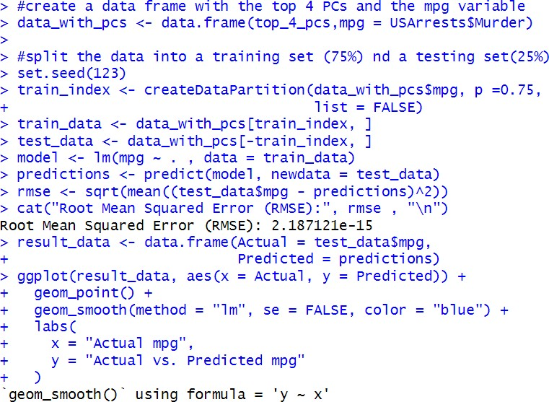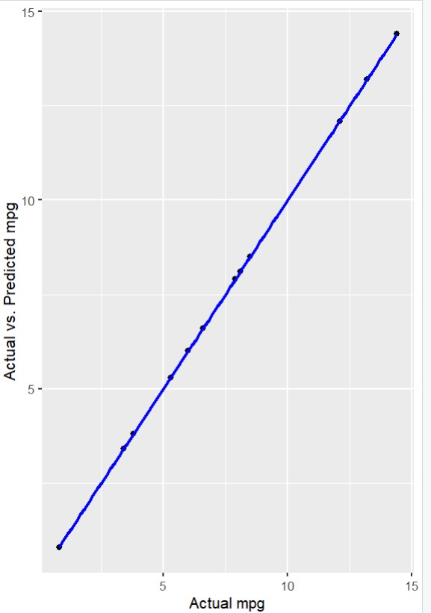

**CODE:**

summary_plot <- grid.arrange(screen_plot, residuals_plot, actual_vs_predicted_plot, ncol = 2)

print(summary_plot)

**OUTPUT:**

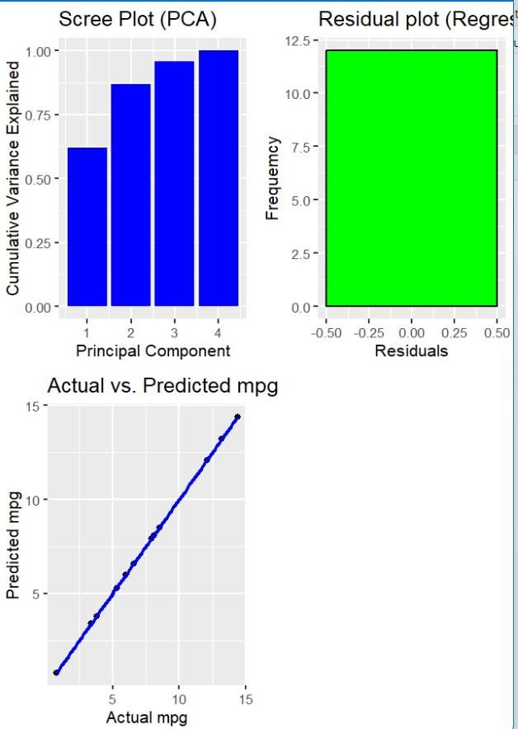

**EXPERIMENT NO:9**

**AIM: To Perform K-Means Clustering on NC160 Dataset.**

**DESCRIPTION:** K-means clustering is a technique in which we place each observation in a dataset into one of K clusters. The end goal is to have K clusters in which the observations within each cluster are quite similar to each other while the observations in different clusters are quite different from each other.

In practice, we use the following steps to perform K-means clustering:

1.Choose a value for K.

• First, we must decide how many clusters we’d like to identify in the data. Often we have to simply test several different values for K and analyze the results to see which number of clusters seems to make the most sense for a given problem.

2. Randomly assign each observation to an initial cluster, from 1 to K.

3. Perform the following procedure until the cluster assignments stop changing.

• For each of the K clusters, compute the cluster centroid. This is simply the vector of the p feature means for the observations in the kth cluster.

• Assign each observation to the cluster whose centroid is closest. Here, closest is defined using Euclidean distance.

**K-Means Clustering in R.**

The following tutorial provides a step-by-step example of how to perform k-means clustering in R.

**Step 1**: Load the Necessary Packages

First, we’ll load two packages that contain several useful functions for k-means clustering in R

**Step 2**: Load and Prep the Data

For this example we’ll use the USArrests dataset built into R, which contains the number of arrests per 100,000 residents in each U.S. state in 1973 for Murder, Assault, and Rape along with the percentage of the population in each state living in urban areas, UrbanPop.

The following code shows how to do the following:

• Load the USArrests dataset

• Remove any rows with missing values

• Scale each variable in the dataset to have a mean of 0 and a standard deviation of 1

**Step 3**: Find the Optimal Number of Clusters

To perform k-means clustering in R we can use the built-in kmeans() function, which uses the following syntax:

**kmeans(data, centers, nstart)**

where:

• data: Name of the dataset.

• centers: The number of clusters, denoted k.

• nstart: The number of initial configurations. Because it’s possible that different initial starting clusters can lead to different results, it’s recommended to use several different initial configurations. The k-means algorithm will find the initial configurations that lead to the smallest within-cluster variation.

Since we don’t know beforehand how many clusters is optimal, we’ll create two different plots that can help us decide:

1.Number of Clusters vs. the Total Within Sum of Squares

First, we’ll use the fviz_nbclust() function to create a plot of the number of clusters vs. the total within sum of squares.

Typically when we create this type of plot we look for an “elbow” where the sum of squares begins to “bend” or level off. This is typically the optimal number of clusters.

For this plot it appears that there is a bit of an elbow or “bend” at k = 4 clusters.

2. Number of Clusters vs. Gap Statistic

Another way to determine the optimal number of clusters is to use a metric known as the gap statistic, which compares the total intra-cluster variation for different values of k with their expected values for a distribution with no clustering.

We can calculate the gap statistic for each number of clusters using the clusGap() function from the cluster package along with a plot of clusters vs. gap statistic using the fviz_gap_stat() function

From the plot we can see that gap statistic is highest at k = 4 clusters, which matches the elbow method we used earlier.

**Step 4**: Perform K-Means Clustering with Optimal K

Lastly, we can perform k-means clustering on the dataset using the optimal value for k of 4.

From the results we can see that:

• 16 states were assigned to the first cluster

• 13 states were assigned to the second cluster

• 13 states were assigned to the third cluster

• 8 states were assigned to the fourth cluster.

We can visualize the clusters on a scatterplot that displays the first two principal components on the axes using the fivz_cluster() function

We can also use the aggregate() function to find the mean of the variables in each cluster.

We interpret this output is as follows:

• The mean number of murders per 100,000 citizens among the states in cluster 1 is 3.6.

• The mean number of assaults per 100,000 citizens among the states in cluster 1 is 78.5.

• The mean percentage of residents living in an urban area among the states in cluster 1 is 52.1%.

• The mean number of rapes per 100,000 citizens among the states in cluster 1 is 12.2.

And so on.

We can also append the cluster assignments of each state back to the original dataset.

**CODE:**

**#Load necessary packages**

library(factoextra)

library(cluster)

**#load data**

df <- USArrests

**#remove rows with missing values**

df <- na.omit(df)

**#scale each variable to have a mean of 0 and sd of 1**

df <- scale(df)

**#view first six rows of dataset**

head(df)

**#Number of Clusters vs. the Total Within Sum of Squares**

fviz_nbclust(df, kmeans, method = "wss")

**#calculate gap statistic based on number of clusters**

gap_stat <- clusGap(df,FUN = kmeans,

nstart = 25,

K.max = 10,

B = 50)

**OUTPUT:**

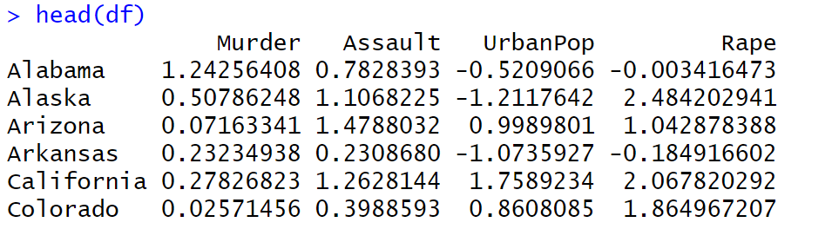

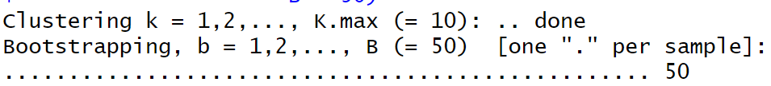

**CODE:**

**#plot number of clusters vs. gap statistic**

fviz_gap_stat(gap_stat)

**#make this example reproducible**

set.seed(1**)**

**#perform k-means clustering with k = 4 clusters**

km <- kmeans(df, centers = 4, nstart = 25)

**CODE:**

**#view results**

Km

**#plot results of final k-means model**

fviz_cluster(km, data = df)

**OUTPUT:**

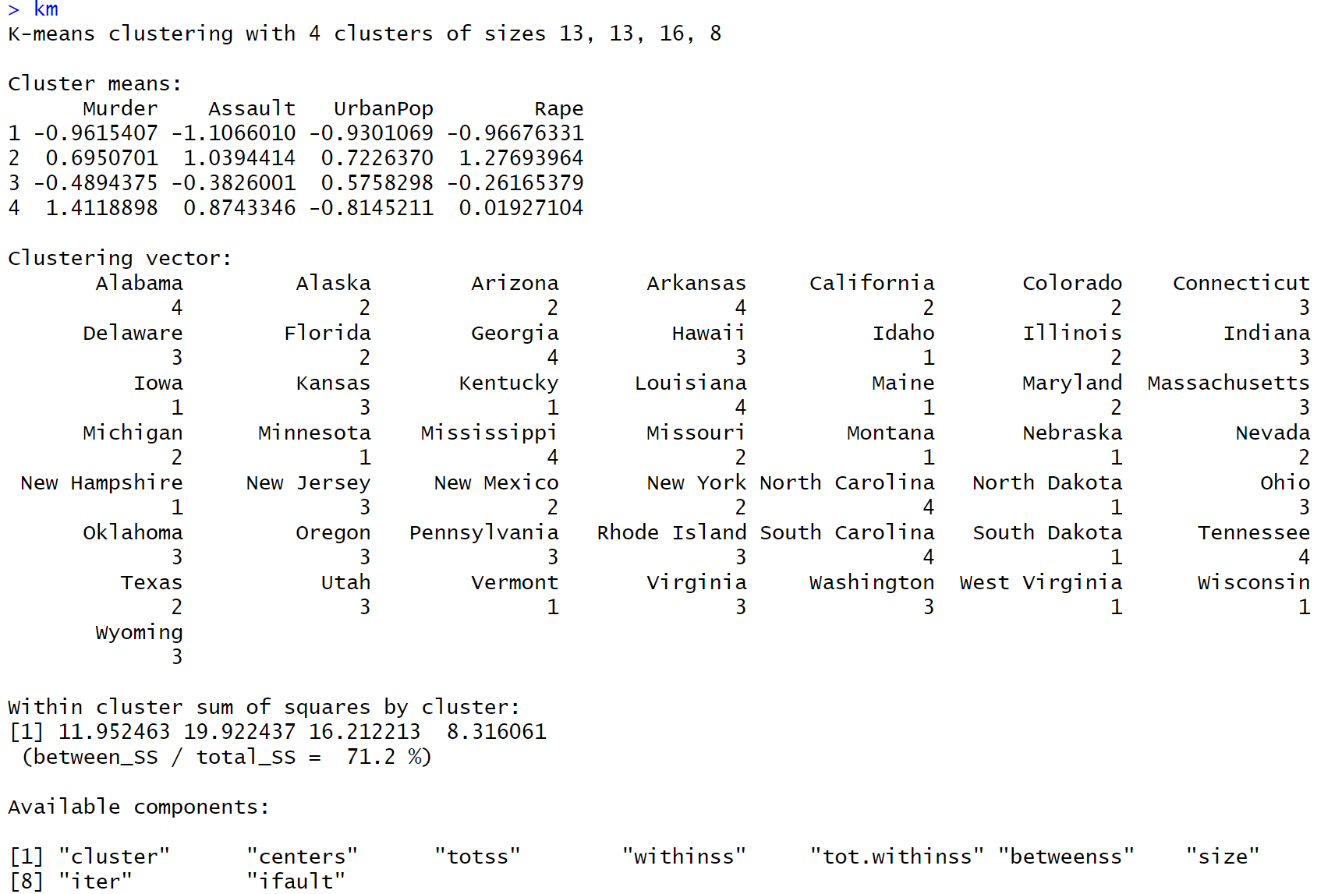

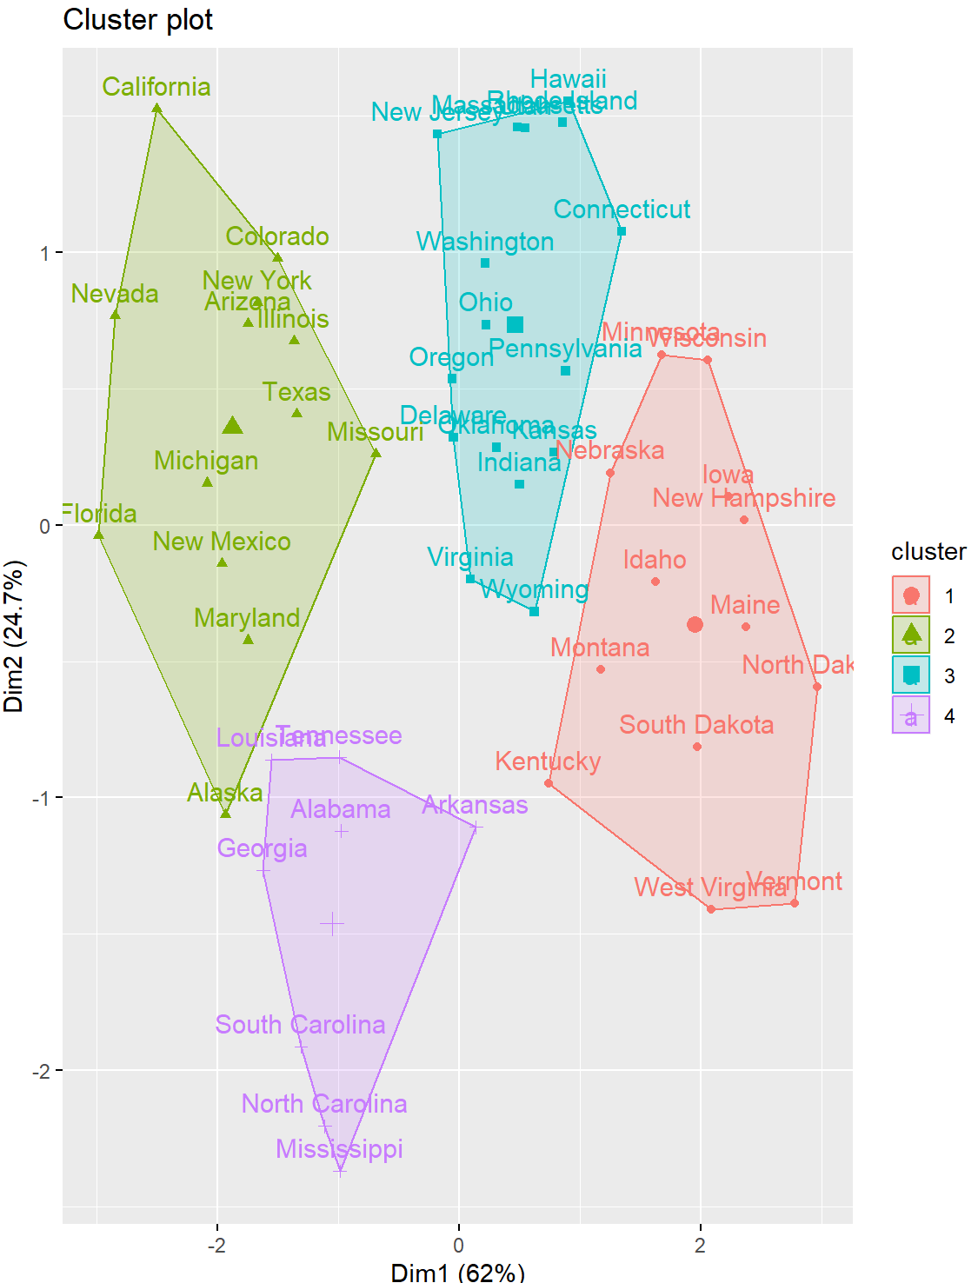

**CODE:**

**#find means of each cluster**

aggregate(USArrests, by=list(cluster=km$cluster),mean)

**#add cluster assigment to original data**

final_data <- cbind(USArrests, cluster = km$cluster)

**#view final data**

head(final_data)

**OUTPUT:**

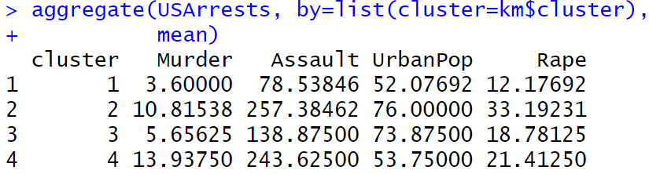

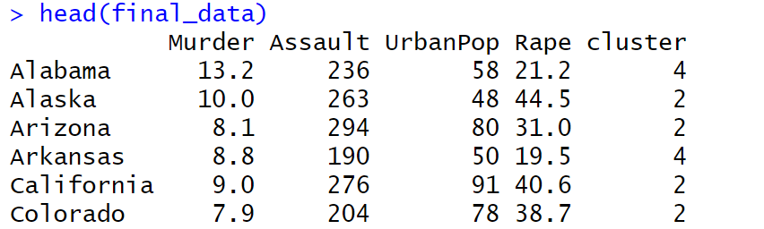

**Pros & Cons of K-Means Clustering:**

K-means clustering offers the following benefits:

• It is a fast algorithm.

• It can handle large datasets well.

However, it comes with the following potential drawbacks:

• It requires us to specify the number of clusters before performing the algorithm.

• It’s sensitive to outliers.

Two alternatives to k-means clustering are k-means clustering and hierarchical clustering.

**EXPERIMENT NO:10**

**AIM: Implement R program on Hierarchical Clustering on mtcars Dataset.**

**DESCRIPTION:**

[**Hierarchical clustering**](https://www.geeksforgeeks.org/hierarchical-clustering-in-data-mining/)**in R Programming Language** is an Unsupervised non-linear algorithm in which clusters are created such that they have a hierarchy(or a pre-determined ordering). For example, consider a family of up to three generations. A grandfather and mother have their children that become father and mother of their children. So, they all are grouped together to the same family i.e they form a hierarchy.

Hierarchical clustering is of two types:

* **Agglomerative Hierarchical clustering:** It starts at individual leaves and successfully merges clusters together. Its a Bottom-up approach.
* **Divisive Hierarchical clustering:** It starts at the root and recursively split the clusters. It’s a top-down approach.

In hierarchical clustering, Objects are categorized into a hierarchy similar to a tree-shaped structure which is used to interpret hierarchical clustering models. The algorithm is as follows:

1. Make each data point in a single point cluster that forms **N** clusters.
2. Take the two closest data points and make them one cluster that forms **N-1** clusters.
3. Take the two closest clusters and make them one cluster that forms **N-2** clusters.
4. Repeat steps 3 until there is only one cluster.

Dendrogram is a hierarchy of clusters in which distances are converted into heights. It clusters **n** units or objects each with p feature into smaller groups. Units in the same cluster are joined by a horizontal line. The leaves at the bottom represent individual units. It provides a visual representation of clusters.  
**Thumb Rule:** Largest vertical distance which doesn’t cut any horizontal line defines the optimal number of clusters.

**mtcars**(motor trend car road test) comprise fuel consumption, performance, and 10 aspects of automobile design for 32 automobiles. It comes pre-installed with dplyr package in R.

## Performing Hierarchical clustering on Dataset

Using Hierarchical Clustering algorithm on the dataset using **hclust()** which is pre-installed in stats package when R is installed.

* The values are shown as per the distance matrix calculation with the method as euclidean.
* In the model, the cluster method is average, distance is euclidean and no. of objects are 32.
* The plot dendrogram is shown with x-axis as distance matrix and y-axis as height.
* So, Tree is cut where k = 3 and each category represents its number of clusters.
* The plot denotes dendrogram after being cut. The green lines show the number of clusters as per the thumb rule.

**CODE:**

**#loading packages**

library(dplyr)

library(ggplot2)

**#summary of the dataset in the package**

head(mtcars)

OUTPUT:

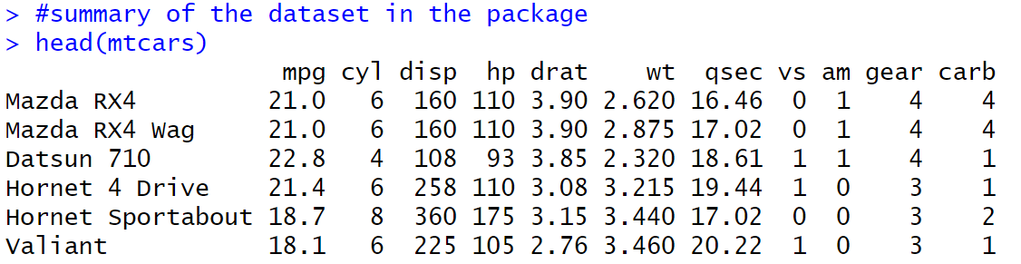

**CODE:**

**#finding the distance matrix**

distance_mat<-dist(mtcars,method='euclidean')

distance_mat

**OUTPUT:**

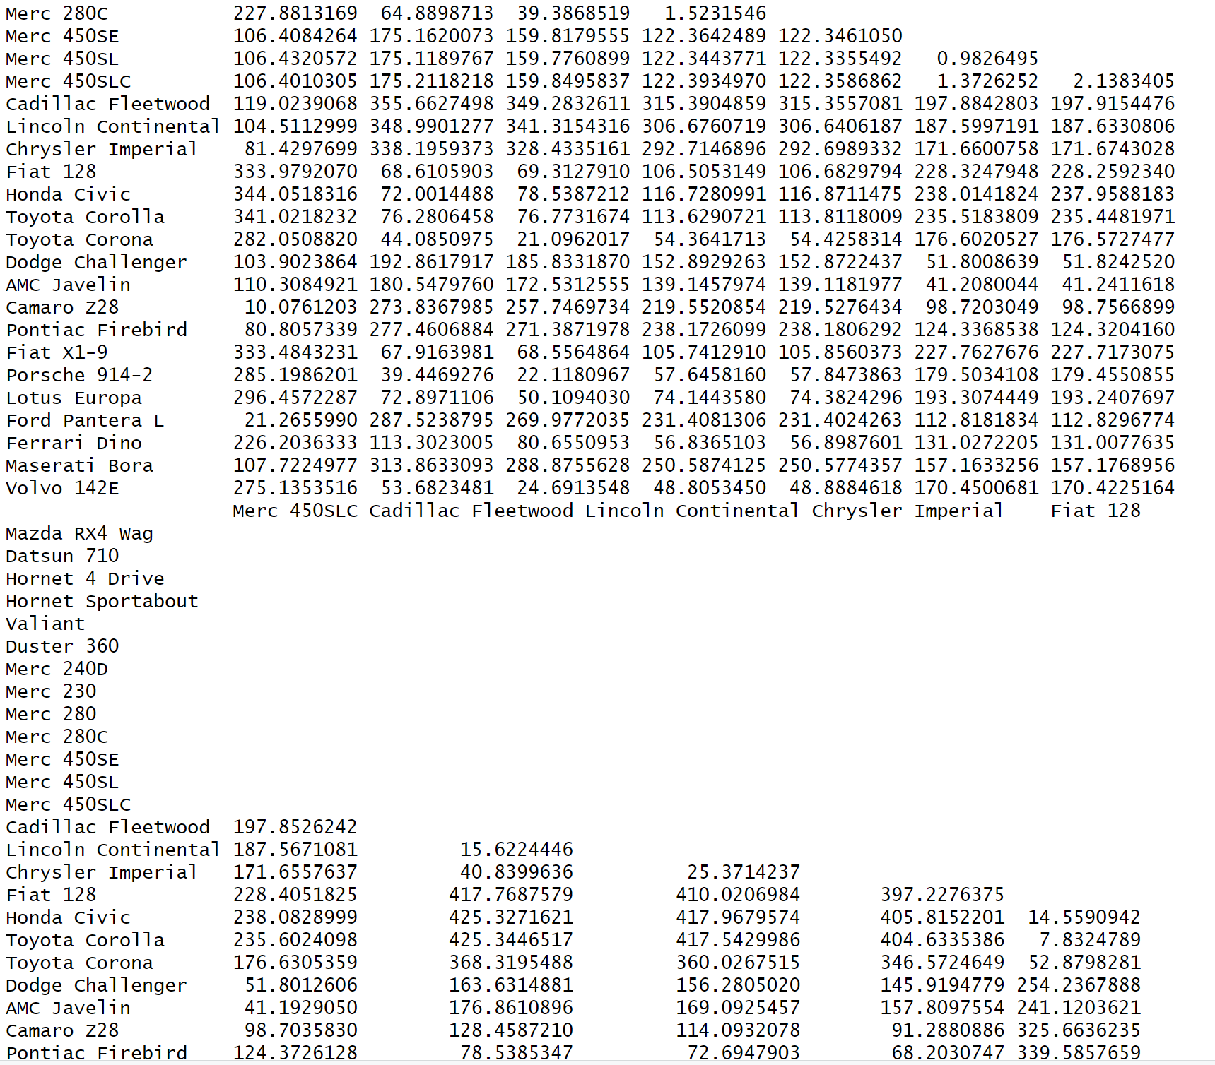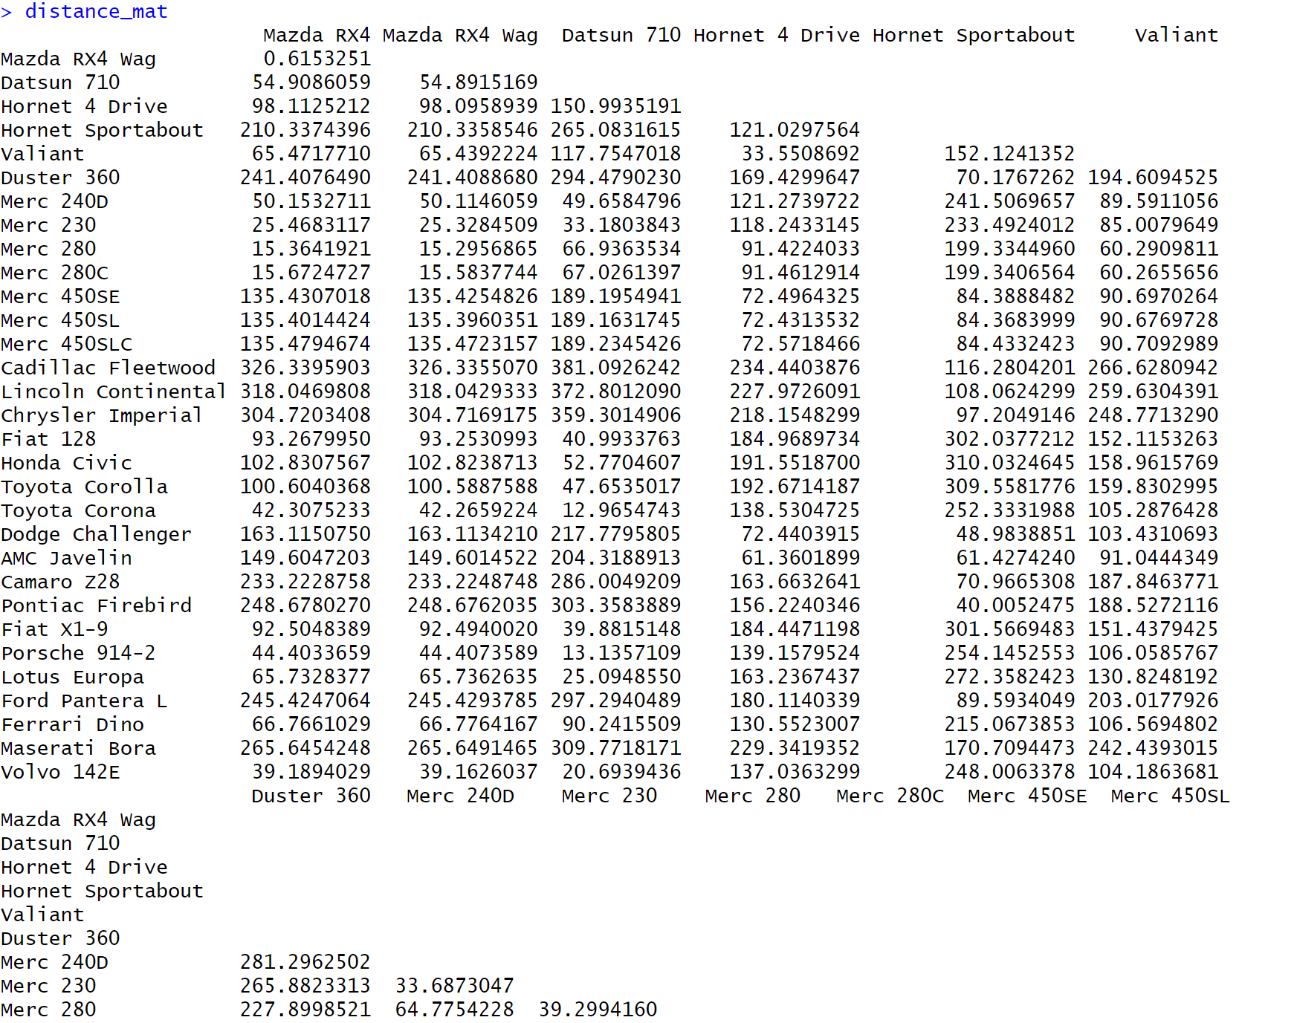

**OUTPUT:**

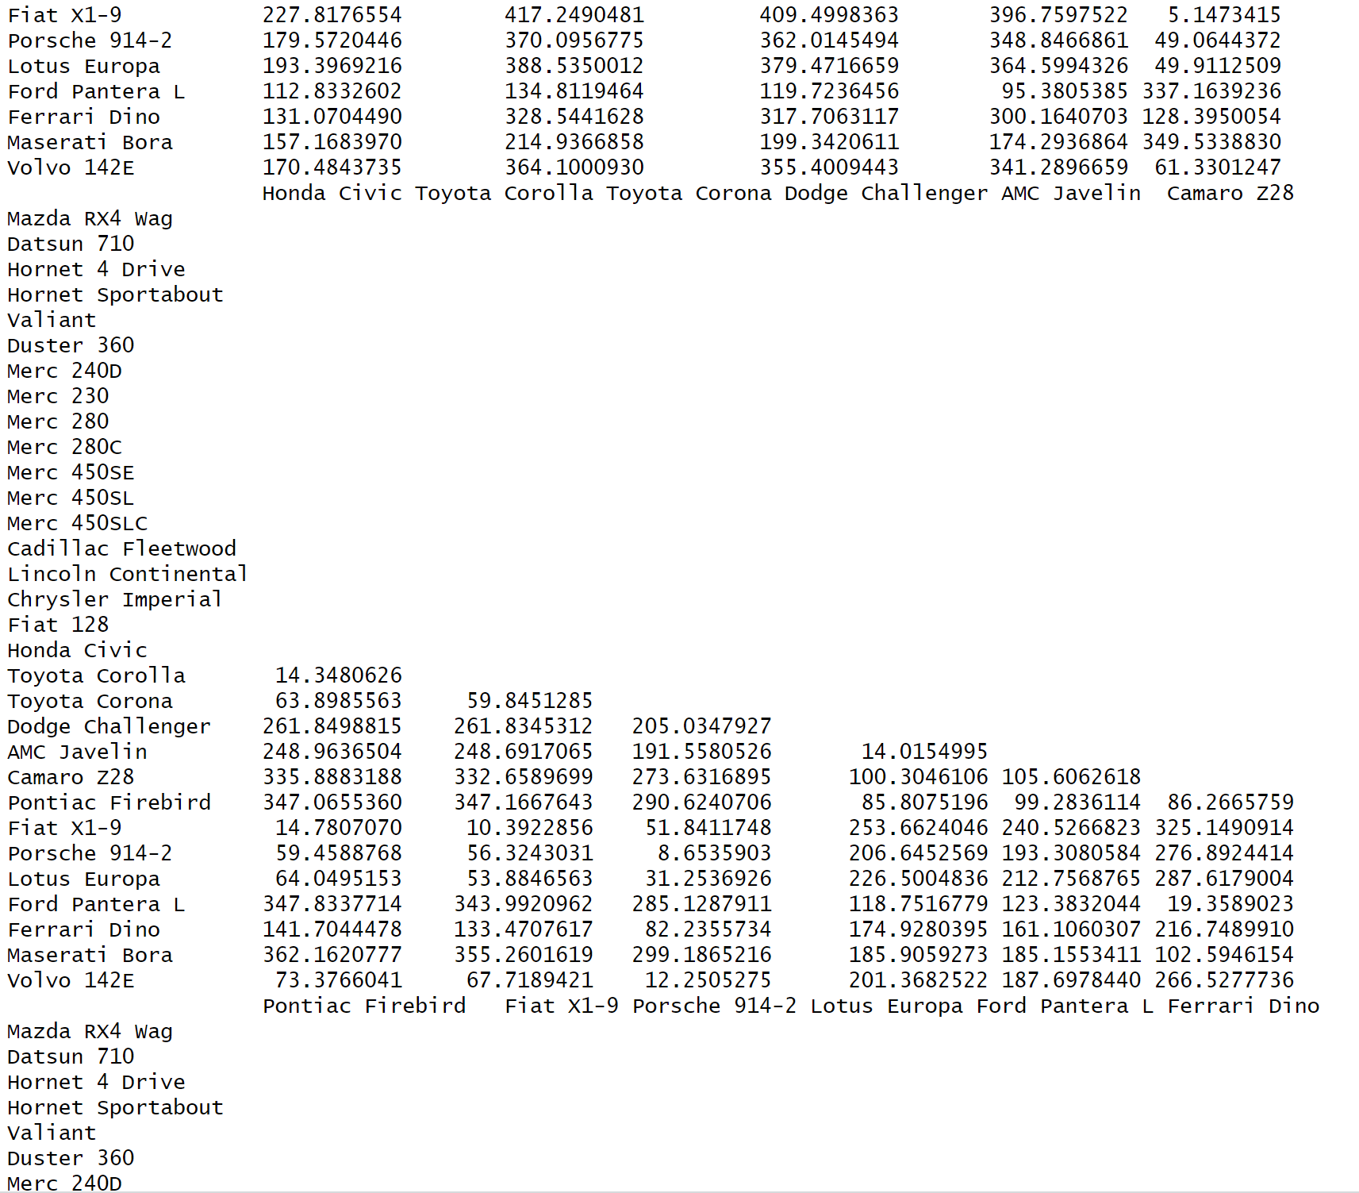

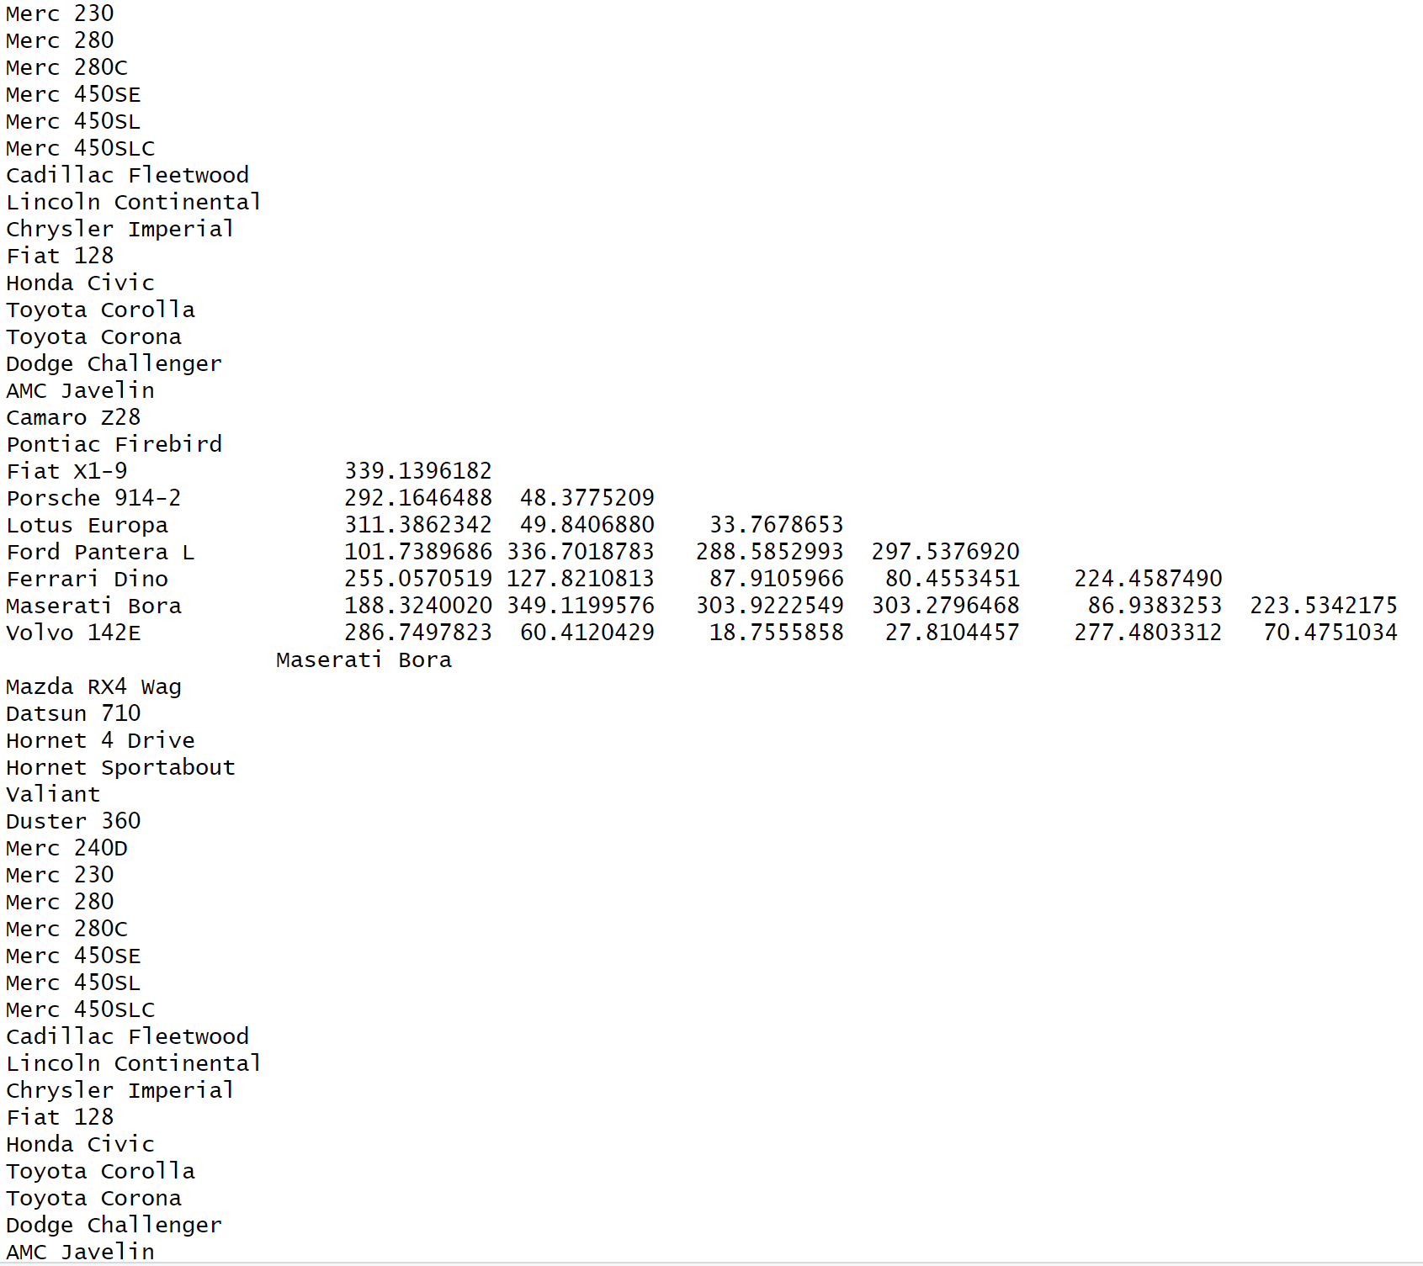

**OUTPUT:**

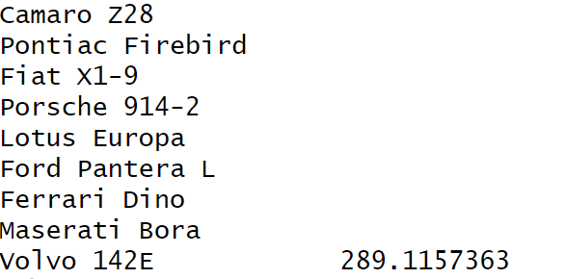

**CODE:**

**#fitting the hierarchical clustering model to the training data**

Hierar_cl<-hclust(distance_mat,method="average")

**#plotting the dendrogram**

plot(Hierar_cl)

**OUTPUT:**

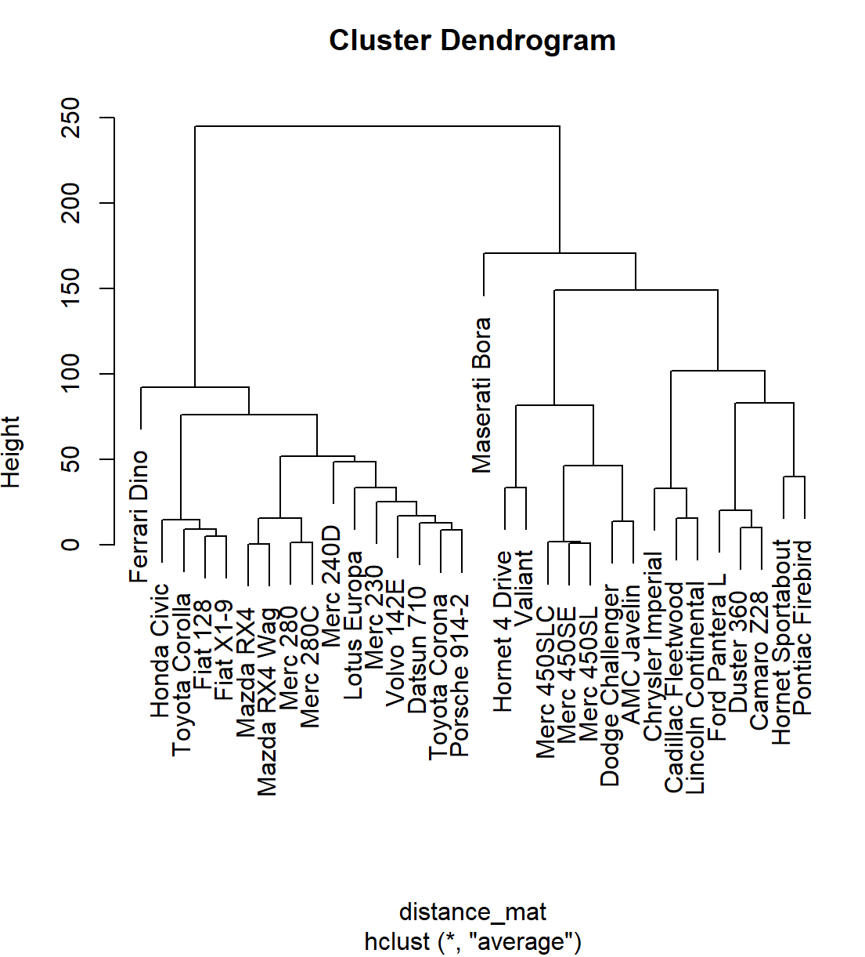

**CODE:**

**#choosing the number of clusters (cut by the number of clustering)**

num_clusters<-3 **#change this to the desired number of clusters**

fit<-cutree(Hierar_cl,k=num_clusters)

fit

**#display the count of datapoints in each cluster**

table(fit)

**OUTPUT:**

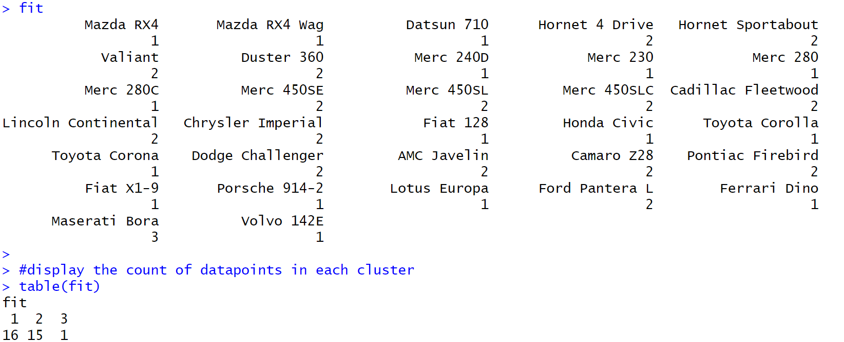

**CODE:**

**#highlight clusters on the dendrogram**

rect.hclust(Hierar_cl,k=num_clusters,border="green")

**#create a dataframe with cluster assignments**

clustered_data<-data.frame(mtcars,Cluster=factor(fit))

**#define the custom cluster colors**

custom_colors<-c("red","pink","lavender")

**#create a scatterplot with custom colors**

scatterplot<-ggplot(clustered_data,aes(x=mpg,

y=disp,

color=Cluster))+

geom_point(size=3)+

geom_text(aes(label=Cluster),hjust=0,vjust=0,

nudge_x=1,nudge_y=20,size=4)+

labs(x="Miles per Gallon(mpg)",y="Displacement(disp)",

title="scatterplot of clusters with custom colors")+

scale_color_manual(values=custom_colors,name='Cluster')

**#display scatter plot**

scatterplot

**OUTPUT:**

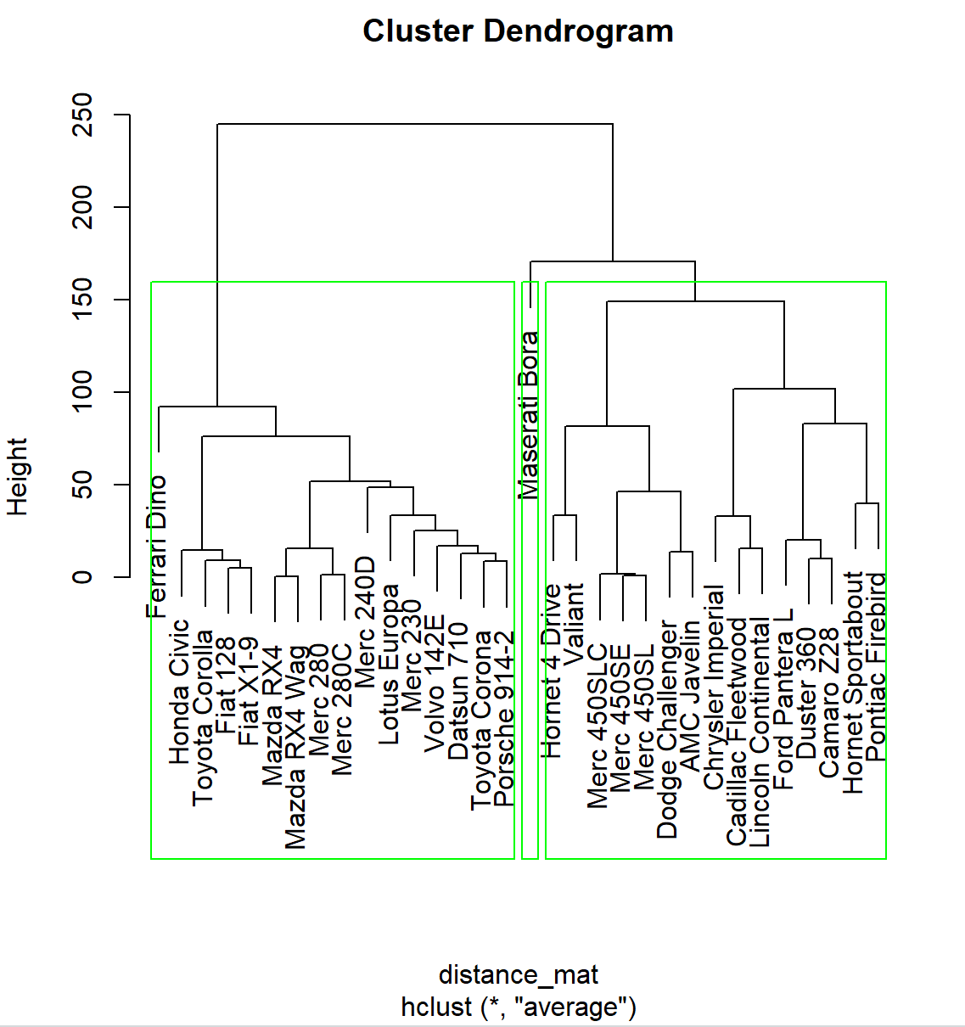

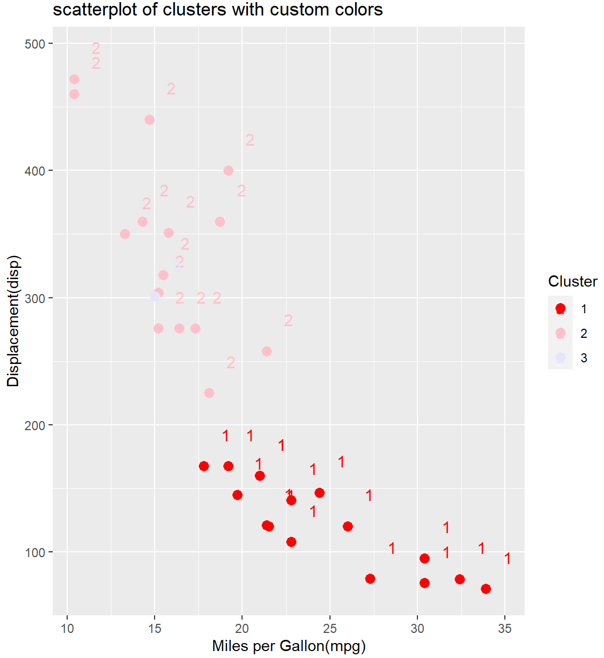

**CODE:**

**# Calculate the mean mpg for each cluster**

cluster_means <- clustered_data %>%

group_by(Cluster) %>%

summarise(mean_mpg = mean(mpg))

**# Create bar graphs for "mpg" variable within each cluster**

bar_graph <- ggplot(cluster_means, aes(x = Cluster, y = mean_mpg, fill = Cluster)) +

geom_bar(stat = "identity", position = "dodge") +

geom_text(aes(label = round(mean_mpg, 2), y = mean_mpg + 0.5), vjust = -0.5, position = position_dodge(width = 0.9)) +

labs(x = "Cluster", y = "Miles per Gallon (mpg)", title = "Bar Graphs of miles per gallon (mpg) by Cluster") +

scale_fill_manual(values = custom_colors, name = "Cluster") +

theme_minimal()

**#display barplot**

print(bar_graph)

**OUTPUT:**

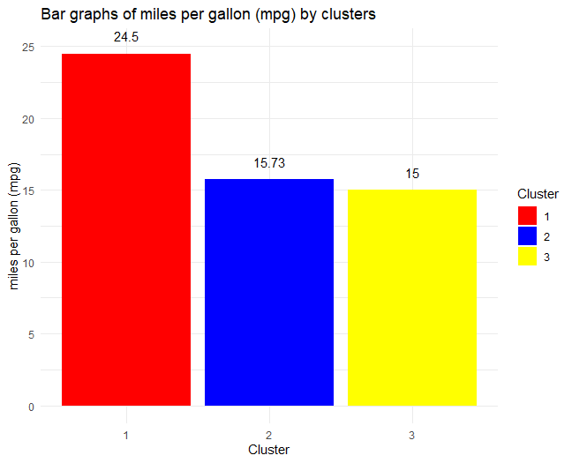

**EXPERIMENT:11**

**AIM:**Create a R program to implement CART, K-Nearest Neighbours, SVM, LDA, Random Forest on PimaIndianDiabetes dataset and compare and visualize the results

**DESCRIPTION:**The “**PimaIndianDiabetes”** Dataset, originally from the National Institute of Diabetes and Digestive and Kidney Diseases, contains information of 768 women from a population near Phoenix, Arizona, USA. The outcome tested was Diabetes, 258 tested positive and 500 tested negative. Therefore, there is one target (dependent) variable and the 8 attributes (TYNECKI, 2018): pregnancies, OGTT(Oral Glucose Tolerance Test), blood pressure, skin thickness, insulin, BMI(Body Mass Index), age, pedigree diabetes function.

**CODE:**

**# load libraries**

library(mlbench)

library(caret)

**# load the dataset**

data(PimaIndiansDiabetes)

**# prepare training scheme**

control <- trainControl(method="repeatedcv", number=10, repeats=3)

**# CART**

set.seed(7)

fit.cart<- train(diabetes~., data=PimaIndiansDiabetes, method="rpart", trControl=control)

**# LDA**

set.seed(7)

fit.lda<- train(diabetes~., data=PimaIndiansDiabetes, method="lda", trControl=control)

**# SVM**

set.seed(7)

fit.svm<- train(diabetes~., data=PimaIndiansDiabetes, method="svmRadial", trControl=control)

**# kNN**

set.seed(7)

fit.knn<- train(diabetes~., data=PimaIndiansDiabetes, method="knn", trControl=control)

**# Random Forest**

set.seed(7)

fit.rf<- train(diabetes~., data=PimaIndiansDiabetes, method="rf", trControl=control)

**# collect resamples**

results <- resamples(list(CART=fit.cart, LDA=fit.lda, SVM=fit.svm, KNN=fit.knn, RF=fit.rf))

**# summarize differences between modes**

summary(results)

**OUTPUT:**

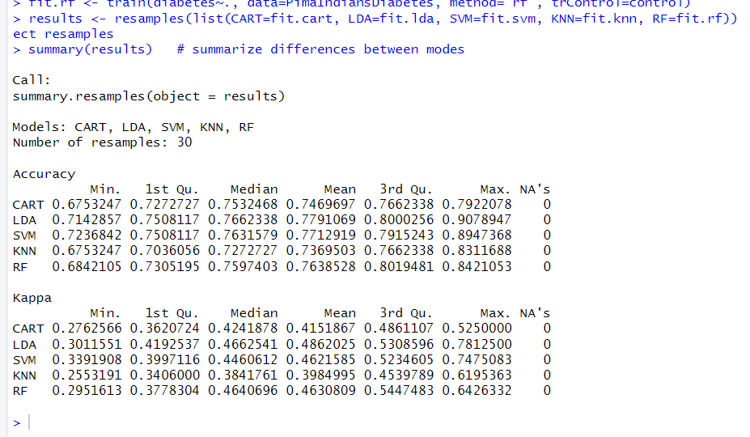

**CODE:**

**# box and whisker plots to compare models**

scales <- list(x=list(relation="free"), y=list(relation="free"))

bwplot(results, scales=scales)

**OUTPUT:**

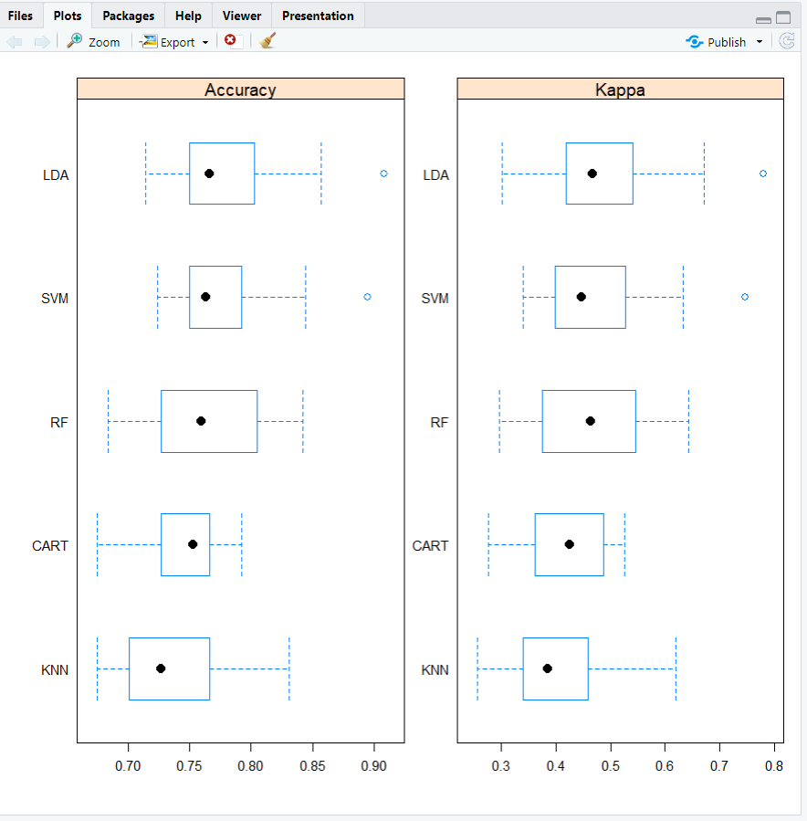

**CODE:**

**# density plots of accuracy**

scales <- list(x=list(relation="free"), y=list(relation="free"))

densityplot(results, scales=scales, pch = "|")

**OUTPUT:**

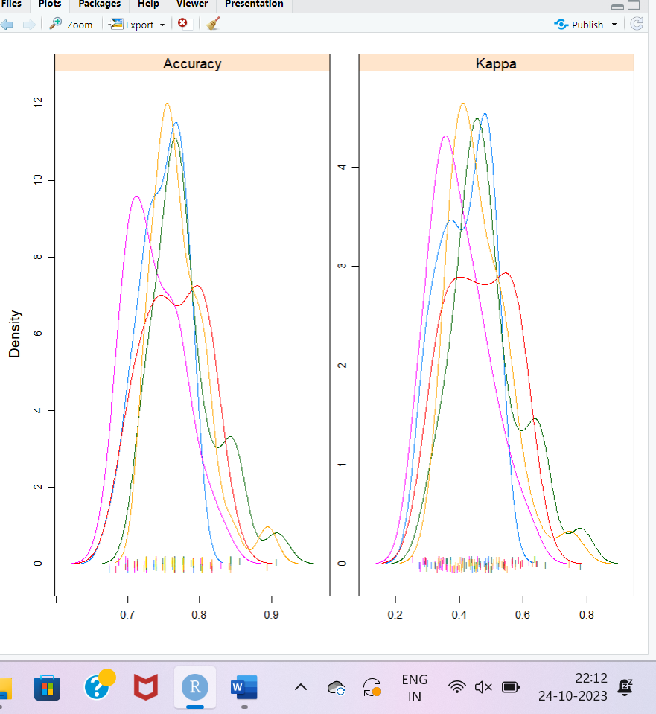

**CODE:**

**# dot plots of accuracy**

scales <- list(x=list(relation="free"), y=list(relation="free"))

dotplot(results, scales=scales)

**OUTPUT:**

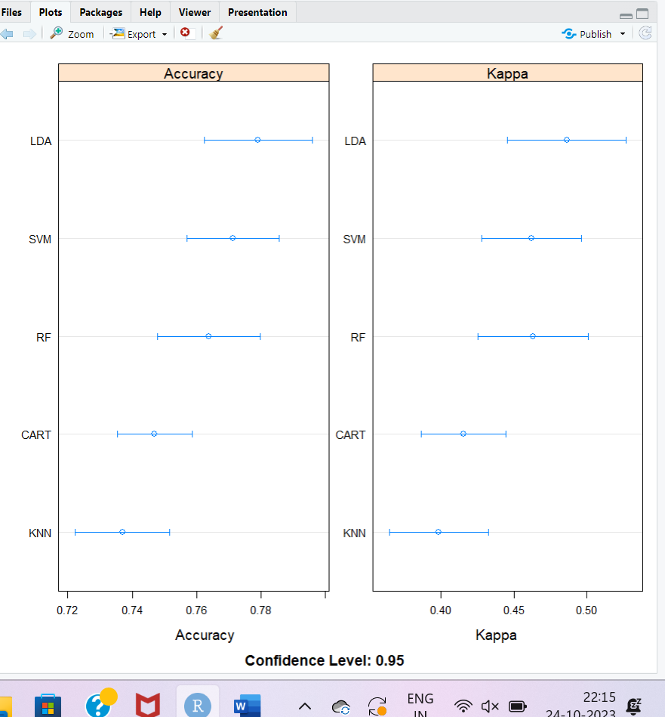

**CODE:**

parallelplot(results) **# parallel plots to compare models**

**OUTPUT:**

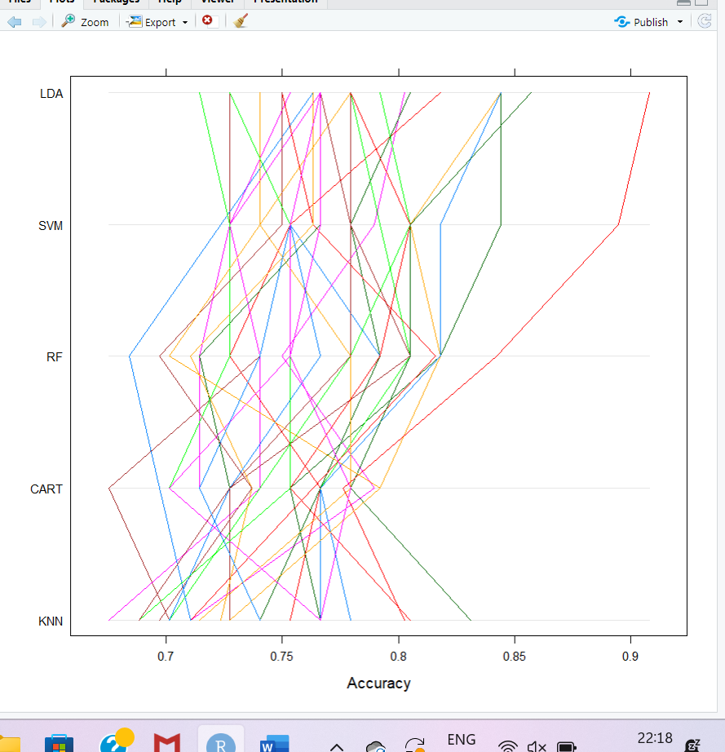

**CODE:**

splom(results)  **# pair-wise scatterplots of predictions to compare models**

xyplot(results, models=c("LDA", "SVM")) **# xyplot plots to compare models**

**OUTPUT:**

|  |  |
| --- | --- |
|  |  |

**CODE:**

diffs <- diff(results) **# difference in model predictions**

summary(diffs) **# summarize p-values for pair-wise comparisons**

**OUTPUT:**

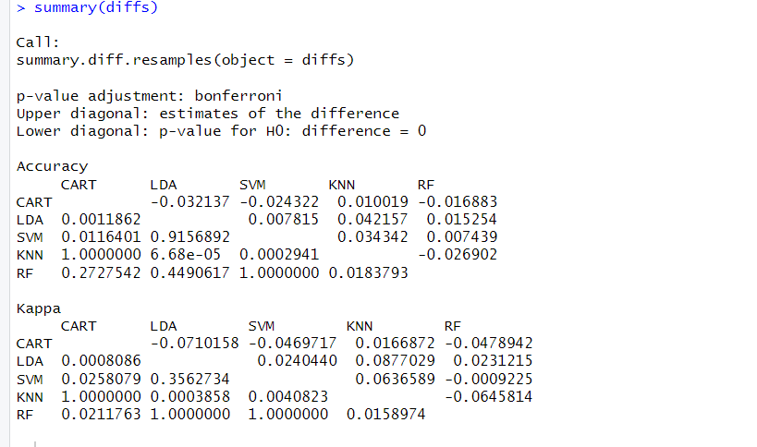

**EXPERIMENT NO:12**

**AIM:**Create aR program to implement Regression Comparison on Boston Housing dataset and compare and visualize the results

**DESCRIPTION:**The “**Boston”** Housing dataset is a commonly used dataset for regression tasks in machine learning. It contains various features related to housing in Boston, such as the crime rate, average number of rooms per dwelling, and more. The target variable in this dataset is typically the median value of owner-occupied homes (in thousands of dollars).

**CODE:**

**# Load necessary libraries**

library(MASS)

library(caret)

library(e1071)

library(randomForest)

library(rpart)

library(rpart.plot)

data(Boston)  **# Load BostonHousing dataset**

set.seed(123) **# Set seed for reproducibility**

**# Split data into training and testing sets**

trainIndex<- createDataPartition(Boston$medv, p = 0.8, list = FALSE)

trainData<- Boston[trainIndex, ]

testData<- Boston[-trainIndex, ]

**# Linear Regression**

lm_model<- lm(medv ~ ., data = trainData)

lm_predictions<- predict(lm_model, newdata = testData)

plot(lm_predictions, testData$medv, main = "Linear Regression")

**OUTPUT:**

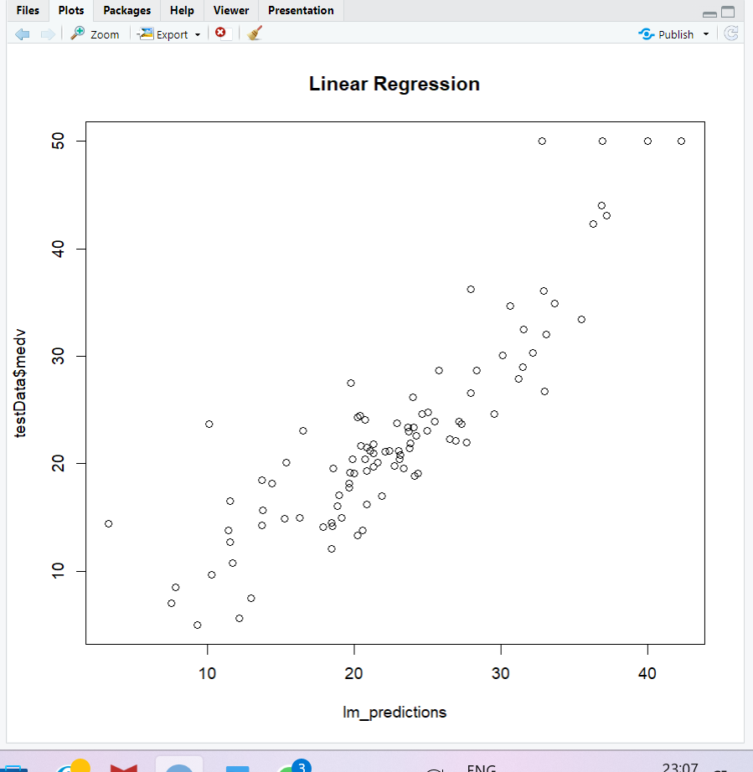

**CODE:**

**# Polynomial Regression (excluding 'chas')**

poly_model<- lm(medv ~ poly(crim, 2) + poly(zn, 2) + poly(indus, 2) + poly(nox, 2) + poly(rm, 2) + poly(age, 2) + poly(dis, 2) + poly(rad, 2) + poly(tax, 2) + poly(ptratio, 2) + poly(black, 2) + poly(lstat, 2), data = trainData)

poly_predictions<- predict(poly_model, newdata = testData)

plot(poly_predictions, testData$medv, main = "Polynomial Regression")

**OUTPUT:**

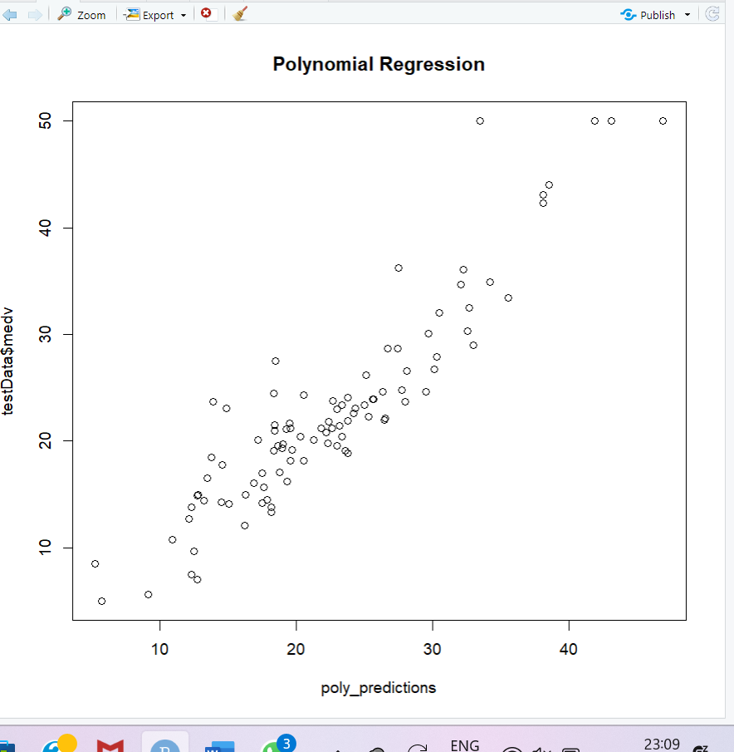

**CODE:**

**# Decision Tree Regression**

tree_model<- rpart(medv ~ ., data = trainData, method = "anova")

tree_predictions<- predict(tree_model, newdata = testData)

rpart.plot(tree_model, main = "Decision Tree Regression")

**OUTPUT:**

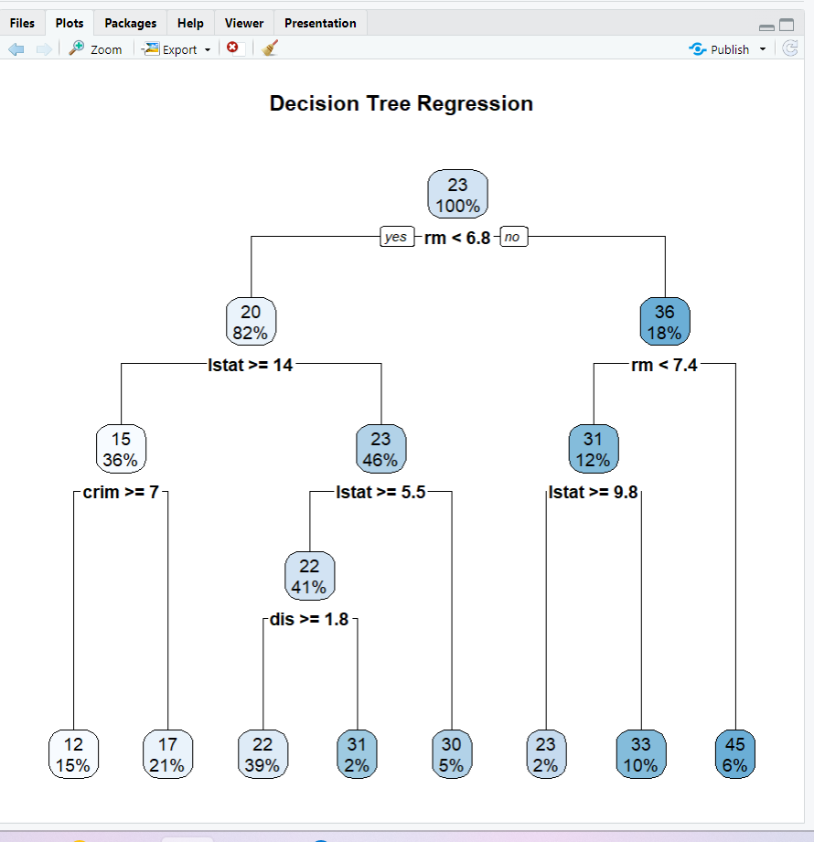

**CODE:**

**# Support Vector Regression**

svm_model<- svm(medv ~ ., data = trainData)

svm_predictions<- predict(svm_model, newdata = testData)

plot(svm_predictions, testData$medv, main = "Support Vector Regression")

**OUTPUT:**

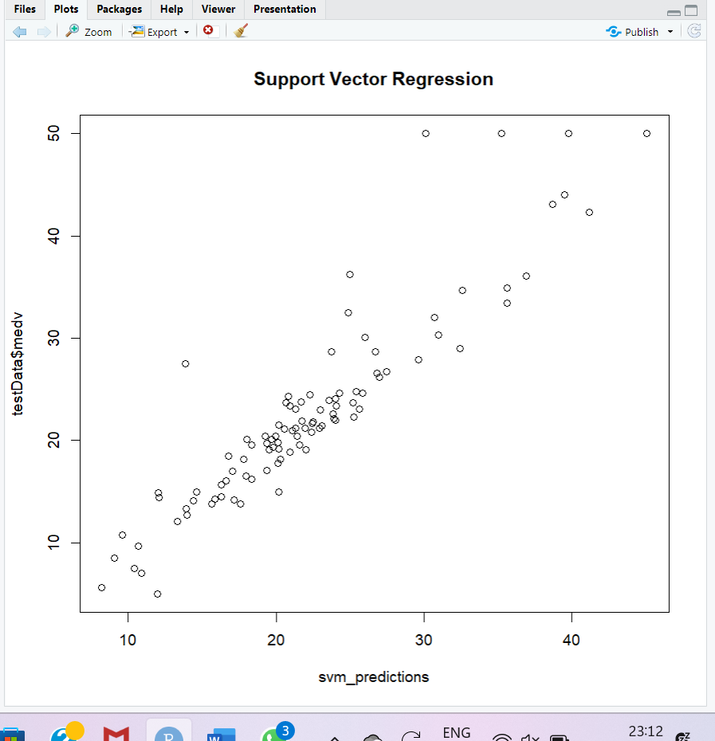

**CODE:**

**# Random Forest Regression**

rf_model<- randomForest(medv ~ ., data = trainData)

rf_predictions<- predict(rf_model, newdata = testData)

plot(rf_predictions, testData$medv, main = "Random Forest Regression")

**OUTPUT:**

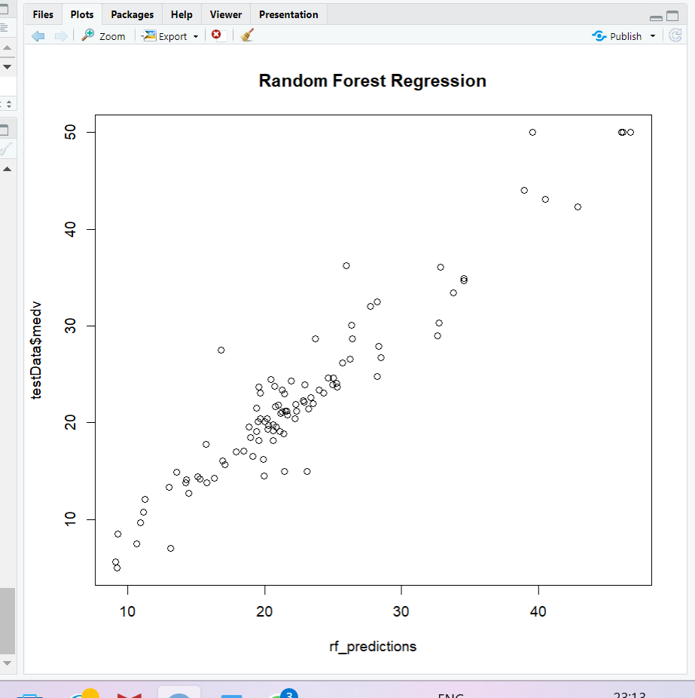

**CODE:**

**# Model Summaries**

summary(lm_model)

summary(poly_model)

**OUTPUT:**

|  |  |
| --- | --- |
|  |  |

**CODE:**

print(tree_model)

**OUTPUT:**

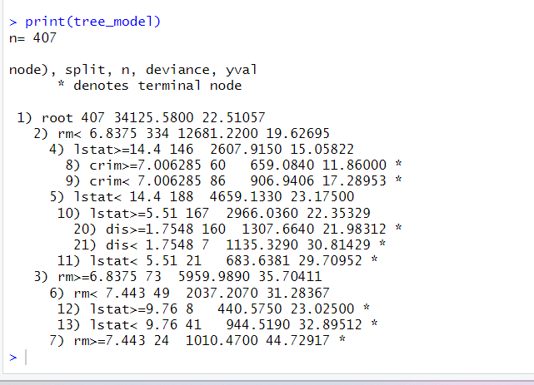

**CODE:**

summary(svm_model)

print(rf_model)

**OUTPUT:**

|  |  |
| --- | --- |
|  |  |

**CODE:**

**# Calculate RMSE for each model**

lm_rmse<- rmse(testData$medv - lm_predictions)

poly_rmse<- rmse(testData$medv - poly_predictions)

tree_rmse<- rmse(testData$medv - tree_predictions)

svm_rmse<- rmse(testData$medv - svm_predictions)

rf_rmse<- rmse(testData$medv - rf_predictions)

**# Print RMSEs for each model**

cat("Linear Regression RMSE:",lm_rmse,”\n”)

cat("Polynomial Regression RMSE:",ploy_rmse,”\n”)

cat("Decision Tree Regression RMSE:",tree_rmse,”\n”)

cat("Support Vector Regression RMSE:",svm_rmse,”\n”)

cat("Random Forest Regression RMSE:",rf_rmse,”\n”)

**OUTPUT:**

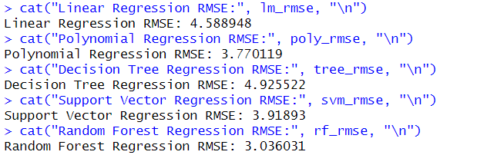

**CODE:**

**# Create bar graphs for each model's predictions**

models <- c("Linear Regression", "Polynomial Regression", "Decision Tree Regression", "Support Vector Regression", "Random Forest Regression")

predictions <- list(lm_predictions, poly_predictions, tree_predictions, svm_predictions, rf_predictions)

for (i in 1:length(models)) {

par(mfrow=c(1,1))

barplot(predictions[[i]], main = paste(models[i], "Predictions"), ylab = "Predicted Values")}

**OUTPUT:**

|  |  |
| --- | --- |
|  |  |
|  |  |

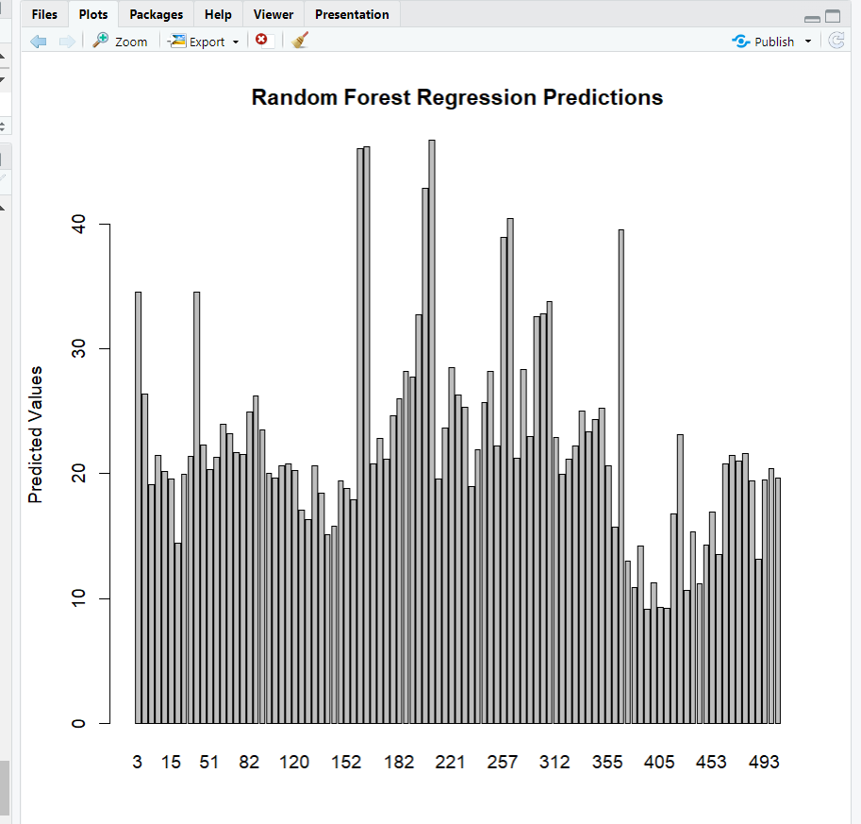

**EXPERIMENT NO:13**

**AIM:**Create a R program to implement Clustering Comparison on College dataset and compare and visualize the results

**DESCRIPTION:**The "**College**" dataset is another commonly used dataset, typically for tasks like clustering and classification. This dataset contains information about various colleges in the United States. The dataset includes features related to the colleges, such as their names, types (public or private), number of students, acceptance rates, and more. One of the common uses of this dataset is for clustering colleges based on their characteristics.

**CODE:**

**# Load required libraries**

library(ISLR2)

library(cluster)

library(dbscan)

library(factoextra)

library(mclust)

library(ggplot2)

library(kohonen)

library(e1071) **# For FCM**

library(reshape2) **# For data manipulation**

data("College") **# Load the College dataset**

**# Select relevant features for clustering (excluding the college name)**

college_data<- College[, -1] **# Exclude the first column (college name)**

scaled_data<- scale(college_data)**# Standardize the data**

**# Create a function to calculate silhouette scores**

calculate_silhouette<- function(method, data, clusters) {

if (!is.null(clusters)) {

silhouette_score<- mean(silhouette(clusters, dist(data)))

return(silhouette_score)

} else {

return(NA)

}}

**# Initialize a dataframe to store results**

results <- data.frame(Method = character(0), Silhouette = numeric(0))

**# Perform K-Means clustering**

kmeans_result<- kmeans(scaled_data, centers = 3, nstart = 25)

kmeans_silhouette<- calculate_silhouette("K-Means", scaled_data, kmeans_result$cluster)

results <- rbind(results, data.frame(Method = "K-Means", Silhouette = kmeans_silhouette))

**# Perform Hierarchical Clustering**

hierarchical_result<- hclust(dist(scaled_data))

hierarchical_silhouette<- calculate_silhouette("Hierarchical", scaled_data, cutree(hierarchical_result, k = 3))

results <- rbind(results, data.frame(Method = "Hierarchical", Silhouette = hierarchical_silhouette))

**# Perform DBSCAN clustering**

dbscan_result<- dbscan(scaled_data, eps = 3, MinPts = 5)

dbscan_silhouette<- calculate_silhouette("DBSCAN", scaled_data, dbscan_result$cluster)

results <- rbind(results, data.frame(Method = "DBSCAN", Silhouette = dbscan_silhouette))

**# Perform Gaussian Mixture Model (GMM) clustering**

gmm_result<-Mclust(scaled_data,G=3)

**OUTPUT:**

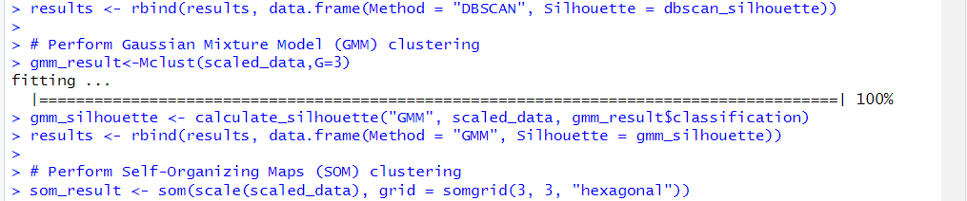

gmm_silhouette<- calculate_silhouette("GMM", scaled_data, gmm_result$classification)

results <- rbind(results, data.frame(Method = "GMM", Silhouette = gmm_silhouette))

**# Perform Self-Organizing Maps (SOM) clustering**

som_result<- som(scale(scaled_data), grid = somgrid(3, 3, "hexagonal"))

som_silhouette<- calculate_silhouette("SOM", scale(scaled_data), som_result$unit.classif)

results <- rbind(results, data.frame(Method = "SOM", Silhouette = som_silhouette))

**# Perform Fuzzy C-Means (FCM) clustering**

fcm_result<- cmeans(scaled_data, centers = 3, m = 1.2)

fcm_clusters<- fcm_result$cluster

fcm_silhouette<- calculate_silhouette("FCM", scaled_data, fcm_clusters)

results <- rbind(results, data.frame(Method = "FCM", Silhouette = fcm_silhouette))

Print(results)

**OUTPUT:**

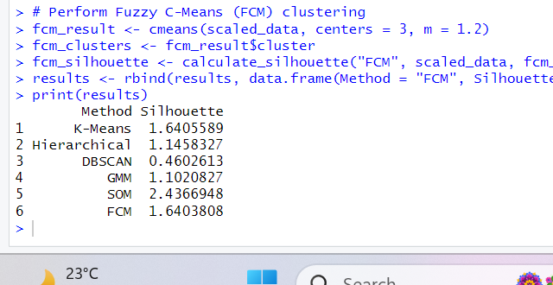

**CODE:**

**# Find the index of the method with the highest silhouette score**

best_method_index<- which.max(results$Silhouette)

best_method<- results$Method[best_method_index]**# Retrieve the best method based on the index**

**# Visualize K-Means clustering**

fviz_cluster(kmeans_result, data = scaled_data, geom = "point", main = "K-Means Clustering")

plot(hierarchical_result, main = "Hierarchical Clustering Dendrogram")**# Visualize Hierarchical Clustering**

**OUTPUT:**

|  |  |
| --- | --- |
|  |  |

**CODE:**

rect.hclust(hierarchical_result, k = 3, border = 2:4)

**# Visualize DBSCAN clustering**

fviz_cluster(dbscan_result, data = scaled_data, geom = "point", main = "DBSCAN Clustering")

**OUTPUT:**

|  |  |
| --- | --- |
|  |  |

**CODE:**

**# Visualize GMM clustering**

plot(gmm_result, what = "classification", main = "GMM Clustering")

**OUTPUT:**

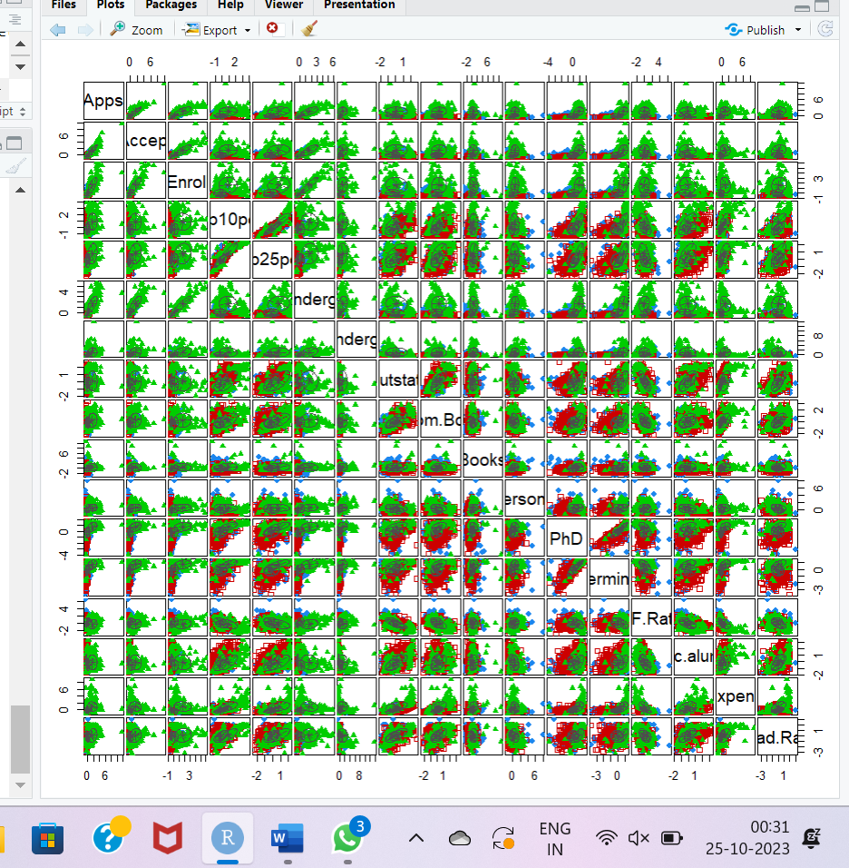

**CODE:**

**# Perform Self-Organizing Maps (SOM) clustering**

som_result<- som(scale(scaled_data), grid = somgrid(3, 3, "hexagonal")

cat(“SOM Cluster Summary:\n”)

print(som_result)

**OUTPUT:**

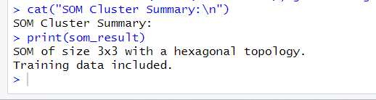

**CODE:**

cluster_assignments<- som_result$unit.classif**# Get cluster assignments from the SOM result**

unique_clusters<- unique(cluster_assignments)**# Create a vector of unique cluster IDs**

cluster_colors<- rainbow(length(unique_clusters))**# Create a color palette for the clusters**

assigned_colors<- cluster_colors[cluster_assignments]**# Map cluster assignments to colors based on cluster IDs**

**# Visualize SOM Clustering with assigned colors**

plot(som_result, type = "mapping", pchs = 20, col = assigned_colors, main = "SOM Clustering")

plot(scaled_data, col = fcm_clusters, pch = 19, main = "FCM Clustering") **# Plot FCM clustering assignments**

**OUTPUT:**

|  |  |
| --- | --- |
|  |  |

**CODE:**

**# Print the best method and its silhouette score**

Cat(“Best Clustering Method:”,best_method,”\n”)

Cat(“Silhouette score:”,results$Silhouette[best_method_index],”\n”)

**OUTPUT:**

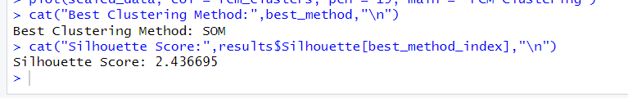

**CODE:**

**# Create a bar plot of silhouette scores with different colors for each bar**

ggplot(results, aes(x = Method, y = Silhouette, fill = Method)) +

geom_bar(stat = "identity") +

geom_text(aes(label = round(Silhouette, 2), vjust = -0.5), position = position_dodge(0.9)) + # Add labels on top of bars

labs(title = "Silhouette Scores for Clustering Algorithms", y = "Silhouette Score") +

theme_minimal() +

theme(axis.text.x = element_text(angle = 45, hjust = 1))  **# Rotate x-axis labels for better readability**

**OUTPUT:**

